Transmission Timings Report Week - 32
5/08/2024 - 11/08/2024

SBR2 Cloud Production2 - Single Requests (SRP)

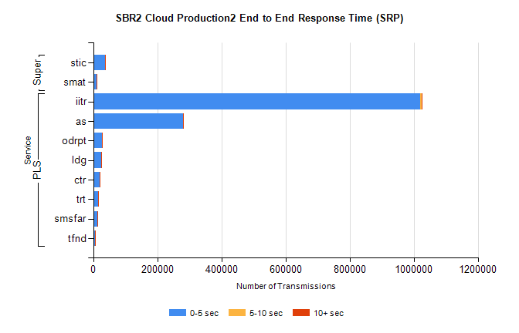
Stream | Service | 0-5 sec | 5-10 sec | >10 sec | Total | % within 5 sec timing target
PLS | iitr | 1019236 | 4999 | 895 | 1025245 | 99.4%
PLS | as | 279944 | 698 | 106 | 280781 | 99.7%
PLS | odrpt | 27477 | 910 | 123 | 28510 | 96.4%
PLS | ldg | 24715 | 68 | 6 | 24789 | 99.7%
PLS | ctr | 19427 | 71 | 14 | 19512 | 99.6%
PLS | trt | 15158 | 61 | 6 | 15234 | 99.5%
PLS | smsfar | 14118 | 58 | 16 | 14192 | 99.5%
PLS | tfnd | 6019 | 27 | 2 | 6048 | 99.5%
Super | stic | 36674 | 265 | 39 | 36978 | 99.2%
Super | smat | 9998 | 162 | 40 | 10200 | 98.0%

SBR2 Cloud Production2 - Bulk or Batch Requests (BBRP)

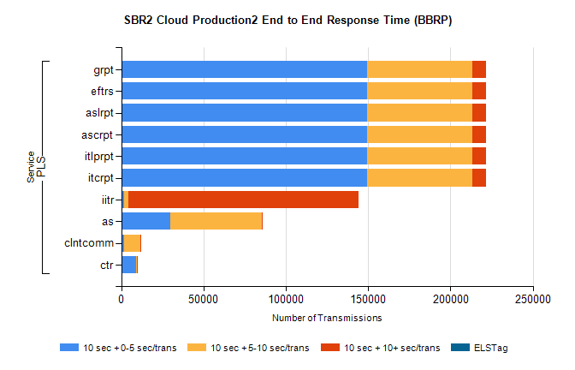
Stream | Service | 10 sec + 0-5 sec /trans | 10 sec + 5-10 sec /trans | 10 sec + >10 sec /trans | Processing Incomplete | ELStag | Total
PLS | itcrpt | 149430 | 64018 | 8220 | 57 | 0 | 224744
PLS | itlprpt | 149430 | 64018 | 8220 | 57 | 0 | 224744
PLS | ascrpt | 149430 | 64018 | 8220 | 57 | 0 | 224744
PLS | aslrpt | 149430 | 64018 | 8220 | 57 | 0 | 224744
PLS | eftrs | 149430 | 64018 | 8220 | 57 | 0 | 224744
PLS | grpt | 149430 | 64018 | 8220 | 57 | 0 | 224744
PLS | iitr | 1937 | 2205 | 139805 | 476 | 0 | 153131
PLS | as | 29588 | 55977 | 139 | 152 | 0 | 86454
PLS | clntcomm | 1512 | 10230 | 498 | 15 | 0 | 13340
PLS | ctr | 8870 | 802 | 5 | 12 | 0 | 9723

SBR2 Cloud Production2 - ...

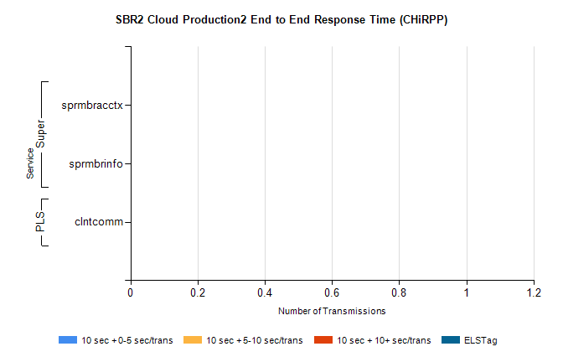
Stream | Service | 10 sec + 0-5 sec /trans | 10 sec + 5-10 sec /trans | 10 sec + >10 sec /trans | Total | % within 5 sec timing target
PLS | clntcomm | 0 | 0 | 0 | 17767 | 0.0%
Super | sprmbracctx | 0 | 0 | 0 | 3319 | 0.0%
Super | sprmbrinfo | 0 | 0 | 0 | 2650 | 0.0%

SBR1 Production Transactions

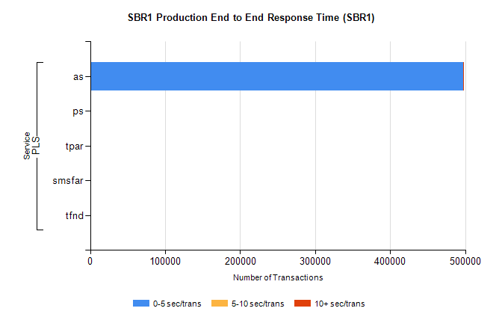
Stream | Service | 0-5 sec/trans | 5-10 sec/trans | 10+ sec/trans | Total | % within 5 sec timing target
PLS | as | 497636 | 168 | 526 | 498330 | 99.9%
PLS | ps | 117 | 143 | 260 | 520 | 22.5%
PLS | tpar | 260 |  |  | 260 | 100.0%
PLS | smsfar | 7 | 7 | 3 | 17 | 41.2%
PLS | tfnd |  | 1 | 1 | 2 | 0.0%

