Transmission Timings Report Week - 33
12/08/2024 - 18/08/2024

SBR2 External Vendor Testing Environment (EVTE3)

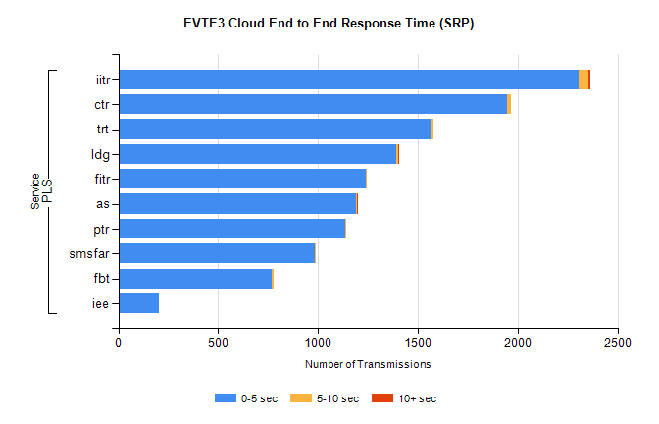
Stream | Service | 0-5 sec | 5-10 sec | >10 sec | Total | % within 5 sec timing target
PLS | iitr | 2304 | 48 | 13 | 2365 | 97.4%
PLS | ctr | 1945 | 19 | 0 | 1974 | 98.5%
PLS | trt | 1567 | 9 | 0 | 1576 | 99.4%
PLS | ldg | 1394 | 8 | 5 | 1407 | 99.1%
PLS | fitr | 1237 | 1 | 0 | 1238 | 99.9%
PLS | as | 1188 | 5 | 7 | 1223 | 97.1%
PLS | ptr | 1136 | 6 | 0 | 1143 | 99.4%
PLS | smsfar | 986 | 5 | 0 | 991 | 99.5%
PLS | fbt | 766 | 11 | 0 | 777 | 98.6%
PLS | iee | 202 | 0 | 0 | 202 | 100.0%

SBR2 External Vendor Testing Environment (EVTE3)

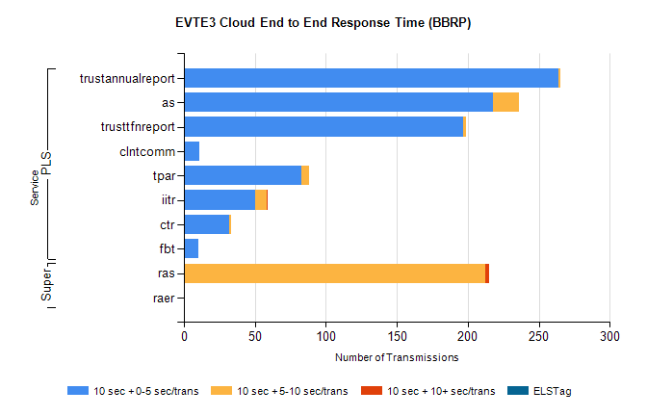
Stream | Service | 10 sec + 0-5 sec /trans | 10 sec + 5-10 sec /trans | 10 sec + >10 sec /trans | Processing Incomplete | ELStag | Total
PLS | trustannualreport | 264 | 1 | 0 | 0 | 0 | 265
PLS | as | 218 | 18 | 0 | 0 | 0 | 236
PLS | trusttfnreport | 197 | 2 | 0 | 0 | 0 | 199
PLS | clntcomm | 11 | 0 | 0 | 71 | 0 | 98
PLS | tpar | 83 | 5 | 0 | 0 | 0 | 91
PLS | iitr | 50 | 8 | 1 | 0 | 0 | 62
PLS | ctr | 32 | 1 | 0 | 0 | 0 | 33
PLS | fbt | 10 | 0 | 0 | 0 | 0 | 10
Super | ras | 1 | 211 | 3 | 0 | 0 | 230
Super | raer | 0 | 0 | 0 | 45 | 0 | 45

