Transmission Timings Report Week - 33
12/08/2024 - 18/08/2024

SBR2 Cloud Production2 - Single Requests (SRP)

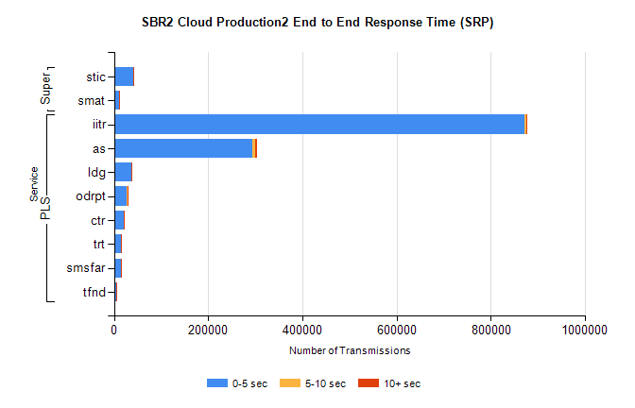
Stream | Service | 0-5 sec | 5-10 sec | >10 sec | Total | % within 5 sec timing target
PLS | iitr | 871289 | 4726 | 1277 | 877390 | 99.3%
PLS | as | 293438 | 6536 | 3365 | 303409 | 96.7%
PLS | ldg | 37705 | 93 | 18 | 37816 | 99.7%
PLS | odrpt | 27482 | 1083 | 207 | 28772 | 95.5%
PLS | ctr | 21007 | 75 | 17 | 21099 | 99.6%
PLS | trt | 15469 | 53 | 12 | 15537 | 99.6%
PLS | smsfar | 14252 | 48 | 17 | 14318 | 99.5%
PLS | tfnd | 5818 | 19 | 6 | 5843 | 99.6%
Super | stic | 40944 | 257 | 39 | 41240 | 99.3%
Super | smat | 10408 | 149 | 38 | 10595 | 98.2%

SBR2 Cloud Production2 - Bulk or Batch Requests (BBRP)

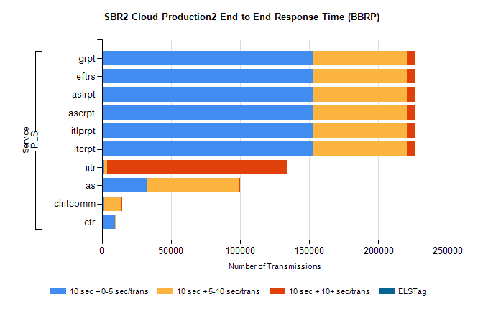
Stream | Service | 10 sec + 0-5 sec /trans | 10 sec + 5-10 sec /trans | 10 sec + >10 sec /trans | Processing Incomplete | ELStag | Total
PLS | itcrpt | 152875 | 67515 | 5614 | 22 | 0 | 229340
PLS | itlprpt | 152875 | 67515 | 5614 | 22 | 0 | 229340
PLS | ascrpt | 152875 | 67515 | 5614 | 22 | 0 | 229340
PLS | aslrpt | 152875 | 67515 | 5614 | 22 | 0 | 229340
PLS | eftrs | 152875 | 67515 | 5614 | 22 | 0 | 229340
PLS | grpt | 152875 | 67515 | 5614 | 22 | 0 | 229340
PLS | iitr | 1837 | 2205 | 130243 | 398 | 0 | 142264
PLS | as | 33133 | 66163 | 718 | 192 | 0 | 103710
PLS | clntcomm | 1931 | 12364 | 358 | 3 | 0 | 15379
PLS | ctr | 9503 | 780 | 46 | 19 | 0 | 10375

SBR2 Cloud Production2 - ...

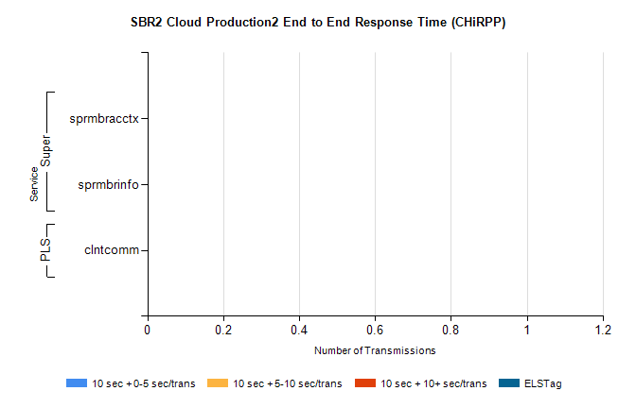
Stream | Service | 10 sec + 0-5 sec /trans | 10 sec + 5-10 sec /trans | 10 sec + >10 sec /trans | Total | % within 5 sec timing target
PLS | clntcomm | 0 | 0 | 0 | 24251 | 0.0%
Super | sprmbracctx | 0 | 0 | 0 | 4135 | 0.0%
Super | sprmbrinfo | 0 | 0 | 0 | 2668 | 0.0%

SBR1 Production Transactions

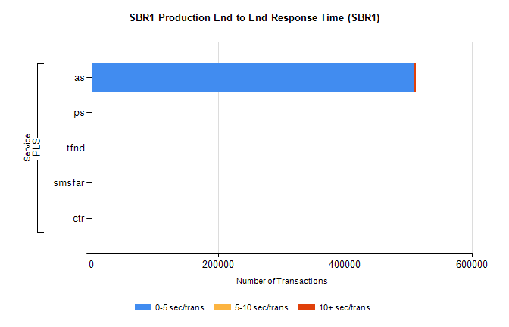
Stream | Service | 0-5 sec/trans | 5-10 sec/trans | 10+ sec/trans | Total | % within 5 sec timing target
PLS | as | 509108 | 410 | 1938 | 511456 | 99.5%
PLS | ps | 215 | 161 | 283 | 659 | 32.6%
PLS | tfnd | 8 | 6 |  | 14 | 57.1%
PLS | smsfar | 1 | 11 | 1 | 13 | 7.7%
PLS | ctr |  |  | 1 | 1 | 0.0%

