Transmission Timings Report Week - 34
19/08/2024 - 25/08/2024

SBR2 External Vendor Testing Environment (EVTE3)

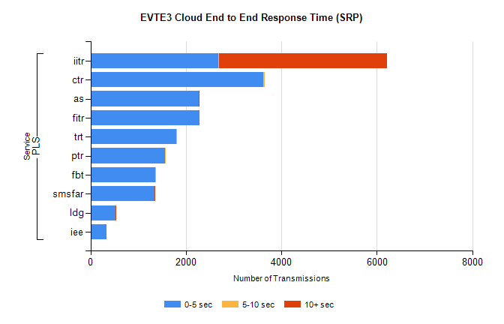
Stream | Service | 0-5 sec | 5-10 sec | >10 sec | Total | % within 5 sec timing target
PLS | iitr | 2671 | 29 | 3509 | 6209 | 43.0%
PLS | ctr | 3628 | 20 | 0 | 3652 | 99.3%
PLS | as | 2263 | 9 | 10 | 2318 | 97.6%
PLS | fitr | 2283 | 0 | 0 | 2284 | 100.0%
PLS | trt | 1797 | 6 | 0 | 1803 | 99.7%
PLS | ptr | 1565 | 9 | 0 | 1576 | 99.3%
PLS | fbt | 1351 | 8 | 0 | 1359 | 99.4%
PLS | smsfar | 1336 | 1 | 2 | 1339 | 99.8%
PLS | ldg | 525 | 5 | 7 | 541 | 97.0%
PLS | iee | 334 | 0 | 0 | 334 | 100.0%

SBR2 External Vendor Testing Environment (EVTE3)

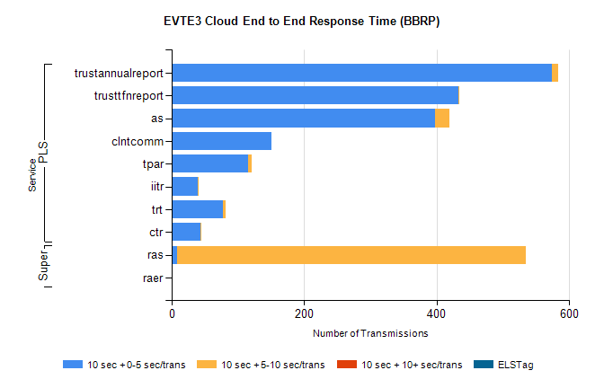
Stream | Service | 10 sec + 0-5 sec /trans | 10 sec + 5-10 sec /trans | 10 sec + >10 sec /trans | Processing Incomplete | ELStag | Total
PLS | trustannualreport | 574 | 9 | 0 | 0 | 0 | 584
PLS | trusttfnreport | 433 | 1 | 0 | 0 | 0 | 434
PLS | as | 397 | 22 | 0 | 1 | 0 | 420
PLS | clntcomm | 150 | 0 | 0 | 43 | 0 | 259
PLS | tpar | 115 | 6 | 0 | 0 | 0 | 128
PLS | iitr | 39 | 2 | 0 | 54 | 0 | 96
PLS | trt | 77 | 5 | 0 | 0 | 0 | 83
PLS | ctr | 43 | 2 | 0 | 0 | 0 | 45
Super | ras | 8 | 526 | 0 | 36 | 0 | 585
Super | raer | 0 | 0 | 0 | 111 | 0 | 111

