Transmission Timings Report Week - 34
19/08/2024 - 25/08/2024

SBR2 Cloud Production2 - Single Requests (SRP)

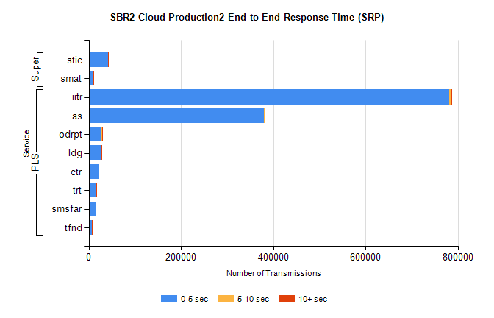
Stream | Service | 0-5 sec | 5-10 sec | >10 sec | Total | % within 5 sec timing target
PLS | iitr | 781873 | 4340 | 1469 | 787994 | 99.2%
PLS | as | 380192 | 1463 | 410 | 382287 | 99.5%
PLS | odrpt | 27751 | 1116 | 208 | 29075 | 95.4%
PLS | ldg | 27753 | 68 | 12 | 27835 | 99.7%
PLS | ctr | 21610 | 53 | 28 | 21697 | 99.6%
PLS | trt | 15867 | 36 | 17 | 15928 | 99.6%
PLS | smsfar | 14841 | 48 | 23 | 14916 | 99.5%
PLS | tfnd | 6364 | 16 | 6 | 6388 | 99.6%
Super | stic | 42088 | 326 | 61 | 42482 | 99.1%
Super | smat | 10898 | 127 | 17 | 11045 | 98.7%

SBR2 Cloud Production2 - Bulk or Batch Requests (BBRP)

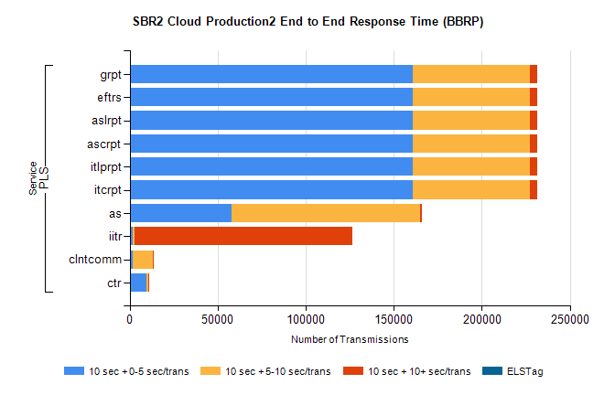
Stream | Service | 10 sec + 0-5 sec /trans | 10 sec + 5-10 sec /trans | 10 sec + >10 sec /trans | Processing Incomplete | ELStag | Total
PLS | itcrpt | 160837 | 66432 | 3923 | 45 | 0 | 234051
PLS | itlprpt | 160837 | 66432 | 3923 | 45 | 0 | 234051
PLS | ascrpt | 160837 | 66432 | 3923 | 45 | 0 | 234051
PLS | aslrpt | 160837 | 66432 | 3923 | 45 | 0 | 234051
PLS | eftrs | 160837 | 66432 | 3923 | 45 | 0 | 234051
PLS | grpt | 160837 | 66432 | 3923 | 45 | 0 | 234051
PLS | as | 57906 | 106892 | 979 | 672 | 0 | 166964
PLS | iitr | 1798 | 1137 | 123598 | 532 | 0 | 132686
PLS | clntcomm | 1803 | 11238 | 527 | 0 | 0 | 14170
PLS | ctr | 9539 | 770 | 91 | 25 | 0 | 10444

SBR2 Cloud Production2 - ...

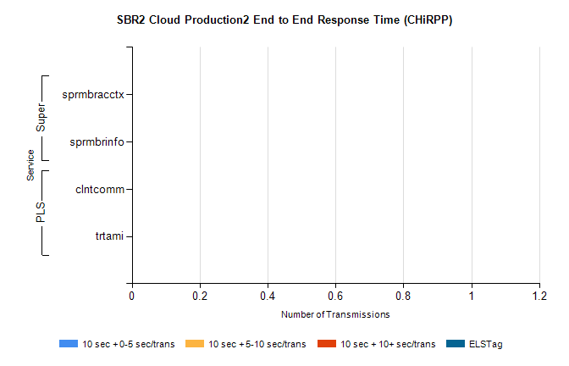
Stream | Service | 10 sec + 0-5 sec /trans | 10 sec + 5-10 sec /trans | 10 sec + >10 sec /trans | Total | % within 5 sec timing target
PLS | clntcomm | 0 | 0 | 0 | 22837 | 0.0%
PLS | trtami | 0 | 0 | 0 | 2 | 0.0%
Super | sprmbracctx | 0 | 0 | 0 | 3064 | 0.0%
Super | sprmbrinfo | 0 | 0 | 0 | 2658 | 0.0%

SBR1 Production Transactions

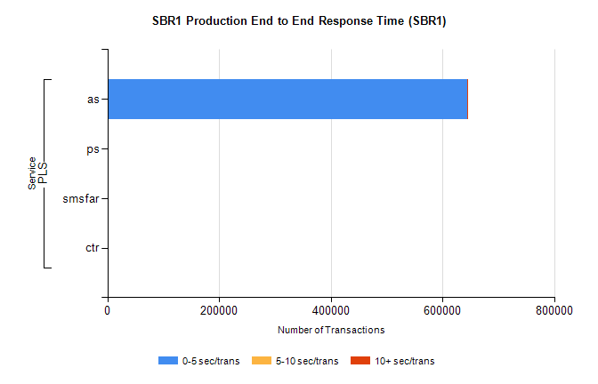
Stream | Service | 0-5 sec/trans | 5-10 sec/trans | 10+ sec/trans | Total | % within 5 sec timing target
PLS | as | 644563 | 346 | 243 | 645152 | 99.9%
PLS | ps | 202 | 169 | 269 | 640 | 31.6%
PLS | smsfar | 7 | 8 | 3 | 18 | 38.9%
PLS | ctr |  |  | 1 | 1 | 0.0%

