Transmission Timings Report Week - 35
26/08/2024 to 1/09/2024

SBR2 External Vendor Testing Environment (EVTE3)

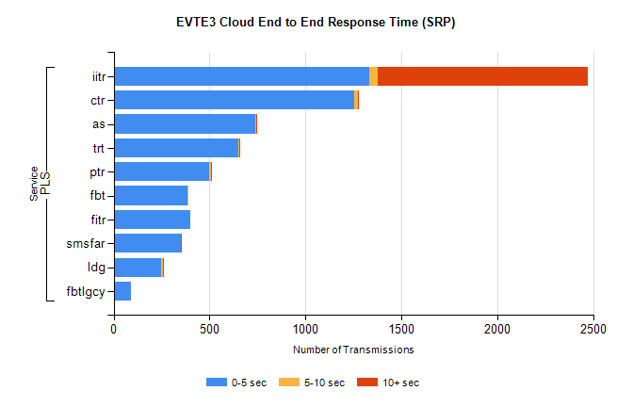
Stream | Service | 0-5 sec | 5-10 sec | >10 sec | Total | % within 5 sec timing target
PLS | iitr | 1335 | 41 | 1098 | 2474 | 54.0%
PLS | ctr | 1256 | 20 | 3 | 1356 | 92.6%
PLS | as | 737 | 7 | 5 | 815 | 90.4%
PLS | trt | 648 | 5 | 3 | 708 | 91.5%
PLS | ptr | 499 | 7 | 2 | 571 | 87.4%
PLS | fbt | 385 | 6 | 0 | 428 | 90.0%
PLS | fitr | 400 | 0 | 0 | 426 | 93.9%
PLS | smsfar | 349 | 1 | 2 | 352 | 99.1%
PLS | ldg | 250 | 7 | 4 | 278 | 89.9%
PLS | fbtlgcy | 90 | 0 | 0 | 90 | 100.0%

SBR2 External Vendor Testing Environment (EVTE3)

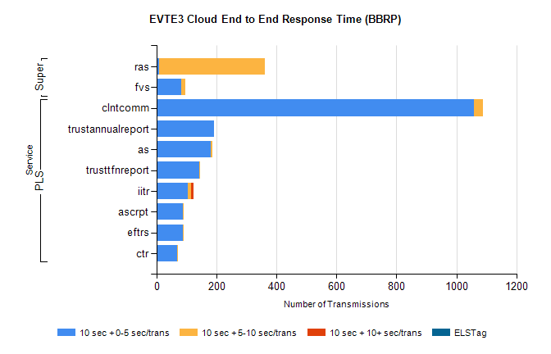
Stream | Service | 10 sec + 0-5 sec /trans | 10 sec + 5-10 sec /trans | 10 sec + >10 sec /trans | Processing Incomplete | ELStag | Total
PLS | clntcomm | 1059 | 30 | 0 | 4 | 0 | 1101
PLS | as | 180 | 6 | 0 | 6 | 0 | 192
PLS | trustannualreport | 192 | 0 | 0 | 0 | 0 | 192
PLS | trusttfnreport | 143 | 2 | 0 | 0 | 0 | 145
PLS | iitr | 104 | 12 | 7 | 6 | 0 | 136
PLS | eftrs | 88 | 2 | 0 | 2 | 0 | 92
PLS | ascrpt | 88 | 2 | 0 | 2 | 0 | 92
PLS | ctr | 69 | 2 | 0 | 1 | 0 | 72
Super | ras | 8 | 353 | 0 | 12 | 0 | 384
Super | fvs | 82 | 13 | 0 | 0 | 0 | 95

