Transmission Timings Report Week - 35
26/08/2024 to 1/09/2024

SBR2 Cloud Production2 - Single Requests (SRP)

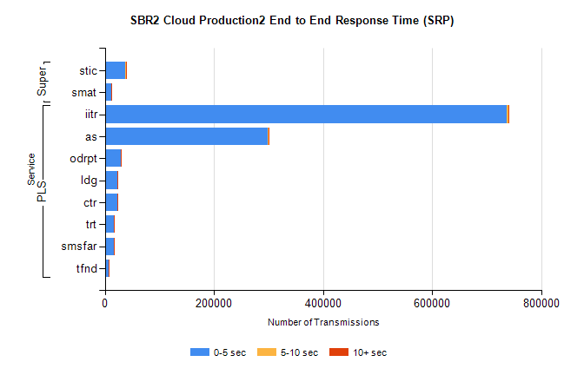
Stream | Service | 0-5 sec | 5-10 sec | >10 sec | Total | % within 5 sec timing target
PLS | iitr | 737482 | 3104 | 645 | 741284 | 99.5%
PLS | as | 299143 | 920 | 123 | 300209 | 99.6%
PLS | odrpt | 29187 | 754 | 60 | 30001 | 97.3%
PLS | ldg | 23125 | 47 | 4 | 23177 | 99.8%
PLS | ctr | 23081 | 52 | 13 | 23149 | 99.7%
PLS | trt | 16795 | 59 | 8 | 16864 | 99.6%
PLS | smsfar | 16202 | 52 | 11 | 16266 | 99.6%
PLS | tfnd | 6751 | 16 | 3 | 6770 | 99.7%
Super | stic | 38064 | 181 | 44 | 38289 | 99.4%
Super | smat | 11369 | 119 | 22 | 11510 | 98.8%

SBR2 Cloud Production2 - Bulk or Batch Requests (BBRP)

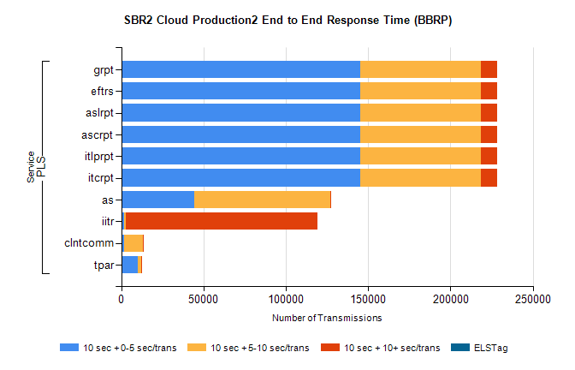
Stream | Service | 10 sec + 0-5 sec /trans | 10 sec + 5-10 sec /trans | 10 sec + >10 sec /trans | Processing Incomplete | ELStag | Total
PLS | itcrpt | 145020 | 73270 | 10152 | 24 | 0 | 234154
PLS | itlprpt | 145020 | 73270 | 10152 | 24 | 0 | 234154
PLS | ascrpt | 145020 | 73270 | 10152 | 24 | 0 | 234154
PLS | aslrpt | 145020 | 73270 | 10152 | 24 | 0 | 234154
PLS | eftrs | 145020 | 73270 | 10152 | 24 | 0 | 234154
PLS | grpt | 145020 | 73270 | 10152 | 24 | 0 | 234154
PLS | as | 44529 | 82519 | 618 | 954 | 0 | 129088
PLS | iitr | 1815 | 1044 | 116468 | 1075 | 0 | 125707
PLS | clntcomm | 1622 | 11442 | 311 | 0 | 0 | 13899
PLS | tpar | 10244 | 2024 | 11 | 222 | 0 | 12535

SBR2 Cloud Production2 - ...

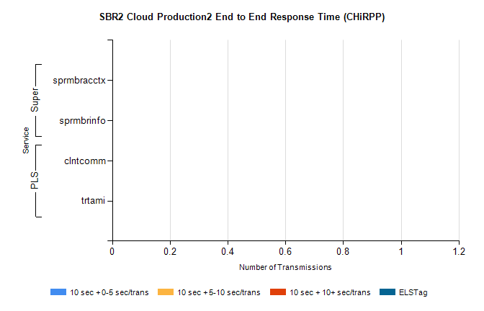
Stream | Service | 10 sec + 0-5 sec /trans | 10 sec + 5-10 sec /trans | 10 sec + >10 sec /trans | Total | % within 5 sec timing target
PLS | clntcomm | 0 | 0 | 0 | 29944 | 0.0%
PLS | trtami | 0 | 0 | 0 | 9 | 0.0%
Super | sprmbracctx | 0 | 0 | 0 | 2925 | 0.0%
Super | sprmbrinfo | 0 | 0 | 0 | 2642 | 0.0%

SBR1 Production Transactions

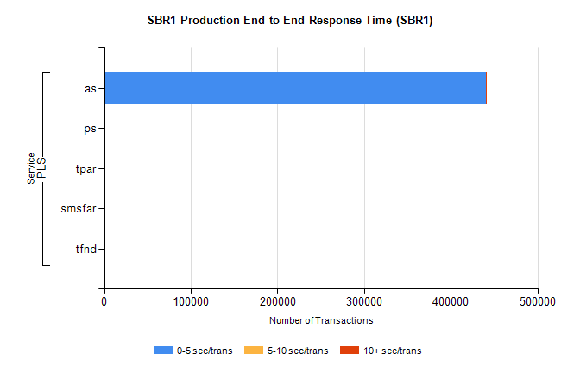
Stream | Service | 0-5 sec/trans | 5-10 sec/trans | 10+ sec/trans | Total | % within 5 sec timing target
PLS | as | 440126 | 149 | 330 | 440605 | 99.9%
PLS | ps | 108 | 131 | 224 | 463 | 23.3%
PLS | tpar | 57 |  |  | 57 | 100.0%
PLS | smsfar | 7 | 27 | 4 | 38 | 18.4%
PLS | tfnd | 18 | 8 |  | 26 | 69.2%

