Transmission Timings Report Week - 36
2/09/2024 to 8/09/2024

SBR2 External Vendor Testing Environment (EVTE3)

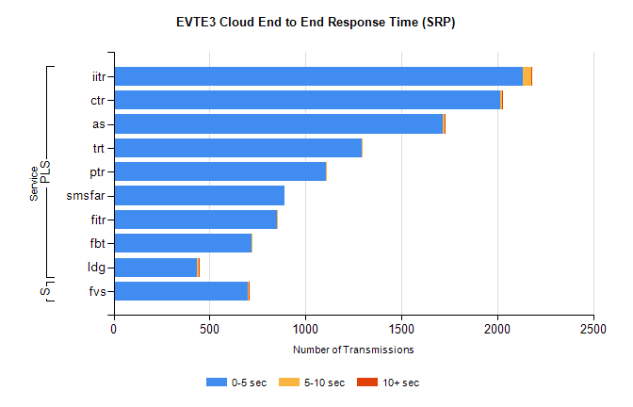
Stream | Service | 0-5 sec | 5-10 sec | >10 sec | Total | % within 5 sec timing target
PLS | iitr | 2134 | 45 | 4 | 2187 | 97.6%
PLS | ctr | 2016 | 10 | 1 | 2045 | 98.6%
PLS | as | 1717 | 8 | 6 | 1897 | 90.5%
PLS | trt | 1292 | 5 | 0 | 1299 | 99.5%
PLS | ptr | 1107 | 2 | 0 | 1112 | 99.6%
PLS | smsfar | 893 | 0 | 0 | 893 | 100.0%
PLS | fitr | 851 | 2 | 0 | 853 | 99.8%
PLS | fbt | 720 | 6 | 0 | 727 | 99.0%
PLS | ldg | 433 | 10 | 2 | 493 | 87.8%
Super | fvs | 701 | 2 | 2 | 705 | 99.4%

SBR2 External Vendor Testing Environment (EVTE3)

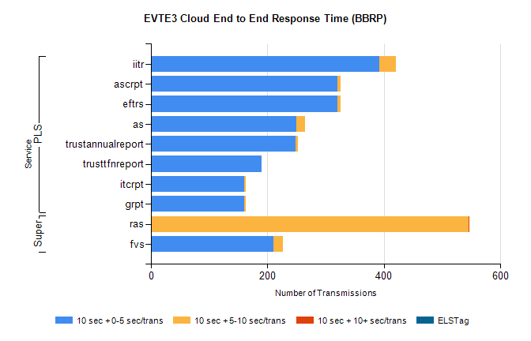
Stream | Service | 10 sec + 0-5 sec /trans | 10 sec + 5-10 sec /trans | 10 sec + >10 sec /trans | Processing Incomplete | ELStag | Total
PLS | iitr | 392 | 28 | 0 | 5 | 0 | 434
PLS | eftrs | 320 | 6 | 0 | 22 | 0 | 348
PLS | ascrpt | 320 | 6 | 0 | 22 | 0 | 348
PLS | as | 249 | 16 | 0 | 2 | 0 | 268
PLS | trustannualreport | 248 | 4 | 0 | 0 | 0 | 252
PLS | trusttfnreport | 190 | 0 | 0 | 0 | 0 | 190
PLS | grpt | 160 | 3 | 0 | 11 | 0 | 174
PLS | itcrpt | 160 | 3 | 0 | 11 | 0 | 174
Super | ras | 2 | 544 | 1 | 0 | 0 | 563
Super | fvs | 210 | 17 | 0 | 0 | 0 | 227

