Transmission Timings Report Week - 36
2/09/2024 to 8/09/2024

SBR2 Cloud Production2 – Single Requests (SRP)

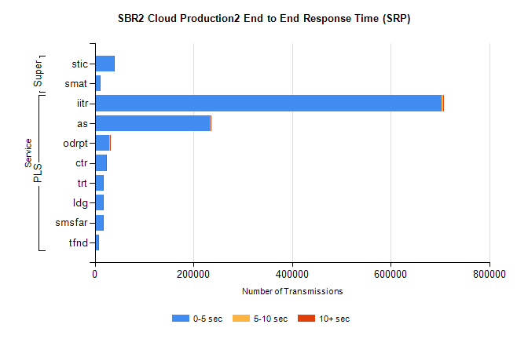
Stream | Service | 0-5 sec | 5-10 sec | >10 sec | Total | % within 5 sec timing target
PLS | iitr | 703815 | 3194 | 690 | 707736 | 99.4%
PLS | as | 233395 | 906 | 101 | 234434 | 99.6%
PLS | odrpt | 29281 | 882 | 79 | 30242 | 96.8%
PLS | ctr | 22538 | 64 | 11 | 22617 | 99.7%
PLS | trt | 16813 | 52 | 9 | 16874 | 99.6%
PLS | ldg | 16749 | 41 | 4 | 16800 | 99.7%
PLS | smsfar | 16220 | 40 | 15 | 16275 | 99.7%
PLS | tfnd | 6505 | 22 | 3 | 6530 | 99.6%
Super | stic | 38399 | 226 | 37 | 38665 | 99.3%
Super | smat | 10466 | 158 | 21 | 10645 | 98.3%

SBR2 Cloud Production2 – Bulk or Batch Requests (BBRP)

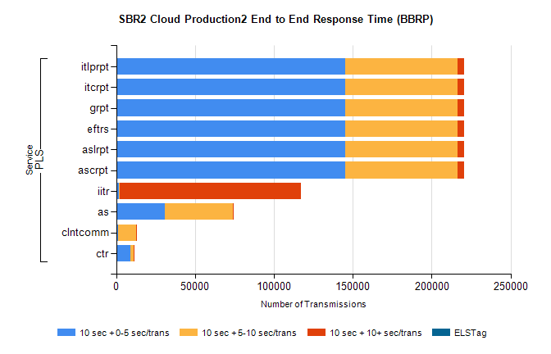
Stream | Service | 10 sec + 0-5 sec /trans | 10 sec + 5-10 sec /trans | 10 sec + >10 sec /trans | Processing Incomplete | ELStag | Total
PLS | ascrpt | 145195 | 71256 | 4327 | 22 | 0 | 226538
PLS | aslrpt | 145195 | 71256 | 4327 | 22 | 0 | 226538
PLS | eftrs | 145195 | 71256 | 4327 | 22 | 0 | 226538
PLS | grpt | 145195 | 71256 | 4327 | 22 | 0 | 226538
PLS | itcrpt | 145195 | 71256 | 4327 | 22 | 0 | 226538
PLS | itlprpt | 145195 | 71256 | 4327 | 22 | 0 | 226538
PLS | iitr | 1493 | 749 | 115108 | 831 | 0 | 121530
PLS | as | 30858 | 43109 | 684 | 299 | 0 | 75428
PLS | clntcomm | 1445 | 11079 | 357 | 0 | 0 | 13558
PLS | ctr | 9248 | 1801 | 95 | 49 | 0 | 11233

SBR2 Cloud Production2 – ...

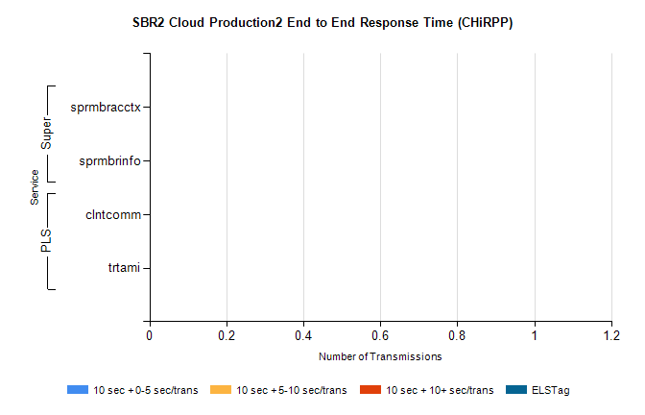
Stream | Service | 10 sec + 0-5 sec /trans | 10 sec + 5-10 sec /trans | 10 sec + >10 sec /trans | Total | % within 5 sec timing target
PLS | clntcomm | 0 | 0 | 0 | 33068 | 0.0%
PLS | trtami | 0 | 0 | 0 | 5 | 0.0%
Super | sprmbracctx | 0 | 0 | 0 | 4981 | 0.0%
Super | sprmbrinfo | 0 | 0 | 0 | 2836 | 0.0%

SBR1 Production Transactions

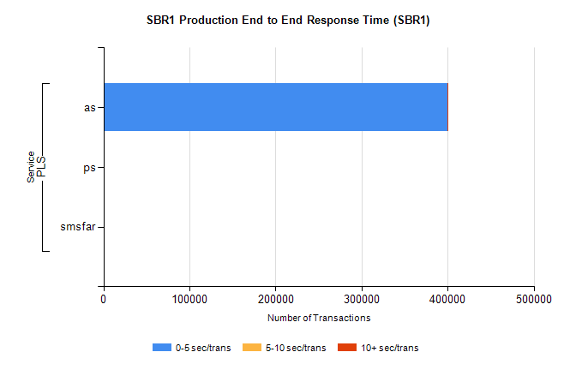
Stream | Service | 0-5 sec/trans | 5-10 sec/trans | 10+ sec/trans | Total | % within 5 sec timing target
PLS | as | 399417 | 171 | 460 | 400048 | 99.8%
PLS | ps | 105 | 142 | 201 | 448 | 23.4%
PLS | smsfar | 2 | 109 | 8 | 119 | 1.7%

