Transmission Timings Report Week - 37
9/09/2024 - 15/09/2024

SBR2 External Vendor Testing Environment (EVTE3)

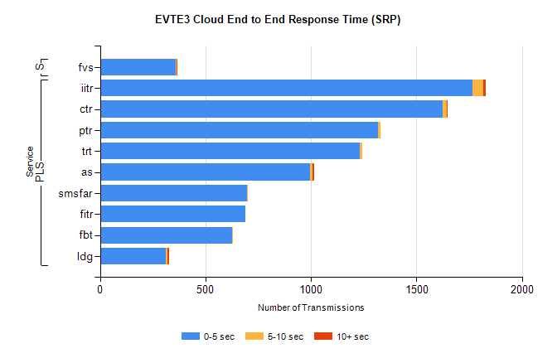
Stream | Service | 0-5 sec | 5-10 sec | >10 sec | Total | % within 5 sec timing target
PLS | iitr | 1766 | 51 | 11 | 1830 | 96.5%
PLS | ctr | 1622 | 22 | 2 | 1651 | 98.2%
PLS | ptr | 1317 | 11 | 0 | 1328 | 99.2%
PLS | trt | 1232 | 9 | 0 | 1241 | 99.3%
PLS | as | 995 | 14 | 6 | 1035 | 96.1%
PLS | smsfar | 696 | 4 | 0 | 700 | 99.4%
PLS | fitr | 689 | 0 | 0 | 689 | 100.0%
PLS | fbt | 625 | 6 | 0 | 634 | 98.6%
PLS | ldg | 313 | 8 | 7 | 341 | 91.8%
Super | fvs | 361 | 1 | 1 | 363 | 99.4%

SBR2 External Vendor Testing Environment (EVTE3)

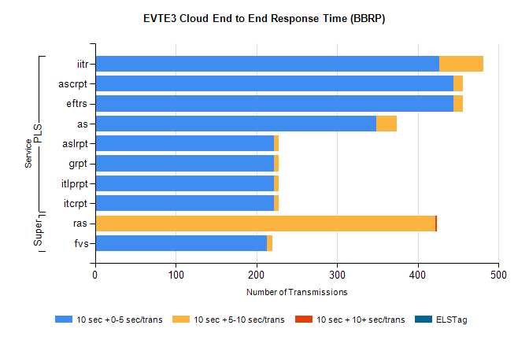
Stream | Service | 10 sec + 0-5 sec /trans | 10 sec + 5-10 sec /trans | 10 sec + >10 sec /trans | Processing Incomplete | ELStag | Total
PLS | iitr | 427 | 54 | 0 | 0 | 0 | 489
PLS | eftrs | 444 | 12 | 0 | 4 | 0 | 460
PLS | ascrpt | 444 | 12 | 0 | 4 | 0 | 460
PLS | as | 349 | 25 | 0 | 4 | 0 | 378
PLS | itcrpt | 222 | 6 | 0 | 2 | 0 | 230
PLS | itlprpt | 222 | 6 | 0 | 2 | 0 | 230
PLS | grpt | 222 | 6 | 0 | 2 | 0 | 230
PLS | aslrpt | 222 | 6 | 0 | 2 | 0 | 230
Super | ras | 1 | 421 | 2 | 0 | 0 | 439
Super | fvs | 213 | 7 | 0 | 0 | 0 | 220

