Transmission Timings Report Week - 37
9/09/2024 - 15/09/2024

SBR2 Cloud Production2 - Single Requests (SRP)

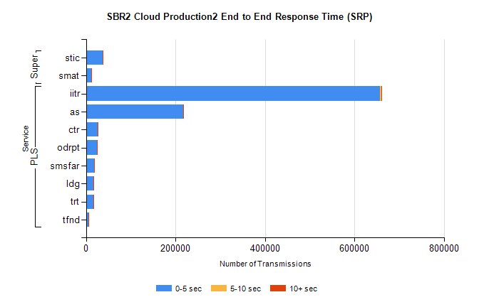
Stream | Service | 0-5 sec | 5-10 sec | >10 sec | Total | % within 5 sec timing target
PLS | iitr | 657104 | 3306 | 552 | 662381 | 99.2%
PLS | as | 216693 | 1153 | 189 | 219677 | 98.6%
PLS | ctr | 25389 | 68 | 14 | 25511 | 99.5%
PLS | odrpt | 24464 | 756 | 51 | 25276 | 96.8%
PLS | smsfar | 17693 | 46 | 11 | 17770 | 99.6%
PLS | ldg | 16844 | 43 | 4 | 16923 | 99.5%
PLS | trt | 16464 | 43 | 11 | 16538 | 99.6%
PLS | tfnd | 6029 | 19 | 3 | 6077 | 99.2%
Super | stic | 37774 | 190 | 47 | 38237 | 98.8%
Super | smat | 11572 | 135 | 23 | 11786 | 98.2%

SBR2 Cloud Production2 - Bulk or Batch Requests (BBRP)

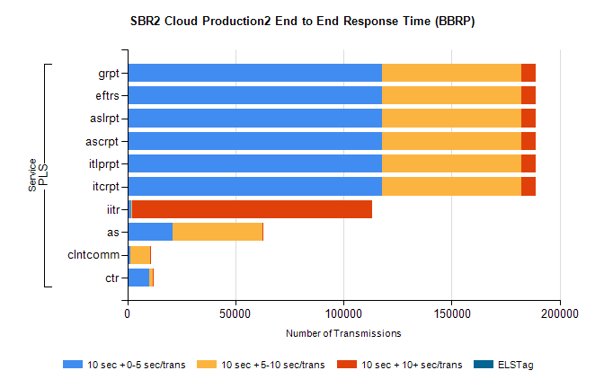
Stream | Service | 10 sec + 0-5 sec /trans | 10 sec + 5-10 sec /trans | 10 sec + >10 sec /trans | Processing Incomplete | ELStag | Total
PLS | itcrpt | 117625 | 64417 | 6833 | 316 | 0 | 195322
PLS | itlprpt | 117625 | 64417 | 6833 | 316 | 0 | 195322
PLS | ascrpt | 117625 | 64417 | 6833 | 316 | 0 | 195322
PLS | aslrpt | 117625 | 64417 | 6833 | 316 | 0 | 195322
PLS | eftrs | 117625 | 64417 | 6833 | 316 | 0 | 195322
PLS | grpt | 117625 | 64417 | 6833 | 316 | 0 | 195322
PLS | iitr | 1585 | 554 | 111237 | 757 | 0 | 116337
PLS | as | 20859 | 41490 | 43 | 390 | 0 | 62984
PLS | clntcomm | 1493 | 9203 | 338 | 2028 | 0 | 13669
PLS | ctr | 10305 | 1374 | 12 | 70 | 0 | 11799

SBR2 Cloud Production2 - ...

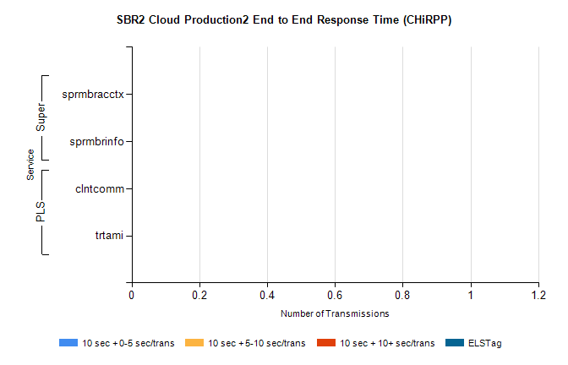
Stream | Service | 10 sec + 0-5 sec /trans | 10 sec + 5-10 sec /trans | 10 sec + >10 sec /trans | Total | % within 5 sec timing target
PLS | clntcomm | 0 | 0 | 0 | 29707 | 0.0%
PLS | trtami | 0 | 0 | 0 | 25 | 0.0%
Super | sprmbracctx | 0 | 0 | 0 | 22461 | 0.0%
Super | sprmbrinfo | 0 | 0 | 0 | 2639 | 0.0%

SBR1 Production Transactions

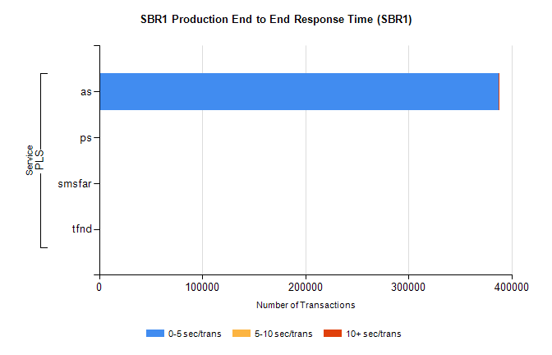
Stream | Service | 0-5 sec/trans | 5-10 sec/trans | 10+ sec/trans | Total | % within 5 sec timing target
PLS | as | 387434 | 289 | 811 | 388534 | 99.7%
PLS | ps | 87 | 81 | 182 | 350 | 24.9%
PLS | smsfar | 6 | 172 | 15 | 193 | 3.1%
PLS | tfnd |  | 6 |  | 6 | 0.0%

