Transmission Timings Report Week - 38
16/09/2024 - 22/09/2024

SBR2 External Vendor Testing Environment (EVTE3)

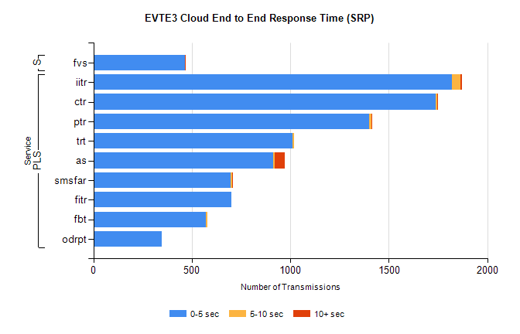
Stream | Service | 0-5 sec | 5-10 sec | >10 sec | Total | % within 5 sec timing target
PLS | iitr | 1822 | 42 | 7 | 1873 | 97.3%
PLS | ctr | 1736 | 10 | 1 | 1747 | 99.4%
PLS | ptr | 1402 | 11 | 3 | 1419 | 98.8%
PLS | trt | 1013 | 6 | 0 | 1019 | 99.4%
PLS | as | 914 | 8 | 51 | 998 | 91.6%
PLS | smsfar | 697 | 6 | 1 | 704 | 99.0%
PLS | fitr | 700 | 0 | 0 | 700 | 100.0%
PLS | fbt | 572 | 7 | 0 | 579 | 98.8%
PLS | odrpt | 346 | 0 | 0 | 346 | 100.0%
Super | fvs | 465 | 2 | 1 | 468 | 99.4%

SBR2 External Vendor Testing Environment (EVTE3)

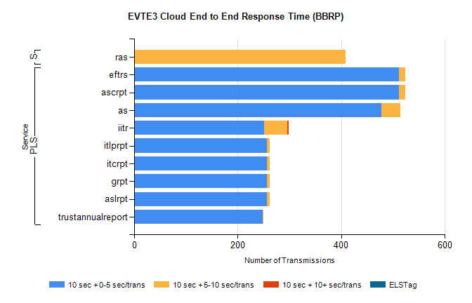
Stream | Service | 10 sec + 0-5 sec /trans | 10 sec + 5-10 sec /trans | 10 sec + >10 sec /trans | Processing Incomplete | ELStag | Total
PLS | ascrpt | 512 | 12 | 0 | 8 | 0 | 534
PLS | eftrs | 512 | 12 | 0 | 8 | 0 | 534
PLS | as | 477 | 37 | 0 | 9 | 0 | 528
PLS | iitr | 251 | 45 | 3 | 1 | 0 | 309
PLS | aslrpt | 256 | 6 | 0 | 4 | 0 | 267
PLS | grpt | 256 | 6 | 0 | 4 | 0 | 267
PLS | itcrpt | 256 | 6 | 0 | 4 | 0 | 267
PLS | itlprpt | 256 | 6 | 0 | 4 | 0 | 267
PLS | trustannualreport | 248 | 2 | 0 | 0 | 0 | 250
Super | ras | 0 | 408 | 0 | 0 | 0 | 421

