Transmission Timings Report Week - 38
16/09/2024 - 22/09/2024

SBR2 Cloud Production2 - Single Requests (SRP)

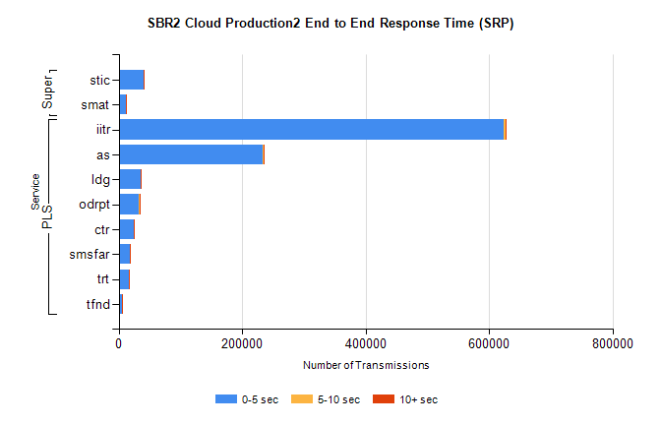
Stream | Service | 0-5 sec | 5-10 sec | >10 sec | Total | % within 5 sec timing target
PLS | iitr | 624285 | 2763 | 1351 | 636557 | 98.1%
PLS | as | 233244 | 1048 | 246 | 239456 | 97.4%
PLS | ldg | 35481 | 41 | 8 | 35564 | 99.8%
PLS | odrpt | 32636 | 901 | 152 | 33692 | 96.9%
PLS | ctr | 24112 | 64 | 36 | 24497 | 98.4%
PLS | smsfar | 18815 | 59 | 34 | 19260 | 97.7%
PLS | trt | 17192 | 52 | 23 | 17411 | 98.7%
PLS | tfnd | 5997 | 25 | 3 | 6068 | 98.8%
Super | stic | 39960 | 204 | 72 | 40929 | 97.6%
Super | smat | 11701 | 117 | 51 | 12221 | 95.7%

SBR2 Cloud Production2 - Bulk or Batch Requests (BBRP)

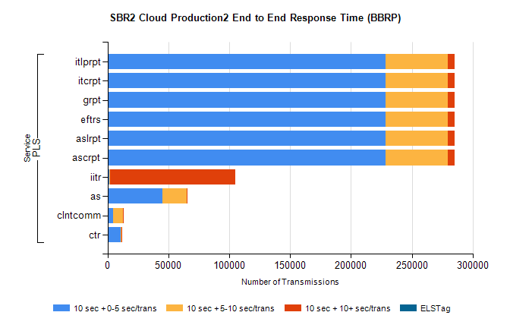
Stream | Service | 10 sec + 0-5 sec /trans | 10 sec + 5-10 sec /trans | 10 sec + >10 sec /trans | Processing Incomplete | ELStag | Total
PLS | ascrpt | 228194 | 51283 | 5831 | 1597 | 0 | 291358
PLS | aslrpt | 228194 | 51283 | 5831 | 1597 | 0 | 291358
PLS | eftrs | 228194 | 51283 | 5831 | 1597 | 0 | 291358
PLS | grpt | 228194 | 51283 | 5831 | 1597 | 0 | 291358
PLS | itcrpt | 228194 | 51283 | 5831 | 1597 | 0 | 291358
PLS | itlprpt | 228194 | 51283 | 5831 | 1597 | 0 | 291358
PLS | iitr | 1561 | 535 | 102569 | 4368 | 0 | 111423
PLS | as | 44940 | 20288 | 160 | 1809 | 0 | 67359
PLS | clntcomm | 4538 | 8354 | 273 | 715 | 0 | 14276
PLS | ctr | 10915 | 316 | 30 | 391 | 0 | 11684

SBR2 Cloud Production2 - ...

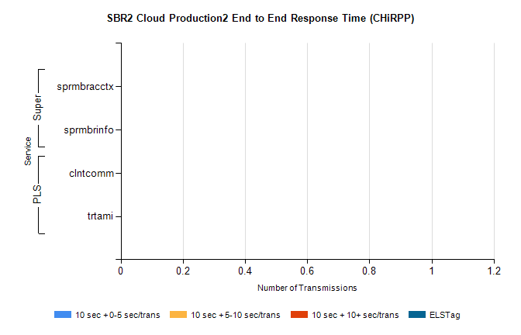
Stream | Service | 10 sec + 0-5 sec /trans | 10 sec + 5-10 sec /trans | 10 sec + >10 sec /trans | Total | % within 5 sec timing target
PLS | clntcomm | 0 | 0 | 0 | 33555 | 0.0%
PLS | trtami | 0 | 0 | 0 | 35 | 0.0%
Super | sprmbracctx | 0 | 0 | 0 | 9951 | 0.0%
Super | sprmbrinfo | 0 | 0 | 0 | 2722 | 0.0%

SBR1 Production Transactions

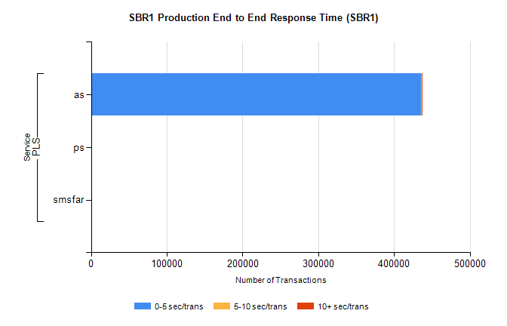
Stream | Service | 0-5 sec/trans | 5-10 sec/trans | 10+ sec/trans | Total | % within 5 sec timing target
PLS | as | 435693 | 404 | 515 | 436612 | 99.8%
PLS | ps | 115 | 106 | 165 | 386 | 29.8%
PLS | smsfar | 5 | 142 | 7 | 154 | 3.2%

