Transmission Timings Report Week - 39
23/09/2024 - 29/09/2024

SBR2 External Vendor Testing Environment (EVTE3)

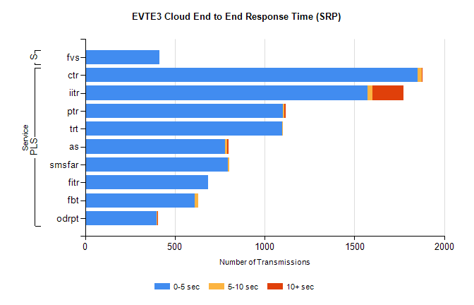
Stream | Service | 0-5 sec | 5-10 sec | >10 sec | Total | % within 5 sec timing target
PLS | ctr | 1851 | 25 | 1 | 1878 | 98.6%
PLS | iitr | 1572 | 29 | 172 | 1774 | 88.6%
PLS | ptr | 1103 | 8 | 5 | 1116 | 98.8%
PLS | trt | 1096 | 6 | 0 | 1102 | 99.5%
PLS | as | 781 | 12 | 6 | 831 | 94.0%
PLS | smsfar | 797 | 7 | 0 | 804 | 99.1%
PLS | fitr | 687 | 0 | 0 | 687 | 100.0%
PLS | fbt | 611 | 20 | 0 | 632 | 96.7%
PLS | odrpt | 400 | 4 | 2 | 406 | 98.5%
Super | fvs | 415 | 0 | 0 | 415 | 100.0%

SBR2 External Vendor Testing Environment (EVTE3)

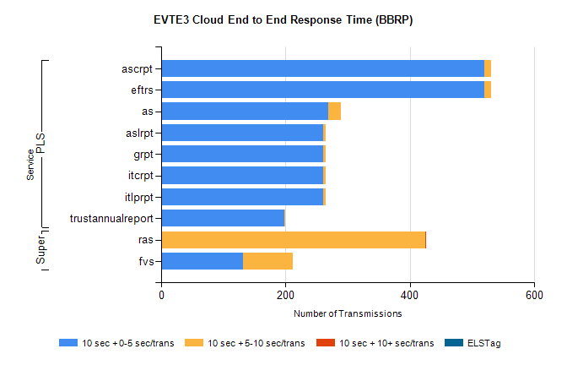
Stream | Service | 10 sec + 0-5 sec /trans | 10 sec + 5-10 sec /trans | 10 sec + >10 sec /trans | Processing Incomplete | ELStag | Total
PLS | eftrs | 520 | 10 | 0 | 12 | 0 | 542
PLS | ascrpt | 520 | 10 | 0 | 12 | 0 | 542
PLS | as | 268 | 21 | 0 | 1 | 0 | 290
PLS | itlprpt | 260 | 5 | 0 | 6 | 0 | 271
PLS | itcrpt | 260 | 5 | 0 | 6 | 0 | 271
PLS | grpt | 260 | 5 | 0 | 6 | 0 | 271
PLS | aslrpt | 260 | 5 | 0 | 6 | 0 | 271
PLS | trustannualreport | 198 | 2 | 0 | 0 | 0 | 200
Super | ras | 0 | 424 | 1 | 8 | 0 | 446
Super | fvs | 131 | 81 | 0 | 0 | 0 | 215

