Transmission Timings Report Week - 39
23/09/2024 - 29/09/2024

SBR2 Cloud Production2 - Single Requests (SRP)

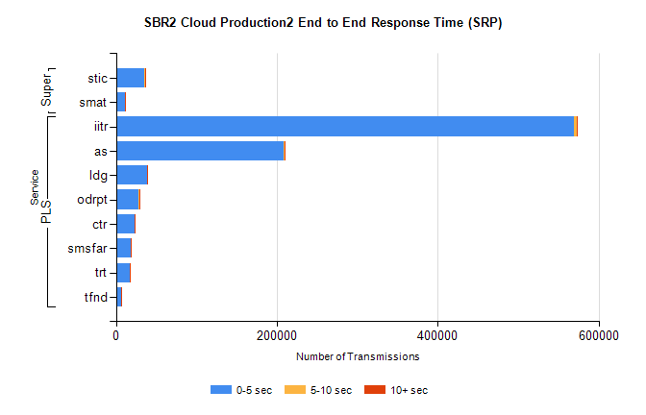
Stream | Service | 0-5 sec | 5-10 sec | >10 sec | Total | % within 5 sec timing target
PLS | iitr | 569834 | 2479 | 683 | 573008 | 99.4%
PLS | as | 208406 | 842 | 114 | 209451 | 99.5%
PLS | ldg | 38605 | 78 | 11 | 38694 | 99.8%
PLS | odrpt | 28574 | 831 | 146 | 29553 | 96.7%
PLS | ctr | 23398 | 66 | 21 | 23486 | 99.6%
PLS | smsfar | 18766 | 56 | 15 | 18844 | 99.6%
PLS | trt | 16648 | 57 | 13 | 16719 | 99.6%
PLS | tfnd | 6422 | 25 | 5 | 6452 | 99.5%
Super | stic | 35598 | 175 | 62 | 35839 | 99.3%
Super | smat | 11084 | 111 | 40 | 11238 | 98.6%

SBR2 Cloud Production2 - Bulk or Batch Requests (BBRP)

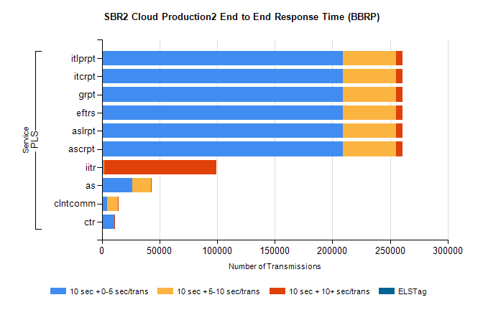
Stream | Service | 10 sec + 0-5 sec /trans | 10 sec + 5-10 sec /trans | 10 sec + >10 sec /trans | Processing Incomplete | ELStag | Total
PLS | ascrpt | 208858 | 46211 | 5526 | 6 | 0 | 263432
PLS | aslrpt | 208858 | 46211 | 5526 | 6 | 0 | 263432
PLS | eftrs | 208858 | 46211 | 5526 | 6 | 0 | 263432
PLS | grpt | 208858 | 46211 | 5526 | 6 | 0 | 263432
PLS | itcrpt | 208858 | 46211 | 5526 | 6 | 0 | 263432
PLS | itlprpt | 208858 | 46211 | 5526 | 6 | 0 | 263432
PLS | iitr | 1428 | 596 | 97511 | 219 | 0 | 102007
PLS | as | 26618 | 15821 | 89 | 139 | 0 | 42806
PLS | clntcomm | 4241 | 9944 | 429 | 9 | 0 | 15484
PLS | ctr | 10484 | 384 | 14 | 11 | 0 | 10920

SBR2 Cloud Production2 - ...

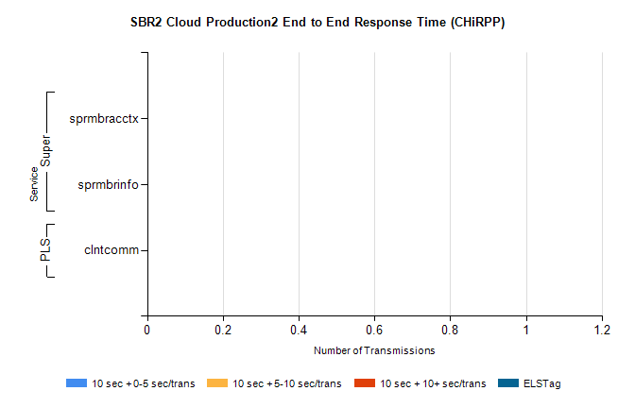
Stream | Service | 10 sec + 0-5 sec /trans | 10 sec + 5-10 sec /trans | 10 sec + >10 sec /trans | Total | % within 5 sec timing target
PLS | clntcomm | 0 | 0 | 0 | 33206 | 0.0%
Super | sprmbracctx | 0 | 0 | 0 | 2963 | 0.0%
Super | sprmbrinfo | 0 | 0 | 0 | 2707 | 0.0%

SBR1 Production Transactions

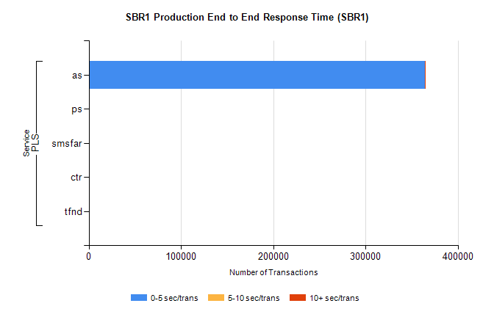
Stream | Service | 0-5 sec/trans | 5-10 sec/trans | 10+ sec/trans | Total | % within 5 sec timing target
PLS | as | 364190 | 198 | 380 | 364768 | 99.8%
PLS | ps | 76 | 122 | 150 | 348 | 21.8%
PLS | smsfar | 15 | 176 | 9 | 200 | 7.5%
PLS | ctr | 14 | 3 | 10 | 27 | 51.9%
PLS | tfnd | 9 | 8 |  | 17 | 52.9%

