Transmission Timings Report Week - 40
30/09/2024 - 6/10/2024

SBR2 Cloud Production2 - Single Requests (SRP)

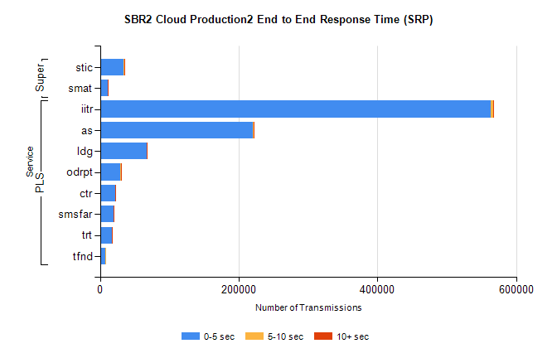
Stream | Service | 0-5 sec | 5-10 sec | >10 sec | Total | % within 5 sec timing target
PLS | iitr | 563708 | 2634 | 759 | 567146 | 99.4%
PLS | as | 220669 | 1113 | 447 | 222235 | 99.3%
PLS | ldg | 67561 | 205 | 62 | 67852 | 99.6%
PLS | odrpt | 29311 | 571 | 83 | 29966 | 97.8%
PLS | ctr | 22503 | 69 | 16 | 22591 | 99.6%
PLS | smsfar | 19992 | 48 | 14 | 20060 | 99.7%
PLS | trt | 17182 | 43 | 11 | 17236 | 99.7%
PLS | tfnd | 7241 | 37 | 0 | 7278 | 99.5%
Super | stic | 34465 | 143 | 35 | 34647 | 99.5%
Super | smat | 10746 | 107 | 31 | 10889 | 98.7%

SBR2 Cloud Production2 - Bulk or Batch Requests (BBRP)

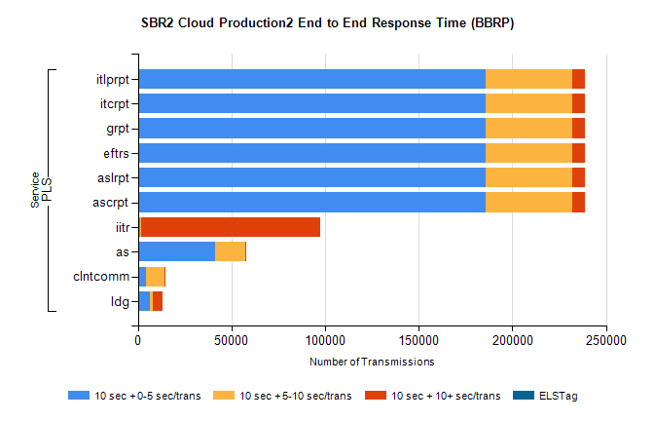
Stream | Service | 10 sec + 0-5 sec /trans | 10 sec + 5-10 sec /trans | 10 sec + >10 sec /trans | Processing Incomplete | ELStag | Total
PLS | ascrpt | 185748 | 46347 | 6731 | 15 | 0 | 242412
PLS | aslrpt | 185748 | 46347 | 6731 | 15 | 0 | 242412
PLS | eftrs | 185748 | 46347 | 6731 | 15 | 0 | 242412
PLS | grpt | 185748 | 46347 | 6731 | 15 | 0 | 242412
PLS | itcrpt | 185748 | 46347 | 6731 | 15 | 0 | 242412
PLS | itlprpt | 185748 | 46347 | 6731 | 15 | 0 | 242412
PLS | iitr | 1350 | 555 | 95470 | 182 | 0 | 99332
PLS | as | 41190 | 16102 | 93 | 78 | 0 | 57595
PLS | clntcomm | 4318 | 9917 | 362 | 0 | 0 | 15234
PLS | ldg | 6581 | 1405 | 5394 | 2 | 0 | 14641

SBR2 Cloud Production2 - ...

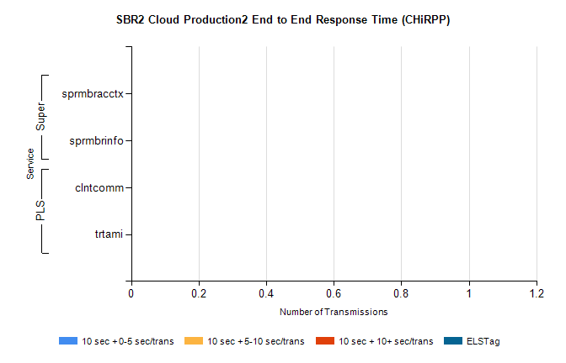
Stream | Service | 10 sec + 0-5 sec /trans | 10 sec + 5-10 sec /trans | 10 sec + >10 sec /trans | Total | % within 5 sec timing target
PLS | clntcomm | 0 | 0 | 0 | 21220 | 0.0%
PLS | trtami | 0 | 0 | 0 | 32 | 0.0%
Super | sprmbracctx | 0 | 0 | 0 | 3367 | 0.0%
Super | sprmbrinfo | 0 | 0 | 0 | 2640 | 0.0%

SBR1 Production Transactions

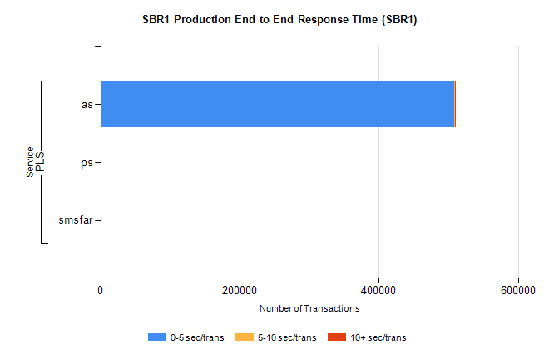
Stream | Service | 0-5 sec/trans | 5-10 sec/trans | 10+ sec/trans | Total | % within 5 sec timing target
PLS | as | 508723 | 549 | 1082 | 510354 | 99.7%
PLS | ps | 76 | 75 | 177 | 328 | 23.2%
PLS | smsfar |  | 89 | 7 | 96 | 0.0%

