Transmission Timings Report Week - 41
7/10/2024 - 13/10/2024

SBR2 External Vendor Testing Environment (EVTE3)

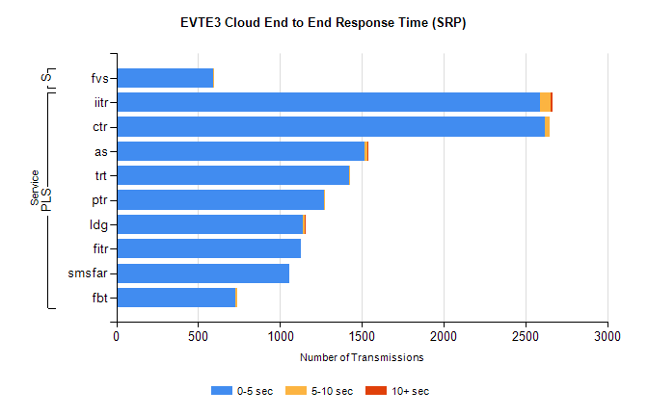
Stream | Service | 0-5 sec | 5-10 sec | >10 sec | Total | % within 5 sec timing target
PLS | iitr | 2591 | 60 | 15 | 2670 | 97.0%
PLS | ctr | 2620 | 29 | 0 | 2652 | 98.8%
PLS | as | 1516 | 16 | 4 | 1565 | 96.9%
PLS | trt | 1422 | 5 | 0 | 1434 | 99.2%
PLS | ptr | 1270 | 1 | 0 | 1271 | 99.9%
PLS | ldg | 1140 | 11 | 3 | 1160 | 98.3%
PLS | fitr | 1128 | 0 | 0 | 1128 | 100.0%
PLS | smsfar | 1058 | 0 | 0 | 1059 | 99.9%
PLS | fbt | 725 | 13 | 0 | 738 | 98.2%
Super | fvs | 589 | 4 | 0 | 593 | 99.3%

SBR2 External Vendor Testing Environment (EVTE3)

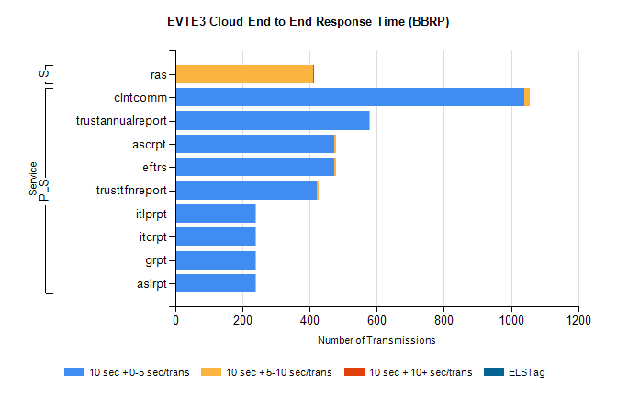
Stream | Service | 10 sec + 0-5 sec /trans | 10 sec + 5-10 sec /trans | 10 sec + >10 sec /trans | Processing Incomplete | ELStag | Total
PLS | clntcomm | 1040 | 16 | 0 | 0 | 0 | 1071
PLS | trustannualreport | 578 | 3 | 0 | 0 | 0 | 581
PLS | eftrs | 474 | 4 | 0 | 4 | 0 | 482
PLS | ascrpt | 474 | 4 | 0 | 4 | 0 | 482
PLS | trusttfnreport | 422 | 5 | 0 | 0 | 0 | 427
PLS | aslrpt | 237 | 2 | 0 | 2 | 0 | 241
PLS | grpt | 237 | 2 | 0 | 2 | 0 | 241
PLS | itcrpt | 237 | 2 | 0 | 2 | 0 | 241
PLS | itlprpt | 237 | 2 | 0 | 2 | 0 | 241
Super | ras | 0 | 411 | 2 | 0 | 0 | 421

