Transmission Timings Report Week - 41
7/10/2024 - 13/10/2024

SBR2 Cloud Production2 - Single Requests (SRP)

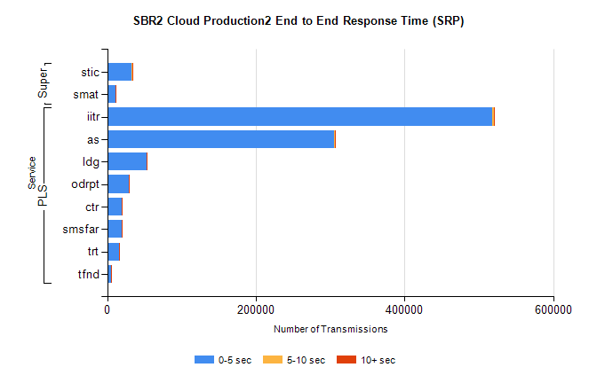
Stream | Service | 0-5 sec | 5-10 sec | >10 sec | Total | % within 5 sec timing target
PLS | iitr | 518479 | 2151 | 518 | 521649 | 99.4%
PLS | as | 305430 | 1245 | 281 | 307074 | 99.5%
PLS | ldg | 53283 | 113 | 14 | 53436 | 99.7%
PLS | odrpt | 28733 | 912 | 170 | 29815 | 96.4%
PLS | ctr | 19858 | 70 | 10 | 19958 | 99.5%
PLS | smsfar | 19105 | 41 | 22 | 19177 | 99.6%
PLS | trt | 15497 | 36 | 9 | 15554 | 99.6%
PLS | tfnd | 5648 | 15 | 1 | 5665 | 99.7%
Super | stic | 33117 | 380 | 209 | 33729 | 98.2%
Super | smat | 10749 | 176 | 81 | 11018 | 97.6%

SBR2 Cloud Production2 - Bulk or Batch Requests (BBRP)

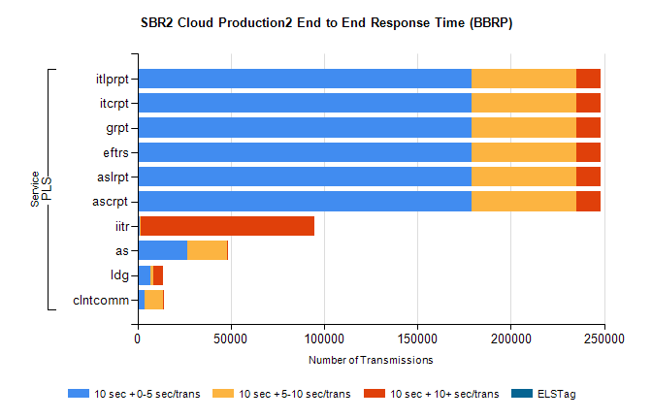
Stream | Service | 10 sec + 0-5 sec /trans | 10 sec + 5-10 sec /trans | 10 sec + >10 sec /trans | Processing Incomplete | ELStag | Total
PLS | ascrpt | 178764 | 56572 | 12580 | 38 | 0 | 253328
PLS | aslrpt | 178764 | 56572 | 12580 | 38 | 0 | 253328
PLS | eftrs | 178764 | 56572 | 12580 | 38 | 0 | 253328
PLS | grpt | 178764 | 56572 | 12580 | 38 | 0 | 253328
PLS | itcrpt | 178764 | 56572 | 12580 | 38 | 0 | 253328
PLS | itlprpt | 178764 | 56572 | 12580 | 38 | 0 | 253328
PLS | iitr | 1397 | 555 | 93008 | 212 | 0 | 96740
PLS | as | 26628 | 21191 | 62 | 101 | 0 | 48104
PLS | ldg | 7082 | 1604 | 5209 | 23 | 0 | 15032
PLS | clntcomm | 3876 | 9550 | 399 | 0 | 0 | 14408

SBR2 Cloud Production2 - ...

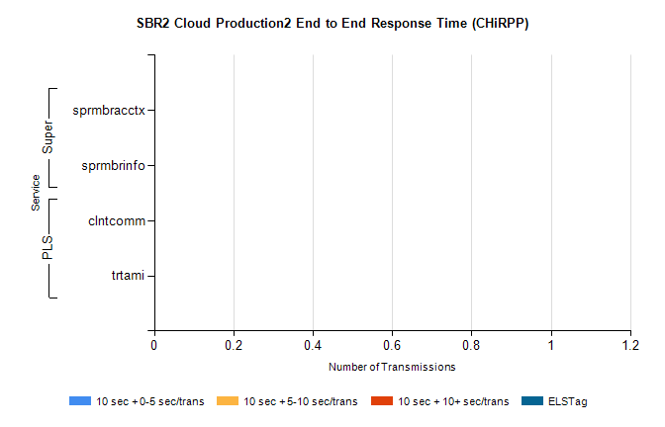
Stream | Service | 10 sec + 0-5 sec /trans | 10 sec + 5-10 sec /trans | 10 sec + >10 sec /trans | Total | % within 5 sec timing target
PLS | clntcomm | 0 | 0 | 0 | 14622 | 0.0%
PLS | trtami | 0 | 0 | 0 | 29 | 0.0%
Super | sprmbracctx | 0 | 0 | 0 | 3312 | 0.0%
Super | sprmbrinfo | 0 | 0 | 0 | 2745 | 0.0%

SBR1 Production Transactions

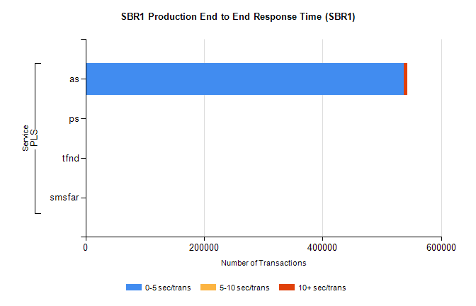
Stream | Service | 0-5 sec/trans | 5-10 sec/trans | 10+ sec/trans | Total | % within 5 sec timing target
PLS | as | 536625 | 290 | 5562 | 542477 | 98.9%
PLS | ps | 70 | 54 | 168 | 292 | 24.0%
PLS | tfnd | 6 | 6 |  | 12 | 50.0%
PLS | smsfar | 3 | 7 |  | 10 | 30.0%

