Transmission Timings Report Week - 42
14/10/2024 - 20/10/2024

SBR2 External Vendor Testing Environment (EVTE3)

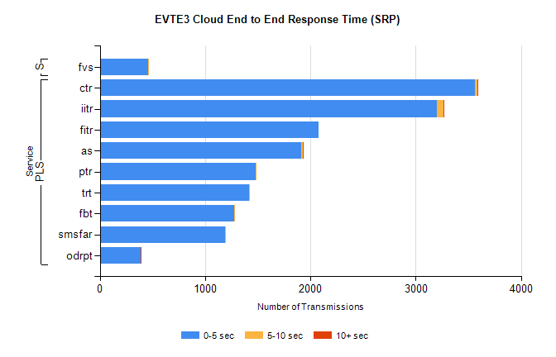
Stream | Service | 0-5 sec | 5-10 sec | >10 sec | Total | % within 5 sec timing target
PLS | ctr | 3563 | 21 | 1 | 3592 | 99.2%
PLS | iitr | 3201 | 59 | 3 | 3263 | 98.1%
PLS | fitr | 2080 | 0 | 0 | 2080 | 100.0%
PLS | as | 1912 | 14 | 6 | 1963 | 97.4%
PLS | ptr | 1478 | 10 | 0 | 1492 | 99.1%
PLS | trt | 1419 | 2 | 0 | 1428 | 99.4%
PLS | fbt | 1274 | 12 | 0 | 1286 | 99.1%
PLS | smsfar | 1191 | 1 | 0 | 1192 | 99.9%
PLS | odrpt | 389 | 0 | 1 | 392 | 99.2%
Super | fvs | 458 | 2 | 0 | 460 | 99.6%

SBR2 External Vendor Testing Environment (EVTE3)

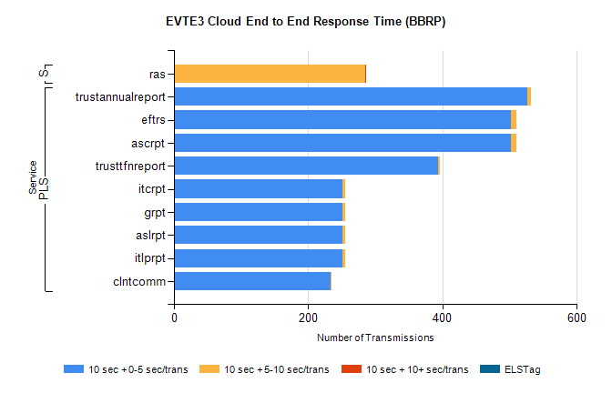
Stream | Service | 10 sec + 0-5 sec /trans | 10 sec + 5-10 sec /trans | 10 sec + >10 sec /trans | Processing Incomplete | ELStag | Total
PLS | trustannualreport | 527 | 5 | 0 | 0 | 0 | 532
PLS | ascrpt | 502 | 8 | 0 | 2 | 0 | 514
PLS | eftrs | 502 | 8 | 0 | 2 | 0 | 514
PLS | trusttfnreport | 394 | 2 | 0 | 0 | 0 | 396
PLS | itlprpt | 251 | 4 | 0 | 1 | 0 | 257
PLS | aslrpt | 251 | 4 | 0 | 1 | 0 | 257
PLS | grpt | 251 | 4 | 0 | 1 | 0 | 257
PLS | itcrpt | 251 | 4 | 0 | 1 | 0 | 257
PLS | clntcomm | 233 | 1 | 0 | 0 | 0 | 234
Super | ras | 0 | 285 | 1 | 0 | 0 | 300

