Transmission Timings Report Week - 42
14/10/2024 - 20/10/2024

SBR2 Cloud Production2 - Single Requests (SRP)

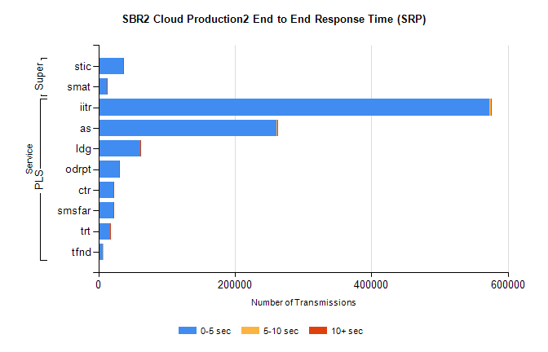
Stream | Service | 0-5 sec | 5-10 sec | >10 sec | Total | % within 5 sec timing target
PLS | iitr | 572602 | 2435 | 587 | 575893 | 99.4%
PLS | as | 260848 | 974 | 224 | 262091 | 99.5%
PLS | ldg | 61263 | 98 | 26 | 61485 | 99.6%
PLS | odrpt | 29896 | 687 | 94 | 30679 | 97.4%
PLS | ctr | 22537 | 61 | 13 | 22616 | 99.7%
PLS | smsfar | 22044 | 44 | 18 | 22115 | 99.7%
PLS | trt | 17645 | 57 | 19 | 17740 | 99.5%
PLS | tfnd | 6156 | 16 | 0 | 6173 | 99.7%
Super | stic | 36091 | 322 | 1036 | 37465 | 96.3%
Super | smat | 12186 | 114 | 227 | 12537 | 97.2%

SBR2 Cloud Production2 - Bulk or Batch Requests (BBRP)

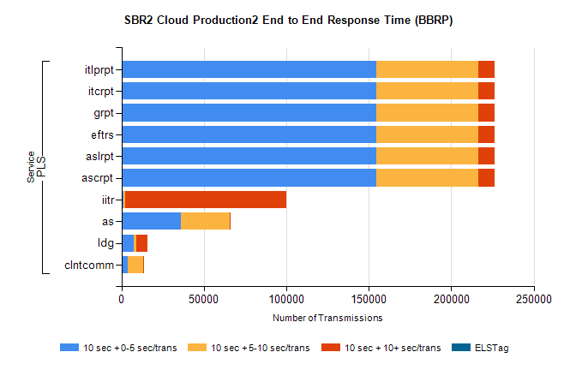
Stream | Service | 10 sec + 0-5 sec /trans | 10 sec + 5-10 sec /trans | 10 sec + >10 sec /trans | Processing Incomplete | ELStag | Total
PLS | ascrpt | 154265 | 62339 | 9472 | 609 | 0 | 232132
PLS | aslrpt | 154265 | 62339 | 9472 | 609 | 0 | 232132
PLS | eftrs | 154265 | 62339 | 9472 | 609 | 0 | 232132
PLS | grpt | 154265 | 62339 | 9472 | 609 | 0 | 232132
PLS | itcrpt | 154265 | 62339 | 9472 | 609 | 0 | 232132
PLS | itlprpt | 154265 | 62339 | 9472 | 609 | 0 | 232132
PLS | iitr | 1365 | 895 | 97466 | 176 | 0 | 102038
PLS | as | 36087 | 29807 | 120 | 211 | 0 | 66427
PLS | ldg | 7265 | 1712 | 6642 | 11 | 0 | 16662
PLS | clntcomm | 3762 | 9209 | 420 | 5 | 0 | 13934

SBR2 Cloud Production2 - ...

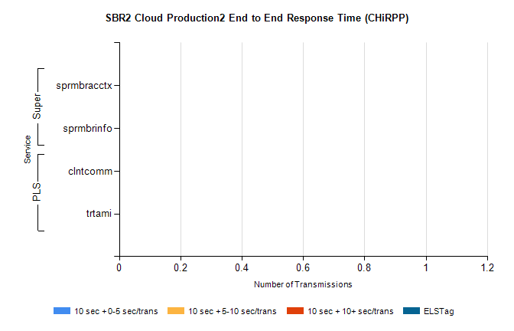
Stream | Service | 10 sec + 0-5 sec /trans | 10 sec + 5-10 sec /trans | 10 sec + >10 sec /trans | Total | % within 5 sec timing target
PLS | clntcomm | 0 | 0 | 0 | 16726 | 0.0%
PLS | trtami | 0 | 0 | 0 | 36 | 0.0%
Super | sprmbracctx | 0 | 0 | 0 | 3896 | 0.0%
Super | sprmbrinfo | 0 | 0 | 0 | 3099 | 0.0%

SBR1 Production Transactions

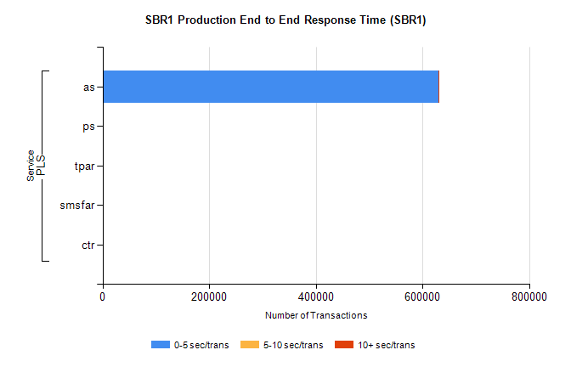
Stream | Service | 0-5 sec/trans | 5-10 sec/trans | 10+ sec/trans | Total | % within 5 sec timing target
PLS | as | 629603 | 452 | 236 | 630291 | 99.9%
PLS | ps | 25 | 49 | 130 | 204 | 12.3%
PLS | tpar | 67 |  |  | 67 | 100.0%
PLS | smsfar | 3 | 16 |  | 19 | 15.8%
PLS | ctr |  | 1 | 9 | 10 | 0.0%

