Transmission Timings Report Week - 43
21/10/2024 - 27/10/2024

SBR2 External Vendor Testing Environment (EVTE3)

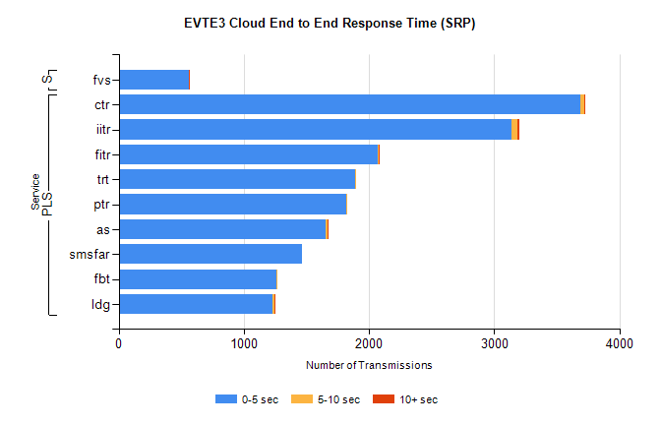
Stream | Service | 0-5 sec | 5-10 sec | >10 sec | Total | % within 5 sec timing target
PLS | ctr | 3689 | 30 | 4 | 3744 | 98.5%
PLS | iitr | 3136 | 46 | 19 | 3202 | 97.9%
PLS | fitr | 2072 | 4 | 1 | 2077 | 99.8%
PLS | trt | 1891 | 5 | 0 | 1896 | 99.7%
PLS | ptr | 1821 | 2 | 0 | 1826 | 99.7%
PLS | as | 1654 | 11 | 11 | 1753 | 94.4%
PLS | smsfar | 1463 | 0 | 0 | 1463 | 100.0%
PLS | fbt | 1258 | 8 | 0 | 1266 | 99.4%
PLS | ldg | 1229 | 13 | 2 | 1257 | 97.8%
Super | fvs | 564 | 0 | 2 | 566 | 99.6%

SBR2 External Vendor Testing Environment (EVTE3)

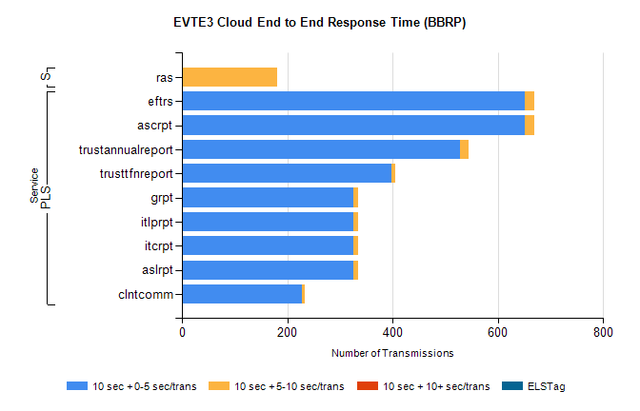
Stream | Service | 10 sec + 0-5 sec /trans | 10 sec + 5-10 sec /trans | 10 sec + >10 sec /trans | Processing Incomplete | ELStag | Total
PLS | ascrpt | 652 | 18 | 0 | 0 | 0 | 670
PLS | eftrs | 652 | 18 | 0 | 0 | 0 | 670
PLS | trustannualreport | 528 | 16 | 0 | 0 | 0 | 544
PLS | trusttfnreport | 398 | 8 | 0 | 0 | 0 | 408
PLS | aslrpt | 326 | 9 | 0 | 0 | 0 | 335
PLS | itcrpt | 326 | 9 | 0 | 0 | 0 | 335
PLS | itlprpt | 326 | 9 | 0 | 0 | 0 | 335
PLS | grpt | 326 | 9 | 0 | 0 | 0 | 335
PLS | clntcomm | 228 | 6 | 0 | 0 | 0 | 235
Super | ras | 1 | 179 | 0 | 200 | 0 | 397

