Transmission Timings Report Week - 43
21/10/2024 - 27/10/2024

SBR2 Cloud Production2 - Single Requests (SRP)

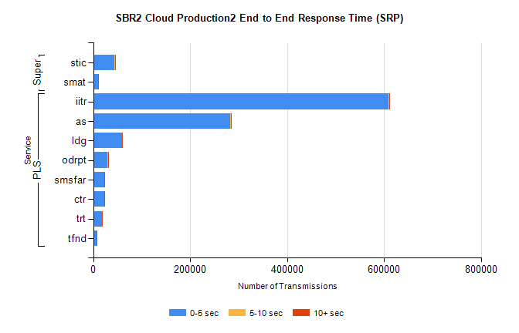
Stream | Service | 0-5 sec | 5-10 sec | >10 sec | Total | % within 5 sec timing target
PLS | iitr | 608872 | 2558 | 1356 | 612821 | 99.4%
PLS | as | 282759 | 1483 | 398 | 284651 | 99.3%
PLS | ldg | 59537 | 129 | 73 | 59740 | 99.7%
PLS | odrpt | 29402 | 917 | 147 | 30466 | 96.5%
PLS | smsfar | 23548 | 55 | 49 | 23654 | 99.6%
PLS | ctr | 23491 | 65 | 30 | 23587 | 99.6%
PLS | trt | 18809 | 52 | 23 | 18899 | 99.5%
PLS | tfnd | 7228 | 28 | 9 | 7265 | 99.5%
Super | stic | 44337 | 226 | 97 | 44660 | 99.3%
Super | smat | 10862 | 116 | 56 | 11036 | 98.4%

SBR2 Cloud Production2 - Bulk or Batch Requests (BBRP)

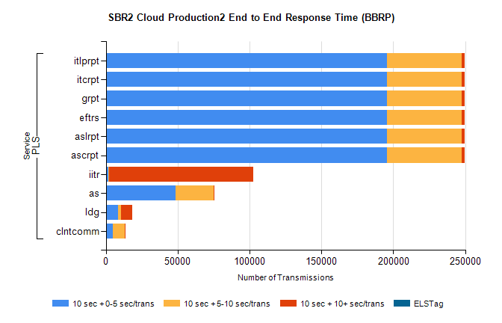
Stream | Service | 10 sec + 0-5 sec /trans | 10 sec + 5-10 sec /trans | 10 sec + >10 sec /trans | Processing Incomplete | ELStag | Total
PLS | ascrpt | 195336 | 52099 | 2130 | 22 | 0 | 253502
PLS | aslrpt | 195336 | 52099 | 2130 | 22 | 0 | 253502
PLS | eftrs | 195336 | 52099 | 2130 | 22 | 0 | 253502
PLS | grpt | 195336 | 52099 | 2130 | 22 | 0 | 253502
PLS | itcrpt | 195336 | 52099 | 2130 | 22 | 0 | 253502
PLS | itlprpt | 195336 | 52099 | 2130 | 22 | 0 | 253502
PLS | iitr | 1601 | 786 | 100190 | 221 | 0 | 104725
PLS | as | 48723 | 26198 | 534 | 164 | 0 | 75898
PLS | ldg | 8452 | 1935 | 7866 | 3 | 0 | 19909
PLS | clntcomm | 4838 | 8529 | 555 | 0 | 0 | 14406

SBR2 Cloud Production2 - ...

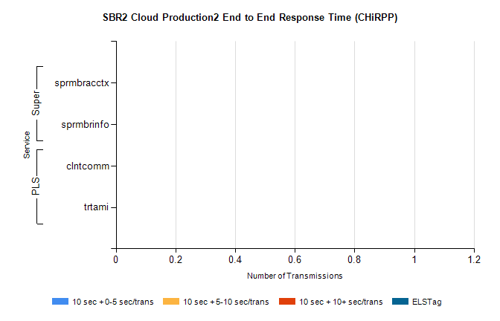
Stream | Service | 10 sec + 0-5 sec /trans | 10 sec + 5-10 sec /trans | 10 sec + >10 sec /trans | Total | % within 5 sec timing target
PLS | clntcomm | 0 | 0 | 0 | 24320 | 0.0%
PLS | trtami | 0 | 0 | 0 | 63 | 0.0%
Super | sprmbracctx | 0 | 0 | 0 | 4448 | 0.0%
Super | sprmbrinfo | 0 | 0 | 0 | 2899 | 0.0%

SBR1 Production Transactions

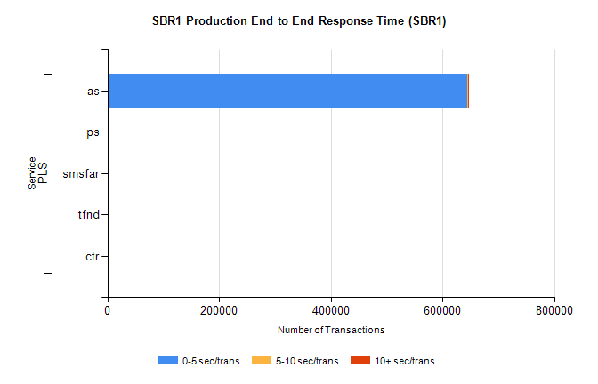
Stream | Service | 0-5 sec/trans | 5-10 sec/trans | 10+ sec/trans | Total | % within 5 sec timing target
PLS | as | 644606 | 755 | 376 | 645737 | 99.8%
PLS | ps | 91 | 47 | 158 | 296 | 30.7%
PLS | smsfar |  | 13 |  | 13 | 0.0%
PLS | tfnd | 5 | 6 | 1 | 12 | 41.7%
PLS | ctr |  |  | 1 | 1 | 0.0%

