Transmission Timings Report Week - 44
28/10/2024 - 3/11/2024

SBR2 External Vendor Testing Environment (EVTE3)

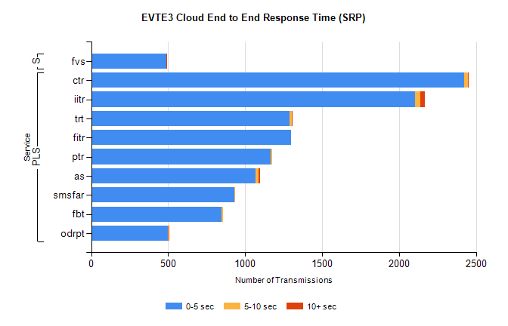
Stream | Service | 0-5 sec | 5-10 sec | >10 sec | Total | % within 5 sec timing target
PLS | ctr | 2422 | 24 | 2 | 2483 | 97.5%
PLS | iitr | 2102 | 36 | 27 | 2190 | 96.0%
PLS | trt | 1290 | 11 | 2 | 1331 | 96.9%
PLS | fitr | 1297 | 0 | 0 | 1309 | 99.1%
PLS | ptr | 1168 | 8 | 0 | 1190 | 98.2%
PLS | as | 1069 | 16 | 13 | 1133 | 94.4%
PLS | smsfar | 931 | 2 | 0 | 944 | 98.6%
PLS | fbt | 848 | 9 | 0 | 870 | 97.5%
PLS | odrpt | 498 | 4 | 2 | 504 | 98.8%
Super | fvs | 490 | 0 | 1 | 491 | 99.8%

SBR2 External Vendor Testing Environment (EVTE3)

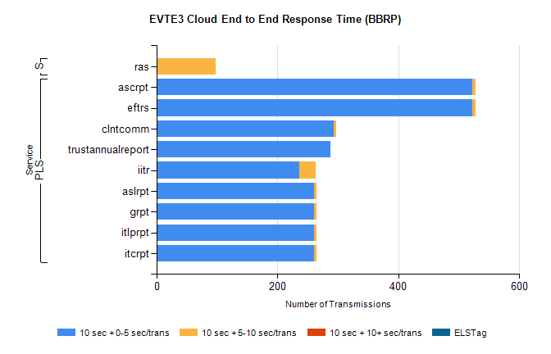
Stream | Service | 10 sec + 0-5 sec /trans | 10 sec + 5-10 sec /trans | 10 sec + >10 sec /trans | Processing Incomplete | ELStag | Total
PLS | eftrs | 522 | 6 | 0 | 0 | 0 | 530
PLS | ascrpt | 522 | 6 | 0 | 0 | 0 | 530
PLS | clntcomm | 293 | 4 | 0 | 0 | 0 | 298
PLS | trustannualreport | 287 | 0 | 0 | 0 | 0 | 287
PLS | iitr | 236 | 27 | 0 | 0 | 0 | 272
PLS | itcrpt | 261 | 3 | 0 | 0 | 0 | 265
PLS | itlprpt | 261 | 3 | 0 | 0 | 0 | 265
PLS | grpt | 261 | 3 | 0 | 0 | 0 | 265
PLS | aslrpt | 261 | 3 | 0 | 0 | 0 | 265
Super | ras | 0 | 98 | 0 | 120 | 0 | 232

