Transmission Timings Report Week - 44
28/10/2024 - 3/11/2024

SBR2 Cloud Production2 - Single Requests (SRP)

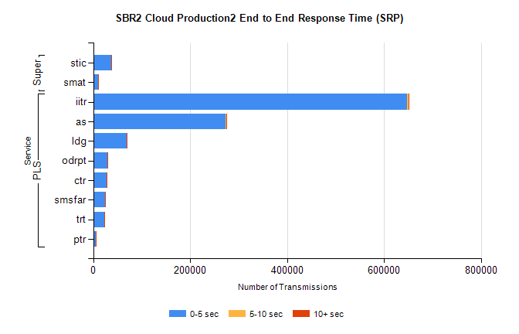
Stream | Service | 0-5 sec | 5-10 sec | >10 sec | Total | % within 5 sec timing target
PLS | iitr | 647880 | 2955 | 2215 | 653099 | 99.2%
PLS | as | 273286 | 1349 | 831 | 275571 | 99.2%
PLS | ldg | 68781 | 132 | 60 | 68990 | 99.7%
PLS | odrpt | 29227 | 783 | 90 | 30102 | 97.1%
PLS | ctr | 27281 | 98 | 97 | 27478 | 99.3%
PLS | smsfar | 23877 | 62 | 81 | 24030 | 99.4%
PLS | trt | 22718 | 82 | 65 | 22871 | 99.3%
PLS | ptr | 6045 | 20 | 16 | 6081 | 99.4%
Super | stic | 36908 | 206 | 874 | 37991 | 97.1%
Super | smat | 9688 | 111 | 227 | 10027 | 96.6%

SBR2 Cloud Production2 - Bulk or Batch Requests (BBRP)

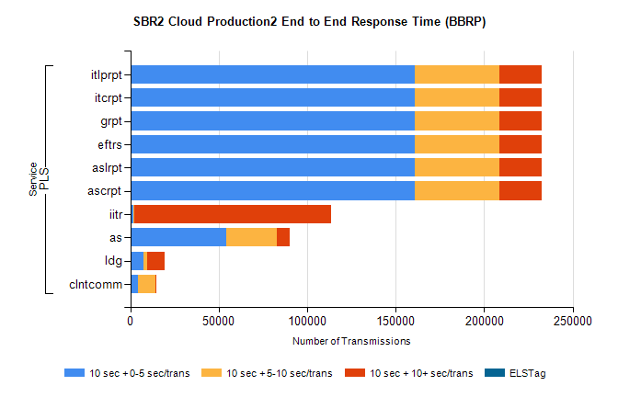
Stream | Service | 10 sec + 0-5 sec /trans | 10 sec + 5-10 sec /trans | 10 sec + >10 sec /trans | Processing Incomplete | ELStag | Total
PLS | ascrpt | 160993 | 47591 | 23664 | 108 | 0 | 244436
PLS | aslrpt | 160993 | 47592 | 23664 | 107 | 0 | 244436
PLS | eftrs | 160993 | 47591 | 23664 | 108 | 0 | 244436
PLS | grpt | 160993 | 47592 | 23664 | 107 | 0 | 244436
PLS | itcrpt | 160993 | 47592 | 23664 | 107 | 0 | 244436
PLS | itlprpt | 160993 | 47592 | 23664 | 107 | 0 | 244436
PLS | iitr | 1534 | 537 | 111640 | 706 | 0 | 116855
PLS | as | 54254 | 28389 | 7280 | 532 | 0 | 91618
PLS | ldg | 7336 | 2014 | 10217 | 6 | 0 | 21003
PLS | clntcomm | 4190 | 10106 | 602 | 4 | 0 | 15651

SBR2 Cloud Production2 - ...

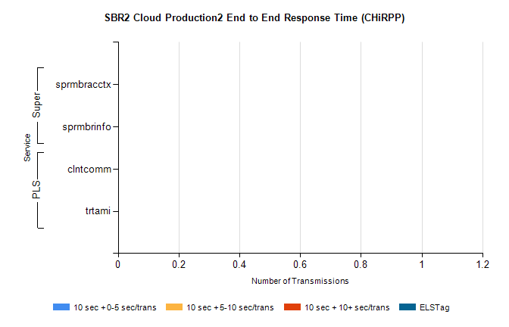
Stream | Service | 10 sec + 0-5 sec /trans | 10 sec + 5-10 sec /trans | 10 sec + >10 sec /trans | Total | % within 5 sec timing target
PLS | clntcomm | 0 | 0 | 0 | 25653 | 0.0%
PLS | trtami | 0 | 0 | 0 | 38 | 0.0%
Super | sprmbracctx | 0 | 0 | 0 | 7128 | 0.0%
Super | sprmbrinfo | 0 | 0 | 0 | 2804 | 0.0%

SBR1 Production Transactions

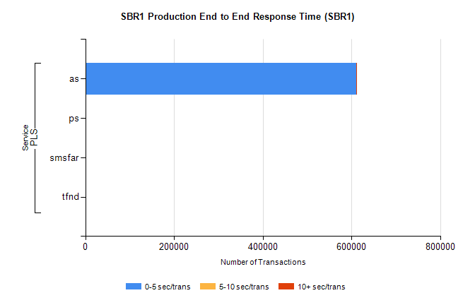
Stream | Service | 0-5 sec/trans | 5-10 sec/trans | 10+ sec/trans | Total | % within 5 sec timing target
PLS | as | 610278 | 373 | 1041 | 611692 | 99.8%
PLS | ps | 34 | 45 | 146 | 225 | 15.1%
PLS | smsfar | 15 | 12 | 11 | 38 | 39.5%
PLS | tfnd |  | 2 |  | 2 | 0.0%

