Transmission Timings Report Week - 45
4/11/2024 - 10/11/2024

SBR2 External Vendor Testing Environment (EVTE3)

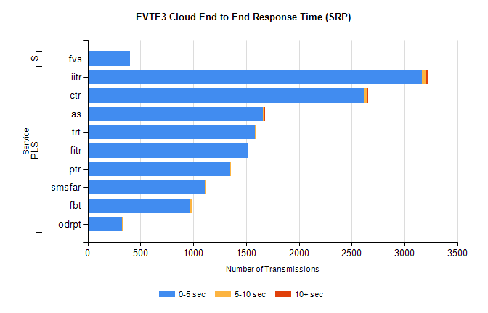
Stream | Service | 0-5 sec | 5-10 sec | >10 sec | Total | % within 5 sec timing target
PLS | iitr | 3166 | 38 | 19 | 3236 | 97.8%
PLS | ctr | 2614 | 35 | 1 | 2691 | 97.1%
PLS | as | 1660 | 10 | 10 | 1742 | 95.3%
PLS | trt | 1583 | 8 | 0 | 1614 | 98.1%
PLS | fitr | 1520 | 0 | 0 | 1530 | 99.3%
PLS | ptr | 1347 | 1 | 0 | 1355 | 99.4%
PLS | smsfar | 1110 | 5 | 0 | 1120 | 99.1%
PLS | fbt | 972 | 12 | 0 | 999 | 97.3%
PLS | odrpt | 323 | 1 | 0 | 328 | 98.5%
Super | fvs | 404 | 0 | 0 | 404 | 100.0%

SBR2 External Vendor Testing Environment (EVTE3)

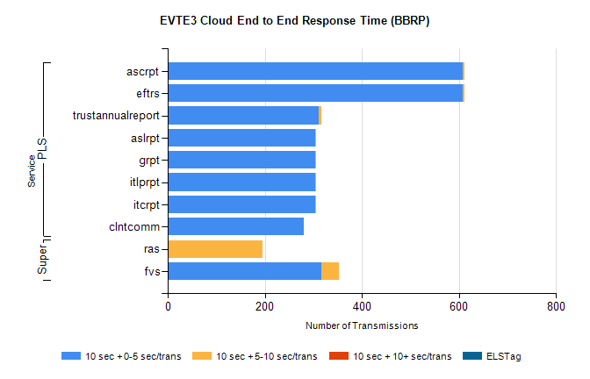
Stream | Service | 10 sec + 0-5 sec /trans | 10 sec + 5-10 sec /trans | 10 sec + >10 sec /trans | Processing Incomplete | ELStag | Total
PLS | eftrs | 608 | 4 | 0 | 2 | 0 | 614
PLS | ascrpt | 608 | 4 | 0 | 2 | 0 | 614
PLS | trustannualreport | 312 | 5 | 0 | 0 | 0 | 317
PLS | itcrpt | 304 | 2 | 0 | 1 | 0 | 307
PLS | itlprpt | 304 | 2 | 0 | 1 | 0 | 307
PLS | grpt | 304 | 2 | 0 | 1 | 0 | 307
PLS | aslrpt | 304 | 2 | 0 | 1 | 0 | 307
PLS | clntcomm | 281 | 0 | 0 | 1 | 0 | 283
Super | ras | 1 | 194 | 0 | 196 | 0 | 408
Super | fvs | 316 | 37 | 0 | 0 | 0 | 354

