Transmission Timings Report Week - 45
4/11/2024 - 10/11/2024

SBR2 Cloud Production2 - Single Requests (SRP)

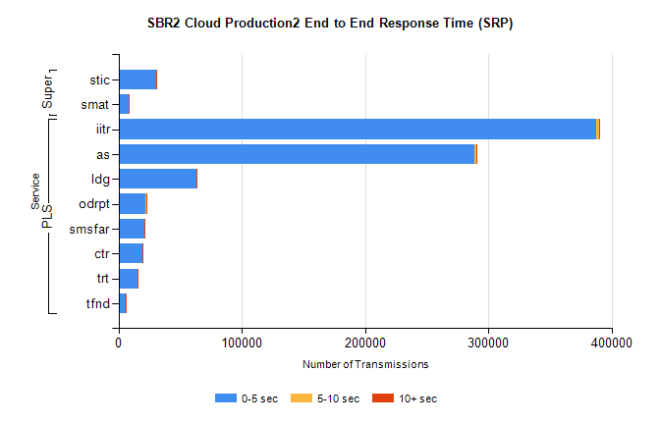
Stream | Service | 0-5 sec | 5-10 sec | >10 sec | Total | % within 5 sec timing target
PLS | iitr | 387329 | 2192 | 399 | 390719 | 99.1%
PLS | as | 289014 | 1328 | 286 | 292966 | 98.7%
PLS | ldg | 62901 | 104 | 20 | 63159 | 99.6%
PLS | odrpt | 21856 | 645 | 93 | 22594 | 96.7%
PLS | smsfar | 21148 | 56 | 33 | 21263 | 99.5%
PLS | ctr | 19521 | 81 | 13 | 19661 | 99.3%
PLS | trt | 15555 | 50 | 14 | 15643 | 99.4%
PLS | tfnd | 6105 | 29 | 2 | 6159 | 99.1%
Super | stic | 30563 | 155 | 76 | 31469 | 97.1%
Super | smat | 8584 | 78 | 40 | 8783 | 97.7%

SBR2 Cloud Production2 - Bulk or Batch Requests (BBRP)

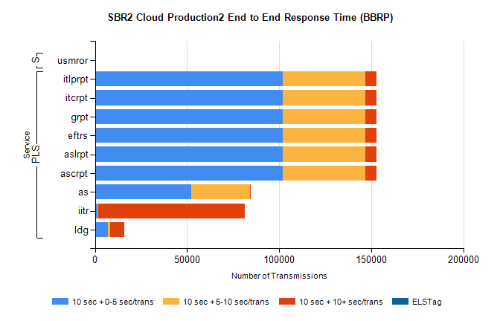
Stream | Service | 10 sec + 0-5 sec /trans | 10 sec + 5-10 sec /trans | 10 sec + >10 sec /trans | Processing Incomplete | ELStag | Total
PLS | ascrpt | 101940 | 44986 | 5759 | 283 | 0 | 157194
PLS | aslrpt | 101940 | 44986 | 5759 | 283 | 0 | 157194
PLS | eftrs | 101940 | 44986 | 5759 | 283 | 0 | 157194
PLS | grpt | 101940 | 44986 | 5759 | 283 | 0 | 157194
PLS | itcrpt | 101940 | 44985 | 5759 | 284 | 0 | 157194
PLS | itlprpt | 101940 | 44986 | 5759 | 283 | 0 | 157194
PLS | as | 52173 | 31813 | 235 | 201 | 0 | 84775
PLS | iitr | 1326 | 327 | 79720 | 103 | 0 | 82357
PLS | ldg | 6945 | 1348 | 7612 | 2369 | 0 | 19211
Super | usmror | 0 | 0 | 0 | 24849 | 0 | 24849

SBR2 Cloud Production2 - ...

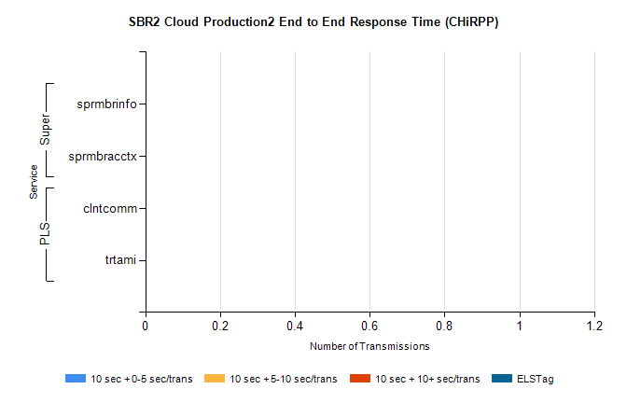
Stream | Service | 10 sec + 0-5 sec /trans | 10 sec + 5-10 sec /trans | 10 sec + >10 sec /trans | Total | % within 5 sec timing target
PLS | clntcomm | 0 | 0 | 0 | 27679 | 0.0%
PLS | trtami | 0 | 0 | 0 | 53 | 0.0%
Super | sprmbrinfo | 0 | 0 | 0 | 3075 | 0.0%
Super | sprmbracctx | 0 | 0 | 0 | 2784 | 0.0%

SBR1 Production Transactions

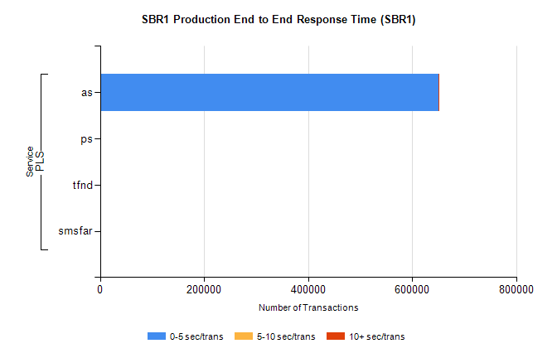
Stream | Service | 0-5 sec/trans | 5-10 sec/trans | 10+ sec/trans | Total | % within 5 sec timing target
PLS | as | 650692 | 232 | 1058 | 651982 | 99.8%
PLS | ps | 26 | 48 | 130 | 204 | 12.7%
PLS | tfnd | 14 | 14 |  | 28 | 50.0%
PLS | smsfar | 3 | 19 | 1 | 23 | 13.0%

