Transmission Timings Report Week - 46
11/11/2024 - 17/11/2024

SBR2 External Vendor Testing Environment (EVTE3)

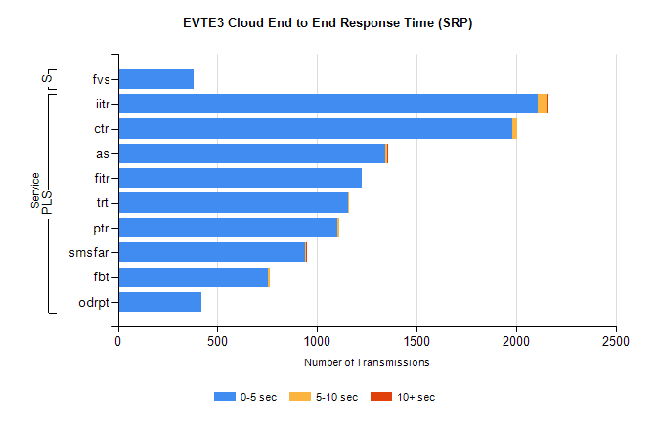
Stream | Service | 0-5 sec | 5-10 sec | >10 sec | Total | % within 5 sec timing target
PLS | iitr | 2109 | 46 | 8 | 2180 | 96.7%
PLS | ctr | 1982 | 23 | 0 | 2046 | 96.9%
PLS | as | 1342 | 9 | 5 | 1482 | 90.6%
PLS | fitr | 1226 | 0 | 0 | 1228 | 99.8%
PLS | trt | 1156 | 2 | 0 | 1164 | 99.3%
PLS | ptr | 1101 | 9 | 0 | 1113 | 98.9%
PLS | smsfar | 938 | 6 | 3 | 950 | 98.7%
PLS | fbt | 754 | 7 | 0 | 824 | 91.5%
PLS | odrpt | 420 | 0 | 0 | 422 | 99.5%
Super | fvs | 380 | 0 | 0 | 380 | 100.0%

SBR2 External Vendor Testing Environment (EVTE3)

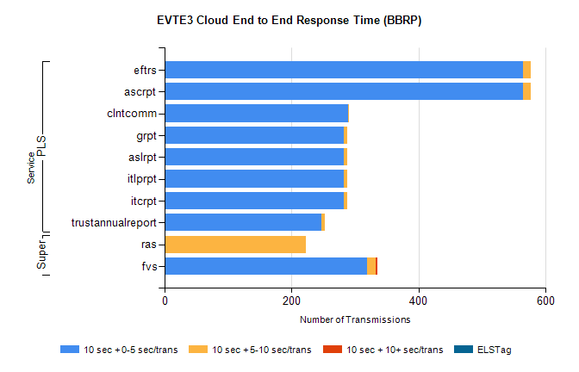
Stream | Service | 10 sec + 0-5 sec /trans | 10 sec + 5-10 sec /trans | 10 sec + >10 sec /trans | Processing Incomplete | ELStag | Total
PLS | ascrpt | 564 | 12 | 0 | 0 | 0 | 576
PLS | eftrs | 564 | 12 | 0 | 0 | 0 | 576
PLS | clntcomm | 289 | 1 | 0 | 0 | 0 | 293
PLS | itcrpt | 282 | 6 | 0 | 0 | 0 | 288
PLS | itlprpt | 282 | 6 | 0 | 0 | 0 | 288
PLS | aslrpt | 282 | 6 | 0 | 0 | 0 | 288
PLS | grpt | 282 | 6 | 0 | 0 | 0 | 288
PLS | trustannualreport | 247 | 5 | 0 | 0 | 0 | 252
Super | ras | 0 | 223 | 0 | 211 | 0 | 446
Super | fvs | 319 | 14 | 2 | 11 | 0 | 346

