Transmission Timings Report Week - 46
11/11/2024 - 17/11/2024

SBR2 Cloud Production2 - Single Requests (SRP)

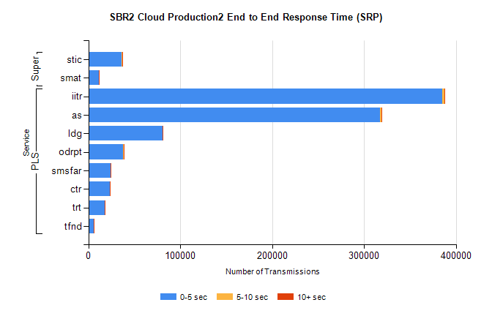
Stream | Service | 0-5 sec | 5-10 sec | >10 sec | Total | % within 5 sec timing target
PLS | iitr | 385098 | 2298 | 368 | 387771 | 99.3%
PLS | as | 317314 | 1599 | 530 | 319455 | 99.3%
PLS | ldg | 80492 | 160 | 24 | 80676 | 99.8%
PLS | odrpt | 37755 | 637 | 89 | 38481 | 98.1%
PLS | smsfar | 24279 | 86 | 35 | 24414 | 99.4%
PLS | ctr | 23053 | 107 | 20 | 23180 | 99.5%
PLS | trt | 18141 | 86 | 19 | 18255 | 99.4%
PLS | tfnd | 5862 | 33 | 8 | 5903 | 99.3%
Super | stic | 36546 | 184 | 94 | 36825 | 99.2%
Super | smat | 11587 | 127 | 35 | 11749 | 98.6%

SBR2 Cloud Production2 - Bulk or Batch Requests (BBRP)

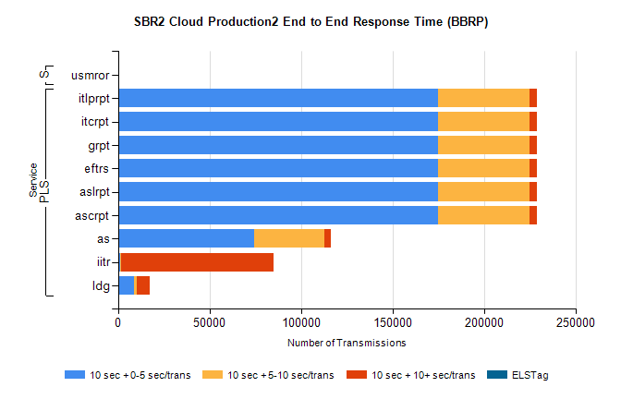
Stream | Service | 10 sec + 0-5 sec /trans | 10 sec + 5-10 sec /trans | 10 sec + >10 sec /trans | Processing Incomplete | ELStag | Total
PLS | ascrpt | 174726 | 50292 | 3757 | 22 | 0 | 233188
PLS | aslrpt | 174726 | 50292 | 3757 | 24 | 0 | 233188
PLS | eftrs | 174726 | 50292 | 3757 | 22 | 0 | 233188
PLS | grpt | 174726 | 50292 | 3757 | 23 | 0 | 233188
PLS | itcrpt | 174726 | 50291 | 3757 | 24 | 0 | 233188
PLS | itlprpt | 174726 | 50291 | 3757 | 23 | 0 | 233188
PLS | as | 74461 | 38270 | 3578 | 282 | 0 | 117174
PLS | iitr | 1341 | 330 | 83405 | 168 | 0 | 86402
PLS | ldg | 8569 | 1551 | 7181 | 14 | 0 | 18533
Super | usmror | 0 | 0 | 0 | 21607 | 0 | 21607

SBR2 Cloud Production2 - ...

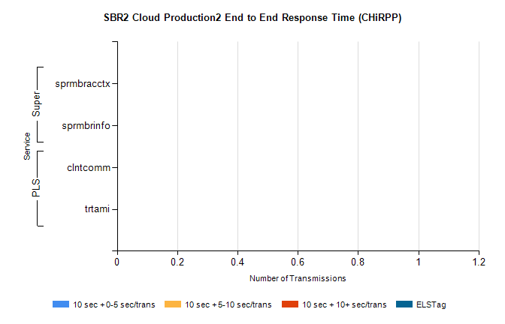
Stream | Service | 10 sec + 0-5 sec /trans | 10 sec + 5-10 sec /trans | 10 sec + >10 sec /trans | Total | % within 5 sec timing target
PLS | clntcomm | 0 | 0 | 0 | 25563 | 0.0%
PLS | trtami | 0 | 0 | 0 | 20 | 0.0%
Super | sprmbracctx | 0 | 0 | 0 | 3280 | 0.0%
Super | sprmbrinfo | 0 | 0 | 0 | 2772 | 0.0%

SBR1 Production Transactions

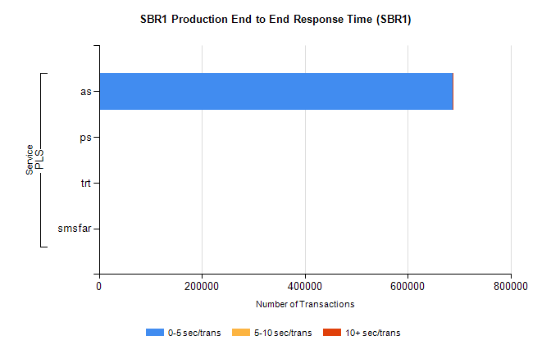
Stream | Service | 0-5 sec/trans | 5-10 sec/trans | 10+ sec/trans | Total | % within 5 sec timing target
PLS | as | 687670 | 215 | 830 | 688715 | 99.8%
PLS | ps | 30 | 29 | 102 | 161 | 18.6%
PLS | trt | 1 |  | 12 | 13 | 7.7%
PLS | smsfar | 1 | 10 |  | 11 | 9.1%

