Transmission Timings Report Week - 47
18/11/2024 - 24/11/2024

SBR2 External Vendor Testing Environment (EVTE3)

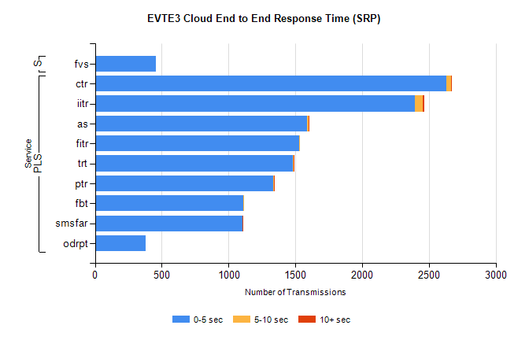
Stream | Service | 0-5 sec | 5-10 sec | >10 sec | Total | % within 5 sec timing target
PLS | ctr | 2632 | 33 | 6 | 2711 | 97.1%
PLS | iitr | 2395 | 58 | 12 | 2472 | 96.9%
PLS | as | 1586 | 13 | 8 | 1678 | 94.5%
PLS | fitr | 1531 | 2 | 0 | 1567 | 97.7%
PLS | trt | 1479 | 7 | 6 | 1515 | 97.6%
PLS | ptr | 1335 | 6 | 2 | 1363 | 97.9%
PLS | fbt | 1111 | 8 | 0 | 1128 | 98.5%
PLS | smsfar | 1102 | 0 | 3 | 1105 | 99.7%
PLS | odrpt | 379 | 0 | 0 | 382 | 99.2%
Super | fvs | 457 | 0 | 0 | 457 | 100.0%

SBR2 External Vendor Testing Environment (EVTE3)

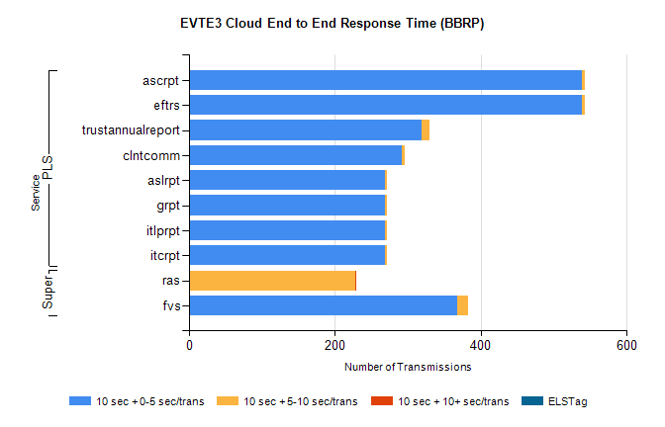
Stream | Service | 10 sec + 0-5 sec /trans | 10 sec + 5-10 sec /trans | 10 sec + >10 sec /trans | Processing Incomplete | ELStag | Total
PLS | eftrs | 538 | 4 | 0 | 0 | 0 | 542
PLS | ascrpt | 538 | 4 | 0 | 0 | 0 | 542
PLS | trustannualreport | 319 | 10 | 0 | 0 | 0 | 330
PLS | clntcomm | 291 | 5 | 0 | 3 | 0 | 299
PLS | itcrpt | 269 | 2 | 0 | 0 | 0 | 271
PLS | itlprpt | 269 | 2 | 0 | 0 | 0 | 271
PLS | grpt | 269 | 2 | 0 | 0 | 0 | 271
PLS | aslrpt | 269 | 2 | 0 | 0 | 0 | 271
Super | ras | 0 | 228 | 1 | 207 | 0 | 449
Super | fvs | 367 | 15 | 0 | 0 | 0 | 382

