Transmission Timings Report Week - 47
18/11/2024 - 24/11/2024

SBR2 Cloud Production2 - Single Requests (SRP)

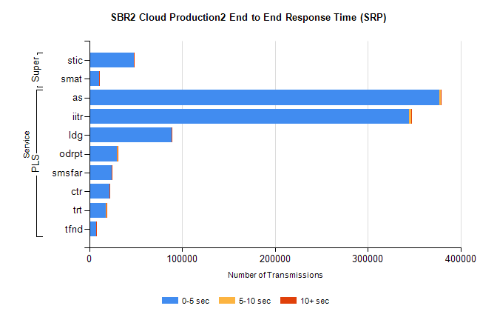
Stream | Service | 0-5 sec | 5-10 sec | >10 sec | Total | % within 5 sec timing target
PLS | as | 377139 | 1841 | 297 | 379342 | 99.4%
PLS | iitr | 344793 | 1785 | 233 | 346849 | 99.4%
PLS | ldg | 88898 | 150 | 17 | 89084 | 99.8%
PLS | odrpt | 29574 | 701 | 150 | 30426 | 97.2%
PLS | smsfar | 24037 | 45 | 16 | 24100 | 99.7%
PLS | ctr | 21845 | 59 | 5 | 21910 | 99.7%
PLS | trt | 18225 | 46 | 11 | 18288 | 99.7%
PLS | tfnd | 7159 | 23 | 3 | 7185 | 99.6%
Super | stic | 47807 | 209 | 86 | 48106 | 99.4%
Super | smat | 10314 | 105 | 34 | 10456 | 98.6%

SBR2 Cloud Production2 - Bulk or Batch Requests (BBRP)

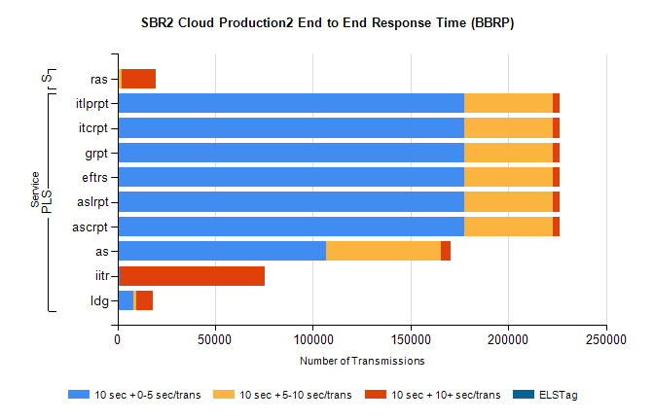
Stream | Service | 10 sec + 0-5 sec /trans | 10 sec + 5-10 sec /trans | 10 sec + >10 sec /trans | Processing Incomplete | ELStag | Total
PLS | ascrpt | 177257 | 45748 | 3468 | 3744 | 0 | 233088
PLS | aslrpt | 177257 | 45754 | 3469 | 3737 | 0 | 233088
PLS | eftrs | 177258 | 45745 | 3468 | 3746 | 0 | 233088
PLS | grpt | 177249 | 45751 | 3468 | 3748 | 0 | 233088
PLS | itcrpt | 177255 | 45745 | 3468 | 3747 | 0 | 233088
PLS | itlprpt | 177260 | 45746 | 3468 | 3744 | 0 | 233088
PLS | as | 106534 | 58940 | 5245 | 2493 | 0 | 173911
PLS | iitr | 1174 | 252 | 73833 | 963 | 0 | 76835
PLS | ldg | 8061 | 1515 | 8517 | 303 | 0 | 19599
Super | ras | 220 | 2038 | 17233 | 199 | 0 | 22163

SBR2 Cloud Production2 - ...

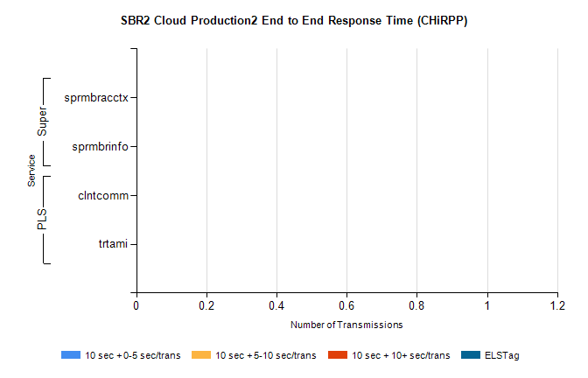
Stream | Service | 10 sec + 0-5 sec /trans | 10 sec + 5-10 sec /trans | 10 sec + >10 sec /trans | Total | % within 5 sec timing target
PLS | clntcomm | 0 | 0 | 0 | 21357 | 0.0%
PLS | trtami | 0 | 0 | 0 | 30 | 0.0%
Super | sprmbracctx | 0 | 0 | 0 | 3363 | 0.0%
Super | sprmbrinfo | 0 | 0 | 0 | 2948 | 0.0%

SBR1 Production Transactions

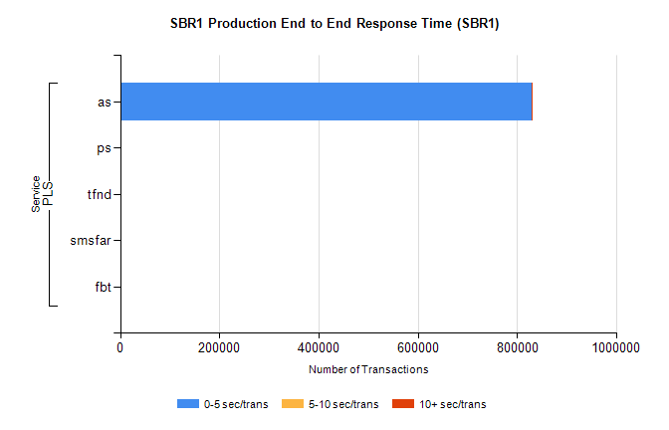
Stream | Service | 0-5 sec/trans | 5-10 sec/trans | 10+ sec/trans | Total | % within 5 sec timing target
PLS | as | 829143 | 309 | 788 | 830240 | 99.9%
PLS | ps | 20 | 25 | 101 | 146 | 13.7%
PLS | tfnd | 112 | 8 | 4 | 124 | 90.3%
PLS | smsfar | 6 | 19 |  | 25 | 24.0%
PLS | fbt | 1 | 5 |  | 6 | 16.7%

