Transmission Timings Report Week - 48
25/11/2024 - 1/12/2024

SBR2 External Vendor Testing Environment (EVTE3)

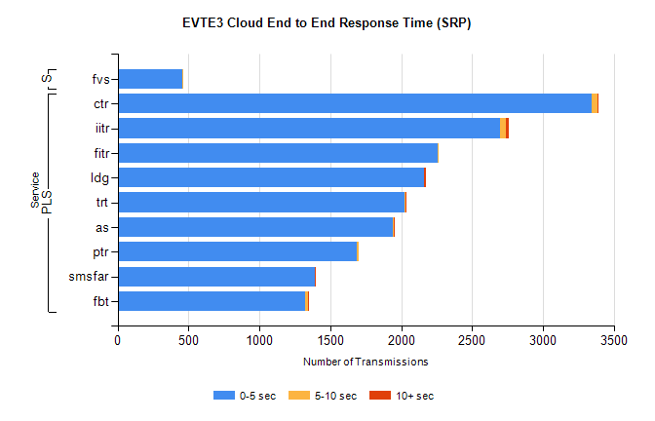
Stream | Service | 0-5 sec | 5-10 sec | >10 sec | Total | % within 5 sec timing target
PLS | ctr | 3346 | 41 | 7 | 3402 | 98.4%
PLS | iitr | 2696 | 42 | 22 | 2790 | 96.6%
PLS | fitr | 2256 | 1 | 0 | 2257 | 100.0%
PLS | ldg | 2159 | 4 | 9 | 2187 | 98.7%
PLS | trt | 2024 | 7 | 4 | 2038 | 99.3%
PLS | as | 1939 | 8 | 4 | 2014 | 96.3%
PLS | ptr | 1690 | 10 | 0 | 1700 | 99.4%
PLS | smsfar | 1392 | 0 | 1 | 1393 | 99.9%
PLS | fbt | 1324 | 16 | 2 | 1344 | 98.5%
Super | fvs | 457 | 1 | 0 | 458 | 99.8%

SBR2 External Vendor Testing Environment (EVTE3)

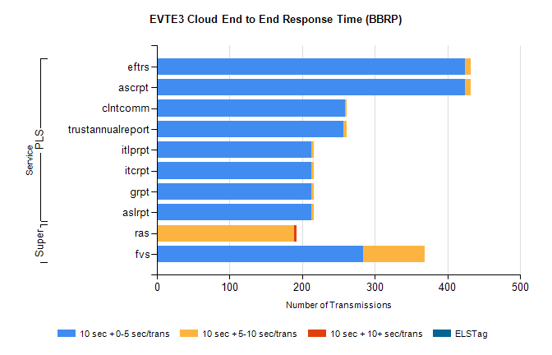
Stream | Service | 10 sec + 0-5 sec /trans | 10 sec + 5-10 sec /trans | 10 sec + >10 sec /trans | Processing Incomplete | ELStag | Total
PLS | ascrpt | 424 | 8 | 0 | 0 | 0 | 432
PLS | eftrs | 424 | 8 | 0 | 0 | 0 | 432
PLS | clntcomm | 259 | 2 | 0 | 0 | 0 | 272
PLS | trustannualreport | 257 | 4 | 0 | 0 | 0 | 261
PLS | aslrpt | 212 | 4 | 0 | 0 | 0 | 216
PLS | grpt | 212 | 4 | 0 | 0 | 0 | 216
PLS | itcrpt | 212 | 4 | 0 | 0 | 0 | 216
PLS | itlprpt | 212 | 4 | 0 | 0 | 0 | 216
Super | ras | 0 | 189 | 3 | 214 | 0 | 422
Super | fvs | 284 | 85 | 0 | 1 | 0 | 372

