Transmission Timings Report Week - 48
25/11/2024 - 1/12/2024

SBR2 Cloud Production2 - Single Requests (SRP)

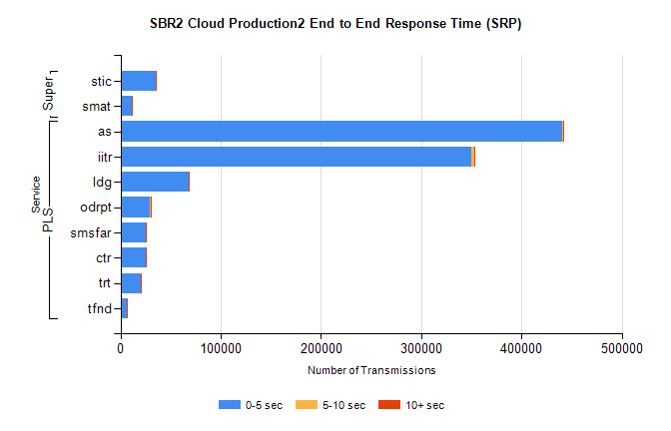
Stream | Service | 0-5 sec | 5-10 sec | >10 sec | Total | % within 5 sec timing target
PLS | as | 440470 | 1453 | 553 | 442476 | 99.5%
PLS | iitr | 350308 | 2264 | 1092 | 353684 | 99.0%
PLS | ldg | 68456 | 104 | 74 | 68634 | 99.7%
PLS | odrpt | 28932 | 1020 | 338 | 30290 | 95.5%
PLS | smsfar | 25655 | 44 | 32 | 25731 | 99.7%
PLS | ctr | 25403 | 77 | 34 | 25514 | 99.6%
PLS | trt | 20422 | 64 | 41 | 20528 | 99.5%
PLS | tfnd | 6615 | 24 | 6 | 6645 | 99.5%
Super | stic | 35609 | 165 | 87 | 35861 | 99.3%
Super | smat | 11152 | 115 | 44 | 11313 | 98.6%

SBR2 Cloud Production2 - Bulk or Batch Requests (BBRP)

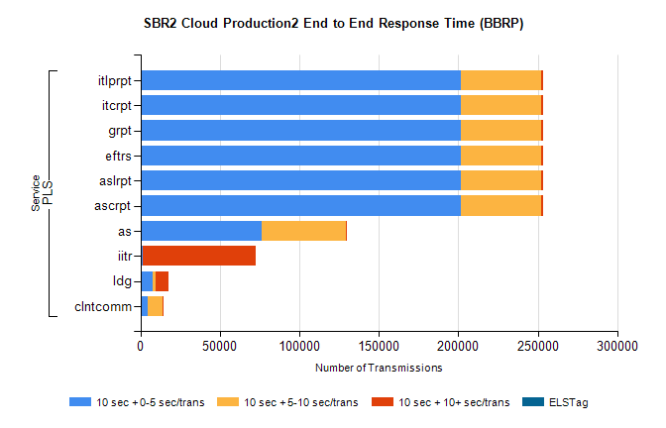
Stream | Service | 10 sec + 0-5 sec /trans | 10 sec + 5-10 sec /trans | 10 sec + >10 sec /trans | Processing Incomplete | ELStag | Total
PLS | ascrpt | 201818 | 50637 | 1222 | 12 | 0 | 256487
PLS | aslrpt | 201818 | 50637 | 1222 | 12 | 0 | 256487
PLS | eftrs | 201818 | 50637 | 1222 | 12 | 0 | 256487
PLS | grpt | 201818 | 50637 | 1222 | 12 | 0 | 256487
PLS | itcrpt | 201818 | 50637 | 1222 | 12 | 0 | 256487
PLS | itlprpt | 201818 | 50637 | 1222 | 12 | 0 | 256487
PLS | as | 76167 | 53429 | 234 | 635 | 0 | 131038
PLS | iitr | 1254 | 285 | 71260 | 127 | 0 | 73868
PLS | ldg | 7788 | 1580 | 8221 | 21 | 0 | 18824
PLS | clntcomm | 4494 | 9649 | 388 | 5 | 0 | 15245

SBR2 Cloud Production2 - ...

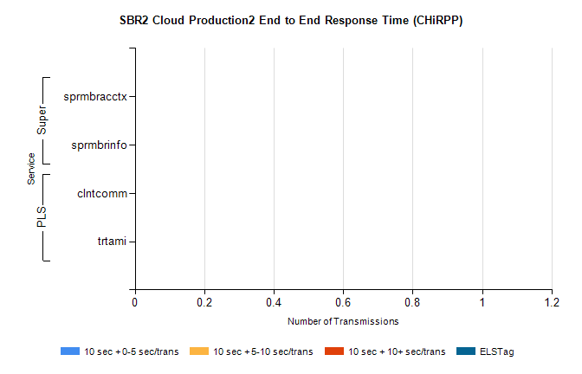
Stream | Service | 10 sec + 0-5 sec /trans | 10 sec + 5-10 sec /trans | 10 sec + >10 sec /trans | Total | % within 5 sec timing target
PLS | clntcomm | 0 | 0 | 0 | 20743 | 0.0%
PLS | trtami | 0 | 0 | 0 | 19 | 0.0%
Super | sprmbracctx | 0 | 0 | 0 | 3056 | 0.0%
Super | sprmbrinfo | 0 | 0 | 0 | 2818 | 0.0%

SBR1 Production Transactions

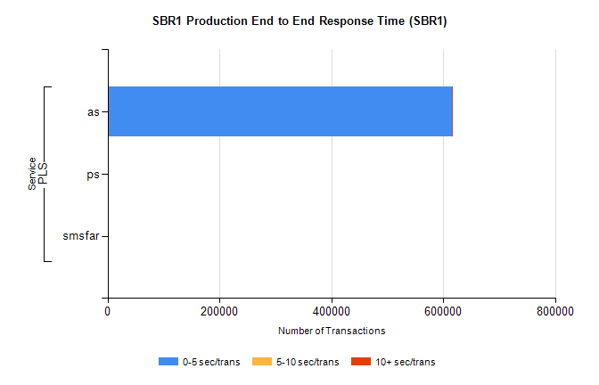
Stream | Service | 0-5 sec/trans | 5-10 sec/trans | 10+ sec/trans | Total | % within 5 sec timing target
PLS | as | 614949 | 755 | 511 | 616215 | 99.8%
PLS | ps | 115 | 72 | 128 | 315 | 36.5%
PLS | smsfar | 4 | 17 |  | 21 | 19.0%

