Transmission Timings Report Week - 49
2/12/2024 - 8/12/2024

SBR2 External Vendor Testing Environment (EVTE3)

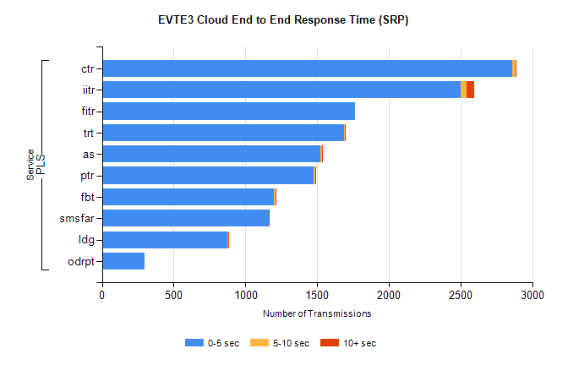
Stream | Service | 0-5 sec | 5-10 sec | >10 sec | Total | % within 5 sec timing target
PLS | ctr | 2859 | 27 | 5 | 2896 | 98.7%
PLS | iitr | 2503 | 39 | 54 | 2617 | 95.6%
PLS | fitr | 1767 | 0 | 0 | 1767 | 100.0%
PLS | trt | 1690 | 6 | 1 | 1699 | 99.5%
PLS | as | 1525 | 10 | 3 | 1585 | 96.2%
PLS | ptr | 1477 | 13 | 5 | 1498 | 98.6%
PLS | fbt | 1200 | 13 | 1 | 1317 | 91.1%
PLS | smsfar | 1161 | 4 | 2 | 1168 | 99.4%
PLS | ldg | 876 | 2 | 6 | 893 | 98.1%
PLS | odrpt | 299 | 0 | 0 | 300 | 99.7%

SBR2 External Vendor Testing Environment (EVTE3)

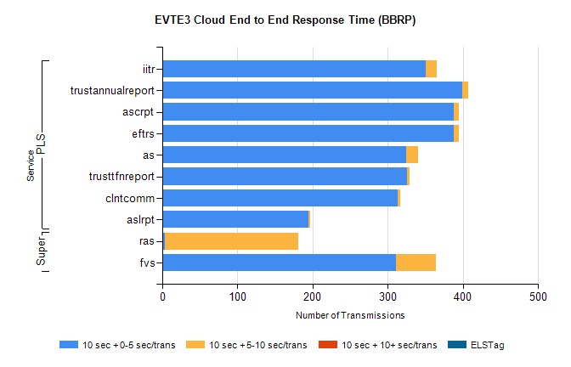
Stream | Service | 10 sec + 0-5 sec /trans | 10 sec + 5-10 sec /trans | 10 sec + >10 sec /trans | Processing Incomplete | ELStag | Total
PLS | iitr | 351 | 14 | 0 | 308 | 0 | 679
PLS | trustannualreport | 399 | 8 | 0 | 0 | 0 | 407
PLS | eftrs | 388 | 6 | 0 | 0 | 0 | 394
PLS | ascrpt | 388 | 6 | 0 | 0 | 0 | 394
PLS | as | 325 | 15 | 0 | 4 | 0 | 345
PLS | trusttfnreport | 326 | 3 | 0 | 0 | 0 | 329
PLS | clntcomm | 313 | 3 | 0 | 0 | 0 | 319
PLS | aslrpt | 194 | 3 | 0 | 0 | 0 | 197
Super | ras | 3 | 178 | 0 | 189 | 0 | 384
Super | fvs | 311 | 53 | 0 | 15 | 0 | 379

