Transmission Timings Report Week - 49
2/12/2024 - 8/12/2024

SBR2 Cloud Production2 - Single Requests (SRP)

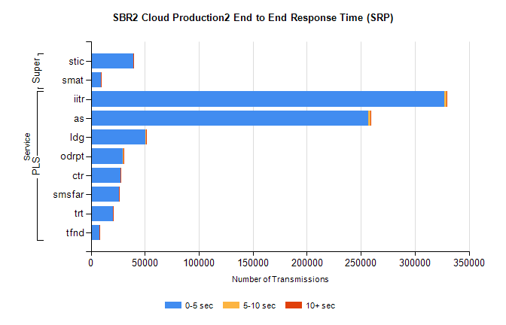
Stream | Service | 0-5 sec | 5-10 sec | >10 sec | Total | % within 5 sec timing target
PLS | iitr | 327275 | 2121 | 662 | 330080 | 99.2%
PLS | as | 257007 | 1681 | 648 | 259342 | 99.1%
PLS | ldg | 50762 | 170 | 167 | 51107 | 99.3%
PLS | odrpt | 29666 | 659 | 61 | 30386 | 97.6%
PLS | ctr | 27296 | 93 | 33 | 27426 | 99.5%
PLS | smsfar | 25861 | 81 | 40 | 25985 | 99.5%
PLS | trt | 20718 | 84 | 29 | 20834 | 99.4%
PLS | tfnd | 7915 | 26 | 23 | 7965 | 99.4%
Super | stic | 39152 | 187 | 127 | 39470 | 99.2%
Super | smat | 9285 | 88 | 49 | 9426 | 98.5%

SBR2 Cloud Production2 - Bulk or Batch Requests (BBRP)

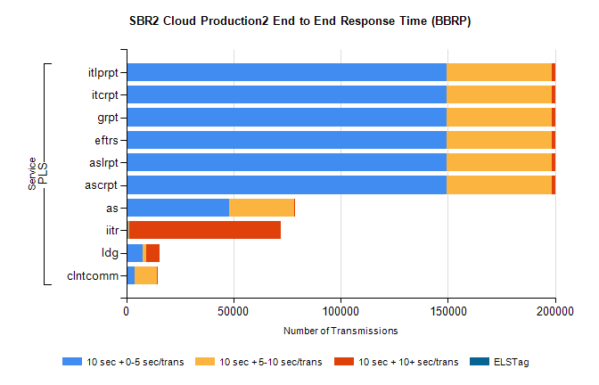
Stream | Service | 10 sec + 0-5 sec /trans | 10 sec + 5-10 sec /trans | 10 sec + >10 sec /trans | Processing Incomplete | ELStag | Total
PLS | ascrpt | 149299 | 49245 | 1391 | 27 | 0 | 203374
PLS | aslrpt | 149299 | 49245 | 1391 | 27 | 0 | 203374
PLS | eftrs | 149299 | 49245 | 1391 | 27 | 0 | 203374
PLS | grpt | 149299 | 49245 | 1391 | 27 | 0 | 203374
PLS | itcrpt | 149299 | 49245 | 1391 | 27 | 0 | 203374
PLS | itlprpt | 149299 | 49245 | 1391 | 27 | 0 | 203374
PLS | as | 47865 | 30276 | 125 | 223 | 0 | 78811
PLS | iitr | 1143 | 315 | 70557 | 93 | 0 | 73268
PLS | ldg | 7567 | 1524 | 6610 | 12 | 0 | 16820
PLS | clntcomm | 3878 | 10364 | 429 | 0 | 0 | 15331

SBR2 Cloud Production2 - ...

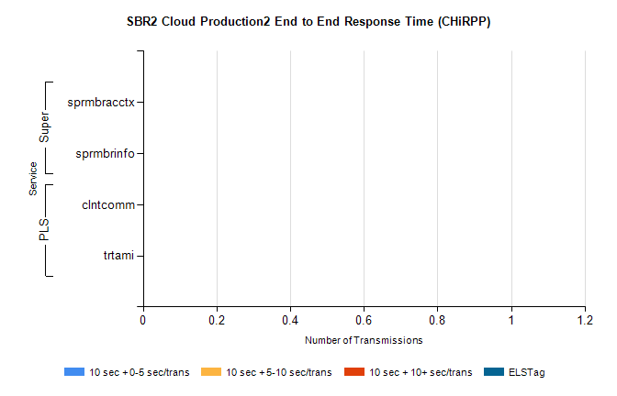
Stream | Service | 10 sec + 0-5 sec /trans | 10 sec + 5-10 sec /trans | 10 sec + >10 sec /trans | Total | % within 5 sec timing target
PLS | clntcomm | 0 | 0 | 0 | 30972 | 0.0%
PLS | trtami | 0 | 0 | 0 | 73 | 0.0%
Super | sprmbracctx | 0 | 0 | 0 | 2945 | 0.0%
Super | sprmbrinfo | 0 | 0 | 0 | 2549 | 0.0%

SBR1 Production Transactions

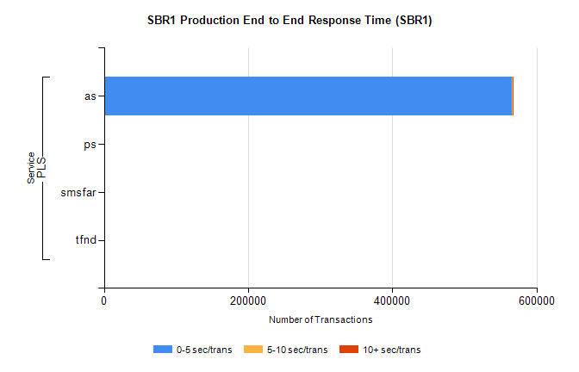
Stream | Service | 0-5 sec/trans | 5-10 sec/trans | 10+ sec/trans | Total | % within 5 sec timing target
PLS | as | 566180 | 509 | 1024 | 567713 | 99.7%
PLS | ps | 41 | 52 | 112 | 205 | 20.0%
PLS | smsfar | 4 | 19 |  | 23 | 17.4%
PLS | tfnd |  | 2 |  | 2 | 0.0%

