Transmission Timings Report Week - 50
9/12/2024 - 15/12/2024

SBR2 External Vendor Testing Environment (EVTE3)

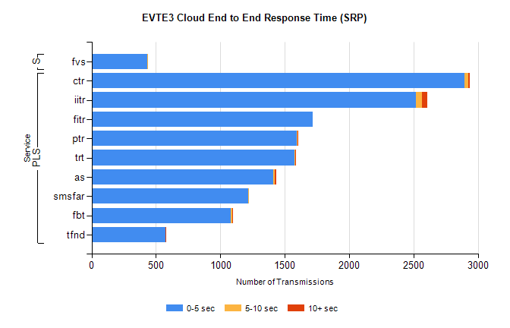
Stream | Service | 0-5 sec | 5-10 sec | >10 sec | Total | % within 5 sec timing target
PLS | ctr | 2898 | 29 | 7 | 2946 | 98.4%
PLS | iitr | 2521 | 42 | 46 | 2610 | 96.6%
PLS | fitr | 1720 | 0 | 0 | 1720 | 100.0%
PLS | ptr | 1595 | 4 | 1 | 1600 | 99.7%
PLS | trt | 1577 | 3 | 1 | 1590 | 99.2%
PLS | as | 1412 | 12 | 8 | 1461 | 96.6%
PLS | smsfar | 1218 | 3 | 0 | 1221 | 99.8%
PLS | fbt | 1080 | 15 | 5 | 1103 | 97.9%
PLS | tfnd | 574 | 0 | 1 | 575 | 99.8%
Super | fvs | 430 | 1 | 0 | 431 | 99.8%

SBR2 External Vendor Testing Environment (EVTE3)

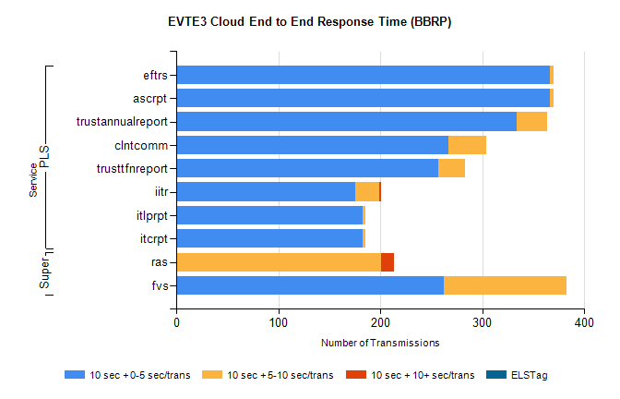
Stream | Service | 10 sec + 0-5 sec /trans | 10 sec + 5-10 sec /trans | 10 sec + >10 sec /trans | Processing Incomplete | ELStag | Total
PLS | ascrpt | 366 | 4 | 0 | 0 | 0 | 370
PLS | eftrs | 366 | 4 | 0 | 0 | 0 | 370
PLS | trustannualreport | 334 | 30 | 0 | 0 | 0 | 368
PLS | clntcomm | 267 | 37 | 0 | 0 | 0 | 304
PLS | trusttfnreport | 257 | 26 | 0 | 0 | 0 | 284
PLS | iitr | 175 | 24 | 2 | 0 | 0 | 207
PLS | itcrpt | 183 | 2 | 0 | 0 | 0 | 185
PLS | itlprpt | 183 | 2 | 0 | 0 | 0 | 185
Super | ras | 0 | 201 | 12 | 247 | 0 | 479
Super | fvs | 262 | 121 | 0 | 0 | 0 | 390

