Transmission Timings Report Week - 50
9/12/2024 - 15/12/2024

SBR2 Cloud Production2 - Single Requests (SRP)

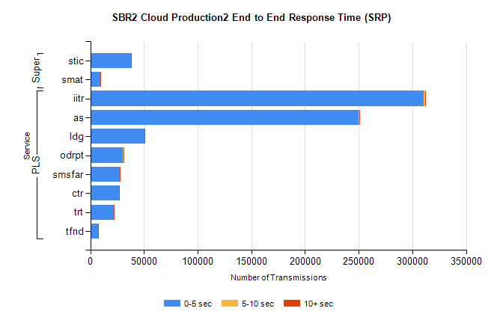
Stream | Service | 0-5 sec | 5-10 sec | >10 sec | Total | % within 5 sec timing target
PLS | iitr | 310508 | 1632 | 477 | 312630 | 99.3%
PLS | as | 249558 | 854 | 263 | 250679 | 99.6%
PLS | ldg | 50327 | 95 | 31 | 50453 | 99.8%
PLS | odrpt | 30313 | 739 | 88 | 31140 | 97.3%
PLS | smsfar | 27322 | 48 | 41 | 27414 | 99.7%
PLS | ctr | 26473 | 81 | 35 | 26591 | 99.6%
PLS | trt | 22023 | 59 | 23 | 22106 | 99.6%
PLS | tfnd | 7084 | 19 | 6 | 7109 | 99.6%
Super | stic | 37983 | 156 | 48 | 38187 | 99.5%
Super | smat | 9428 | 94 | 51 | 9577 | 98.4%

SBR2 Cloud Production2 - Bulk or Batch Requests (BBRP)

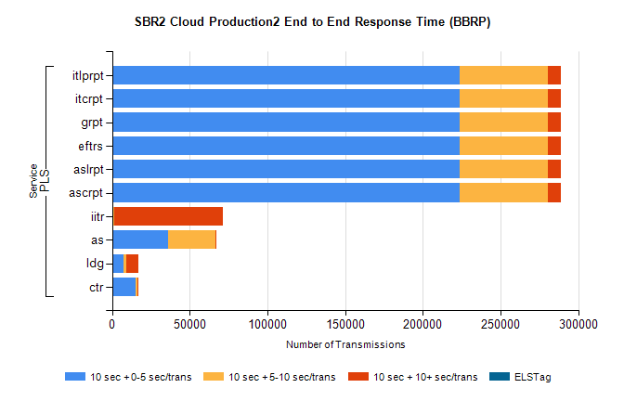
Stream | Service | 10 sec + 0-5 sec /trans | 10 sec + 5-10 sec /trans | 10 sec + >10 sec /trans | Processing Incomplete | ELStag | Total
PLS | ascrpt | 223878 | 56643 | 8172 | 12 | 0 | 295285
PLS | aslrpt | 223878 | 56643 | 8172 | 12 | 0 | 295285
PLS | eftrs | 223878 | 56643 | 8172 | 12 | 0 | 295285
PLS | grpt | 223878 | 56643 | 8172 | 12 | 0 | 295285
PLS | itcrpt | 223878 | 56643 | 8172 | 12 | 0 | 295285
PLS | itlprpt | 223878 | 56643 | 8172 | 12 | 0 | 295285
PLS | iitr | 1147 | 339 | 70142 | 113 | 0 | 72752
PLS | as | 36250 | 30606 | 251 | 727 | 0 | 68053
PLS | ldg | 7316 | 1702 | 7819 | 19 | 0 | 17804
PLS | ctr | 15207 | 1082 | 15 | 6 | 0 | 16337

SBR2 Cloud Production2 - ...

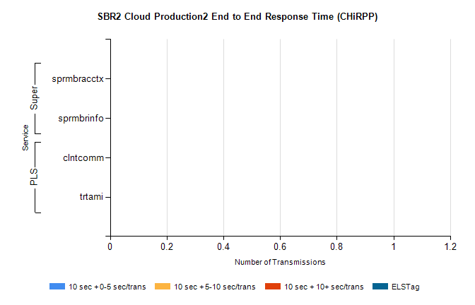
Stream | Service | 10 sec + 0-5 sec /trans | 10 sec + 5-10 sec /trans | 10 sec + >10 sec /trans | Total | % within 5 sec timing target
PLS | clntcomm | 0 | 0 | 0 | 16908 | 0.0%
PLS | trtami | 0 | 0 | 0 | 76 | 0.0%
Super | sprmbracctx | 0 | 0 | 0 | 3411 | 0.0%
Super | sprmbrinfo | 0 | 0 | 0 | 2723 | 0.0%

SBR1 Production Transactions

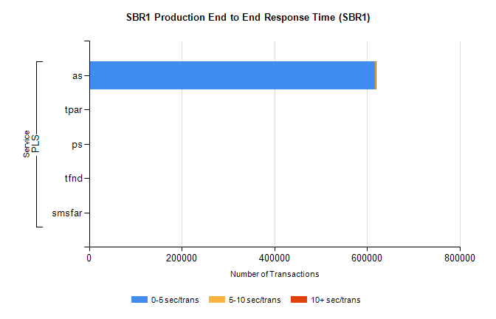
Stream | Service | 0-5 sec/trans | 5-10 sec/trans | 10+ sec/trans | Total | % within 5 sec timing target
PLS | as | 618039 | 182 | 842 | 619063 | 99.8%
PLS | tpar | 405 |  |  | 405 | 100.0%
PLS | ps | 22 | 82 | 128 | 232 | 9.5%
PLS | tfnd | 38 | 8 |  | 46 | 82.6%
PLS | smsfar | 2 | 9 |  | 11 | 18.2%

