Transmission Timings Report Week - 1
30/12/2024 - 5/01/2025

SBR2 External Vendor Testing Environment (EVTE3)

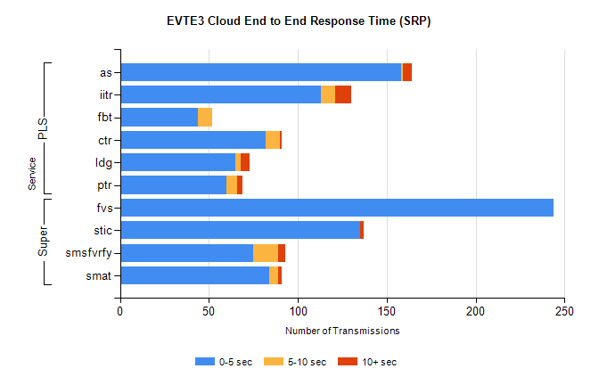
Stream | Service | 0-5 sec | 5-10 sec | >10 sec | Total | % within 5 sec timing target
PLS | as | 158 | 1 | 5 | 182 | 86.8%
PLS | iitr | 113 | 8 | 9 | 130 | 86.9%
PLS | fbt | 44 | 8 | 0 | 93 | 47.3%
PLS | ctr | 82 | 8 | 1 | 91 | 90.1%
PLS | ldg | 65 | 3 | 5 | 75 | 86.7%
PLS | ptr | 60 | 6 | 3 | 71 | 84.5%
Super | fvs | 244 | 0 | 0 | 244 | 100.0%
Super | stic | 135 | 0 | 2 | 137 | 98.5%
Super | smsfvrfy | 75 | 14 | 4 | 93 | 80.6%
Super | smat | 84 | 5 | 2 | 91 | 92.3%

SBR2 External Vendor Testing Environment (EVTE3)

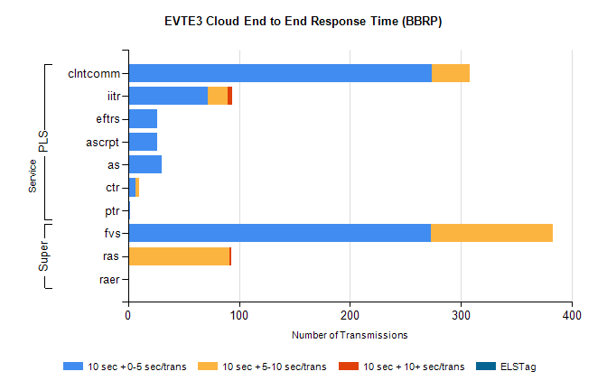
Stream | Service | 10 sec + 0-5 sec /trans | 10 sec + 5-10 sec /trans | 10 sec + >10 sec /trans | Processing Incomplete | ELStag | Total
Super | fvs | 273 | 110 | 0 | 0 | 0 | 390
Super | ras | 0 | 91 | 2 | 109 | 0 | 219
Super | raer | 0 | 0 | 0 | 44 | 0 | 44
PLS | clntcomm | 274 | 34 | 0 | 0 | 0 | 308
PLS | iitr | 72 | 18 | 4 | 0 | 0 | 106
PLS | ascrpt | 26 | 0 | 0 | 8 | 0 | 34
PLS | eftrs | 26 | 0 | 0 | 8 | 0 | 34
PLS | as | 30 | 0 | 0 | 0 | 0 | 30
PLS | ctr | 7 | 3 | 0 | 18 | 0 | 28
PLS | ptr | 2 | 0 | 0 | 25 | 0 | 27

