Transmission Timings Report Week - 1
30/12/2024 - 5/01/2025

SBR2 Cloud Production2 - Single Requests (SRP)

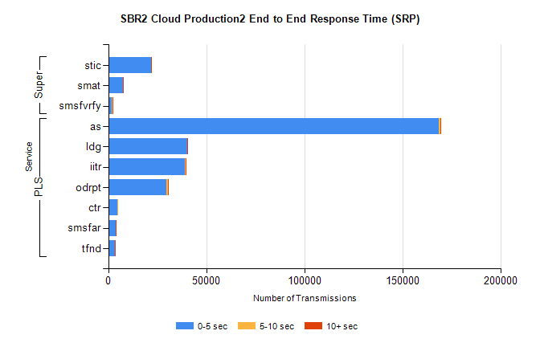
Stream | Service | 0-5 sec | 5-10 sec | >10 sec | Total | % within 5 sec timing target
PLS | as | 168748 | 551 | 236 | 169535 | 99.5%
PLS | ldg | 40213 | 85 | 37 | 40335 | 99.7%
PLS | iitr | 38929 | 435 | 74 | 39438 | 98.7%
PLS | odrpt | 29771 | 708 | 111 | 30590 | 97.3%
PLS | ctr | 4522 | 27 | 0 | 4549 | 99.4%
PLS | smsfar | 3704 | 33 | 7 | 3744 | 98.9%
PLS | tfnd | 3362 | 18 | 1 | 3381 | 99.4%
Super | stic | 21744 | 113 | 31 | 21888 | 99.3%
Super | smat | 7418 | 110 | 24 | 7552 | 98.2%
Super | smsfvrfy | 1946 | 43 | 15 | 2004 | 97.1%

SBR2 Cloud Production2 - Bulk or Batch Requests (BBRP)

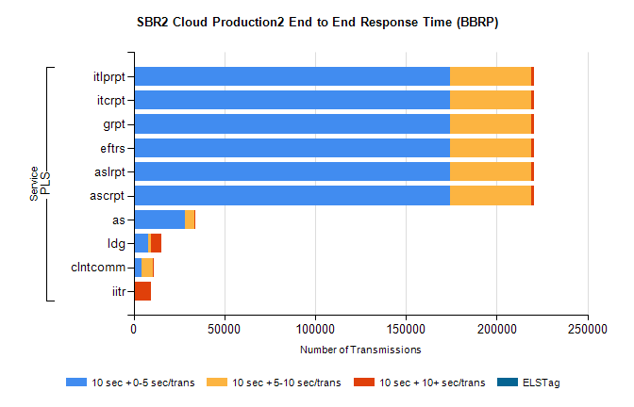
Stream | Service | 10 sec + 0-5 sec /trans | 10 sec + 5-10 sec /trans | 10 sec + >10 sec /trans | Processing Incomplete | ELStag | Total
PLS | ascrpt | 174274 | 44906 | 1181 | 5 | 0 | 224052
PLS | aslrpt | 174274 | 44906 | 1181 | 5 | 0 | 224052
PLS | eftrs | 174274 | 44906 | 1181 | 5 | 0 | 224052
PLS | grpt | 174274 | 44906 | 1181 | 5 | 0 | 224052
PLS | itcrpt | 174274 | 44906 | 1181 | 5 | 0 | 224052
PLS | itlprpt | 174274 | 44906 | 1181 | 5 | 0 | 224052
PLS | as | 28023 | 5272 | 91 | 41 | 0 | 33482
PLS | ldg | 7982 | 1418 | 5621 | 27 | 0 | 16239
PLS | clntcomm | 4187 | 6554 | 346 | 0 | 0 | 11463
PLS | iitr | 345 | 53 | 9276 | 21 | 0 | 9765

SBR2 Cloud Production2 - ...

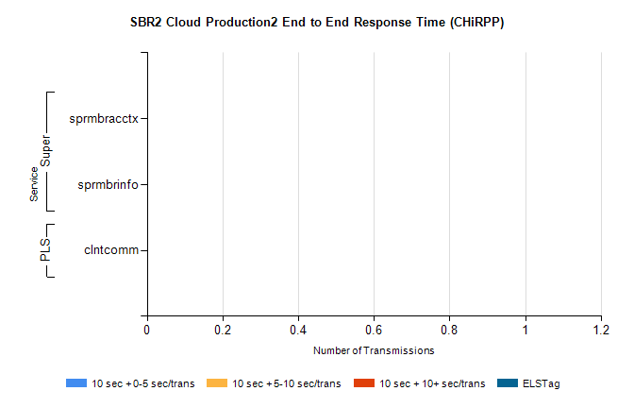
Stream | Service | 10 sec + 0-5 sec /trans | 10 sec + 5-10 sec /trans | 10 sec + >10 sec /trans | Total | % within 5 sec timing target
Super | sprmbracctx | 0 | 0 | 0 | 2474 | 0.0%
Super | sprmbrinfo | 0 | 0 | 0 | 1987 | 0.0%
PLS | clntcomm | 0 | 0 | 0 | 3231 | 0.0%

SBR1 Production Transactions

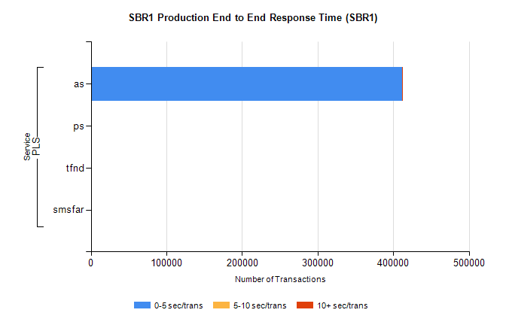
Stream | Service | 0-5 sec/trans | 5-10 sec/trans | 10+ sec/trans | Total | % within 5 sec timing target
PLS | as | 411543 | 154 | 42 | 411739 | 100.0%
PLS | ps | 1 | 6 | 16 | 23 | 4.3%
PLS | tfnd | 5 | 8 | 1 | 14 | 35.7%
PLS | smsfar |  | 6 |  | 6 | 0.0%

