Transmission Timings Report Week - 2
6/01/2025 - 12/01/2025

SBR2 External Vendor Testing Environment (EVTE3)

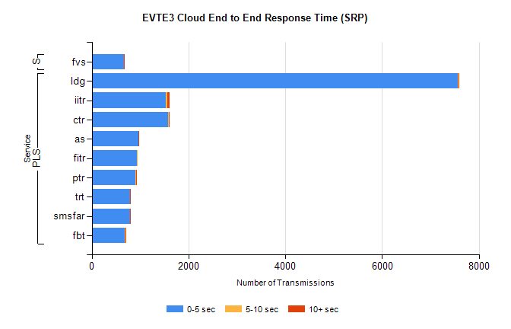
Stream | Service | 0-5 sec | 5-10 sec | >10 sec | Total | % within 5 sec timing target
PLS | ldg | 7565 | 9 | 9 | 7593 | 99.6%
PLS | iitr | 1532 | 38 | 39 | 1614 | 94.9%
PLS | ctr | 1571 | 27 | 6 | 1611 | 97.5%
PLS | as | 958 | 11 | 2 | 999 | 95.9%
PLS | fitr | 936 | 2 | 0 | 939 | 99.7%
PLS | ptr | 905 | 15 | 7 | 933 | 97.0%
PLS | trt | 788 | 8 | 7 | 807 | 97.6%
PLS | smsfar | 786 | 8 | 7 | 801 | 98.1%
PLS | fbt | 677 | 24 | 1 | 771 | 87.8%
Super | fvs | 666 | 2 | 1 | 681 | 97.8%

SBR2 External Vendor Testing Environment (EVTE3)

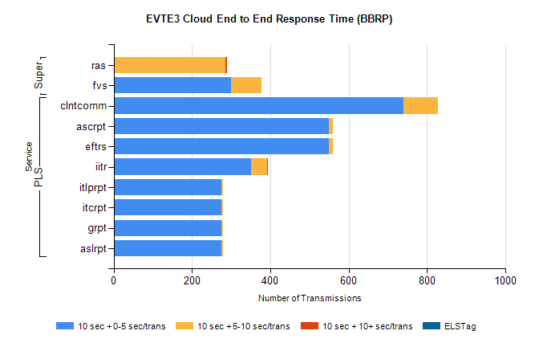
Stream | Service | 10 sec + 0-5 sec /trans | 10 sec + 5-10 sec /trans | 10 sec + >10 sec /trans | Processing Incomplete | ELStag | Total
PLS | clntcomm | 740 | 89 | 0 | 0 | 0 | 829
PLS | eftrs | 550 | 10 | 0 | 20 | 0 | 580
PLS | ascrpt | 550 | 10 | 0 | 20 | 0 | 580
PLS | iitr | 352 | 39 | 1 | 0 | 0 | 404
PLS | aslrpt | 275 | 5 | 0 | 10 | 0 | 290
PLS | grpt | 275 | 5 | 0 | 10 | 0 | 290
PLS | itcrpt | 275 | 5 | 0 | 10 | 0 | 290
PLS | itlprpt | 275 | 5 | 0 | 10 | 0 | 290
Super | ras | 1 | 285 | 4 | 201 | 0 | 501
Super | fvs | 300 | 77 | 0 | 1 | 0 | 384

