Transmission Timings Report Week - 3
13/01/2025 - 19/01/2025

SBR2 External Vendor Testing Environment (EVTE3)

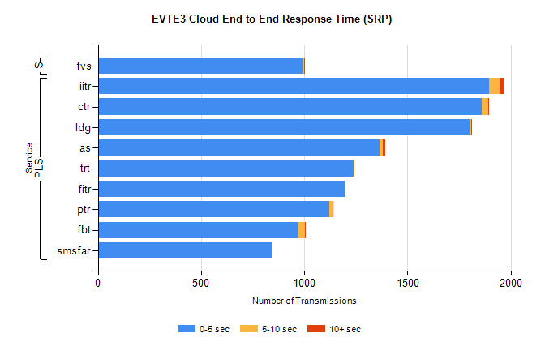
Stream | Service | 0-5 sec | 5-10 sec | >10 sec | Total | % within 5 sec timing target
PLS | iitr | 1895 | 52 | 18 | 1966 | 96.4%
PLS | ctr | 1861 | 31 | 3 | 1896 | 98.2%
PLS | ldg | 1802 | 8 | 4 | 1824 | 98.8%
PLS | as | 1364 | 16 | 12 | 1452 | 93.9%
PLS | trt | 1240 | 4 | 0 | 1248 | 99.4%
PLS | fitr | 1198 | 0 | 0 | 1198 | 100.0%
PLS | ptr | 1120 | 18 | 1 | 1159 | 96.6%
PLS | fbt | 973 | 32 | 1 | 1010 | 96.3%
PLS | smsfar | 846 | 0 | 0 | 846 | 100.0%
Super | fvs | 994 | 4 | 1 | 999 | 99.5%

SBR2 External Vendor Testing Environment (EVTE3)

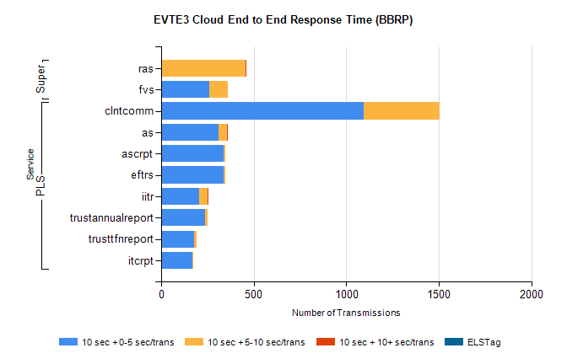
Stream | Service | 10 sec + 0-5 sec /trans | 10 sec + 5-10 sec /trans | 10 sec + >10 sec /trans | Processing Incomplete | ELStag | Total
PLS | clntcomm | 1092 | 411 | 0 | 0 | 0 | 1537
PLS | as | 309 | 45 | 1 | 0 | 0 | 355
PLS | eftrs | 336 | 12 | 0 | 4 | 0 | 352
PLS | ascrpt | 336 | 12 | 0 | 4 | 0 | 352
PLS | iitr | 204 | 48 | 4 | 0 | 0 | 258
PLS | trustannualreport | 238 | 14 | 0 | 0 | 0 | 252
PLS | trusttfnreport | 176 | 16 | 0 | 0 | 0 | 193
PLS | itcrpt | 168 | 6 | 0 | 2 | 0 | 176
Super | ras | 0 | 455 | 4 | 0 | 0 | 475
Super | fvs | 262 | 100 | 0 | 0 | 0 | 372

