Transmission Timings Report Week - 3
13/01/2025 - 19/01/2025

SBR2 Cloud Production2 - Single Requests (SRP)

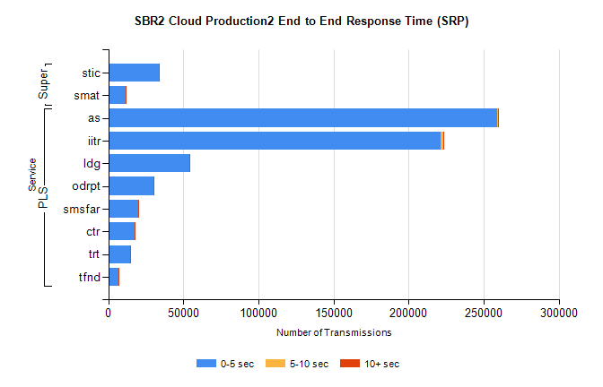
Stream | Service | 0-5 sec | 5-10 sec | >10 sec | Total | % within 5 sec timing target
PLS | as | 259125 | 678 | 165 | 260045 | 99.6%
PLS | iitr | 221435 | 1482 | 324 | 223359 | 99.1%
PLS | ldg | 54189 | 84 | 38 | 54321 | 99.8%
PLS | odrpt | 29873 | 519 | 66 | 30459 | 98.1%
PLS | smsfar | 20083 | 43 | 32 | 20170 | 99.6%
PLS | ctr | 17341 | 34 | 16 | 17398 | 99.7%
PLS | trt | 14366 | 47 | 16 | 14436 | 99.5%
PLS | tfnd | 6950 | 22 | 3 | 6977 | 99.6%
Super | stic | 33478 | 149 | 54 | 33690 | 99.4%
Super | smat | 11478 | 126 | 47 | 11653 | 98.5%

SBR2 Cloud Production2 - Bulk or Batch Requests (BBRP)

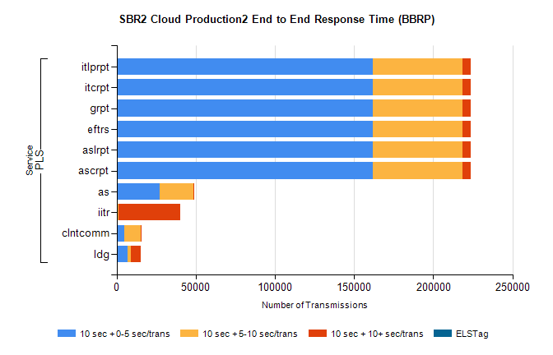
Stream | Service | 10 sec + 0-5 sec /trans | 10 sec + 5-10 sec /trans | 10 sec + >10 sec /trans | Processing Incomplete | ELStag | Total
PLS | ascrpt | 161838 | 56566 | 5487 | 19 | 0 | 228284
PLS | aslrpt | 161838 | 56566 | 5487 | 19 | 0 | 228284
PLS | eftrs | 161838 | 56566 | 5487 | 19 | 0 | 228284
PLS | grpt | 161838 | 56566 | 5487 | 19 | 0 | 228284
PLS | itcrpt | 161838 | 56566 | 5487 | 19 | 0 | 228284
PLS | itlprpt | 161838 | 56566 | 5487 | 19 | 0 | 228284
PLS | as | 27331 | 21268 | 43 | 413 | 0 | 49142
PLS | iitr | 762 | 192 | 39367 | 122 | 0 | 40929
PLS | clntcomm | 4878 | 10426 | 480 | 0 | 0 | 16466
PLS | ldg | 7067 | 1702 | 6482 | 14 | 0 | 16310

SBR2 Cloud Production2 - ...

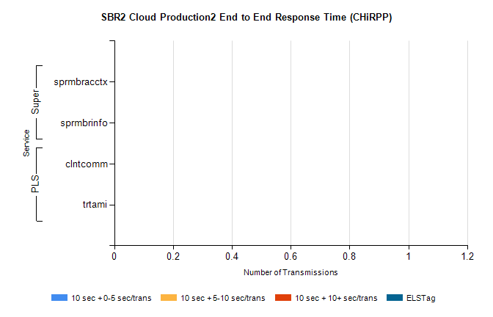
Stream | Service | 10 sec + 0-5 sec /trans | 10 sec + 5-10 sec /trans | 10 sec + >10 sec /trans | Total | % within 5 sec timing target
PLS | clntcomm | 0 | 0 | 0 | 39451 | 0.0%
PLS | trtami | 0 | 0 | 0 | 12 | 0.0%
Super | sprmbracctx | 0 | 0 | 0 | 3159 | 0.0%
Super | sprmbrinfo | 0 | 0 | 0 | 2707 | 0.0%

SBR1 Production Transactions

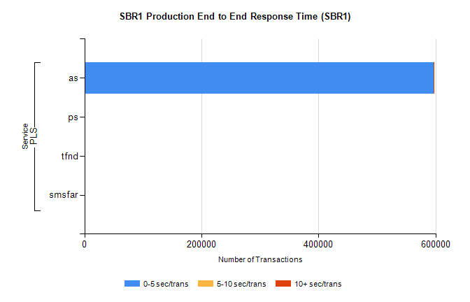
Stream | Service | 0-5 sec/trans | 5-10 sec/trans | 10+ sec/trans | Total | % within 5 sec timing target
PLS | as | 596613 | 273 | 772 | 597658 | 99.8%
PLS | ps | 23 | 54 | 90 | 167 | 13.8%
PLS | tfnd | 11 | 7 |  | 18 | 61.1%
PLS | smsfar |  | 5 |  | 5 | 0.0%

