Transmission Timings Report Week - 4
20/01/2025 - 26/01/2025

SBR2 External Vendor Testing Environment (EVTE3)

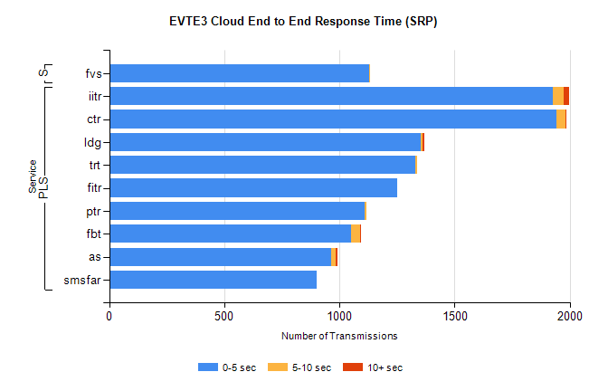
Stream | Service | 0-5 sec | 5-10 sec | >10 sec | Total | % within 5 sec timing target
PLS | iitr | 1928 | 46 | 24 | 2014 | 95.7%
PLS | ctr | 1944 | 36 | 1 | 1998 | 97.3%
PLS | ldg | 1351 | 11 | 8 | 1381 | 97.8%
PLS | trt | 1331 | 8 | 0 | 1367 | 97.4%
PLS | fitr | 1249 | 0 | 0 | 1251 | 99.8%
PLS | ptr | 1111 | 6 | 0 | 1139 | 97.5%
PLS | fbt | 1051 | 39 | 1 | 1098 | 95.7%
PLS | as | 966 | 17 | 7 | 1041 | 92.8%
PLS | smsfar | 901 | 0 | 0 | 905 | 99.6%
Super | fvs | 1128 | 3 | 0 | 1131 | 99.7%

SBR2 External Vendor Testing Environment (EVTE3)

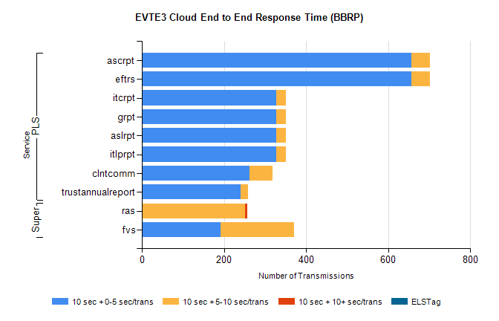
Stream | Service | 10 sec + 0-5 sec /trans | 10 sec + 5-10 sec /trans | 10 sec + >10 sec /trans | Processing Incomplete | ELStag | Total
PLS | eftrs | 656 | 46 | 0 | 0 | 0 | 704
PLS | ascrpt | 656 | 46 | 0 | 0 | 0 | 704
PLS | itlprpt | 328 | 23 | 0 | 0 | 0 | 352
PLS | aslrpt | 328 | 23 | 0 | 0 | 0 | 352
PLS | grpt | 328 | 23 | 0 | 0 | 0 | 352
PLS | itcrpt | 328 | 23 | 0 | 0 | 0 | 352
PLS | clntcomm | 262 | 57 | 0 | 0 | 0 | 328
PLS | trustannualreport | 240 | 19 | 0 | 0 | 0 | 259
Super | ras | 0 | 252 | 5 | 146 | 0 | 423
Super | fvs | 191 | 179 | 0 | 0 | 0 | 379

