Transmission Timings Report Week - 4
20/01/2025 - 26/01/2025

SBR2 Cloud Production2 - Single Requests (SRP)

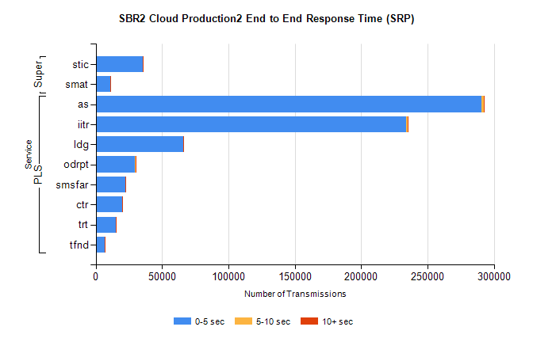
Stream | Service | 0-5 sec | 5-10 sec | >10 sec | Total | % within 5 sec timing target
PLS | as | 290860 | 1569 | 490 | 292966 | 99.3%
PLS | iitr | 233588 | 1274 | 701 | 235605 | 99.1%
PLS | ldg | 65793 | 92 | 82 | 65978 | 99.7%
PLS | odrpt | 29633 | 719 | 121 | 30474 | 97.2%
PLS | smsfar | 22540 | 47 | 70 | 22660 | 99.5%
PLS | ctr | 19729 | 40 | 39 | 19814 | 99.6%
PLS | trt | 15442 | 29 | 42 | 15515 | 99.5%
PLS | tfnd | 7013 | 16 | 17 | 7050 | 99.5%
Super | stic | 35229 | 134 | 100 | 35474 | 99.3%
Super | smat | 10750 | 95 | 47 | 10893 | 98.7%

SBR2 Cloud Production2 - Bulk or Batch Requests (BBRP)

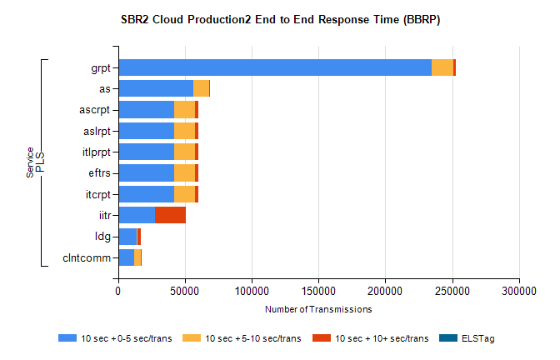
Stream | Service | 10 sec + 0-5 sec /trans | 10 sec + 5-10 sec /trans | 10 sec + >10 sec /trans | Processing Incomplete | ELStag | Total
PLS | grpt | 234785 | 15864 | 2255 | 29 | 0 | 254413
PLS | as | 56309 | 12069 | 71 | 92 | 0 | 68614
PLS | ascrpt | 41912 | 15863 | 2254 | 15 | 0 | 61519
PLS | aslrpt | 41918 | 15851 | 2254 | 15 | 0 | 61512
PLS | itlprpt | 41912 | 15844 | 2253 | 15 | 0 | 61499
PLS | eftrs | 41908 | 15842 | 2252 | 14 | 0 | 61488
PLS | itcrpt | 41892 | 15852 | 2249 | 15 | 0 | 61478
PLS | iitr | 27786 | 148 | 22823 | 57 | 0 | 51292
PLS | ldg | 14020 | 518 | 2247 | 20 | 0 | 17175
PLS | clntcomm | 12266 | 4548 | 100 | 0 | 0 | 17127

SBR2 Cloud Production2 - ...

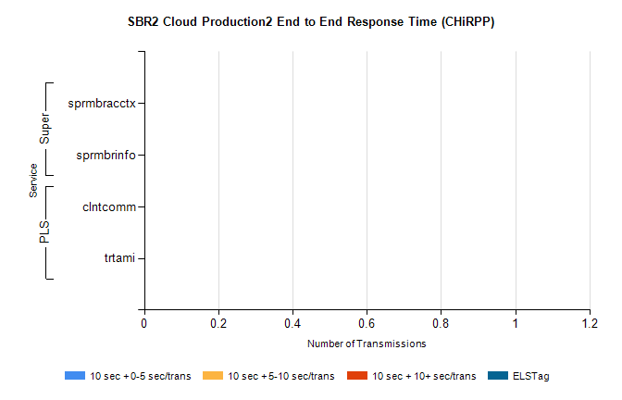
Stream | Service | 10 sec + 0-5 sec /trans | 10 sec + 5-10 sec /trans | 10 sec + >10 sec /trans | Total | % within 5 sec timing target
PLS | clntcomm | 0 | 0 | 0 | 24647 | 0.0%
PLS | trtami | 0 | 0 | 0 | 8 | 0.0%
Super | sprmbracctx | 0 | 0 | 0 | 8093 | 0.0%
Super | sprmbrinfo | 0 | 0 | 0 | 2581 | 0.0%

SBR1 Production Transactions

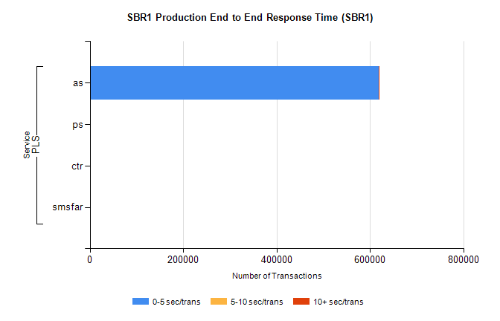
Stream | Service | 0-5 sec/trans | 5-10 sec/trans | 10+ sec/trans | Total | % within 5 sec timing target
PLS | as | 618580 | 376 | 2049 | 621005 | 99.6%
PLS | ps | 17 | 38 | 90 | 145 | 11.7%
PLS | ctr | 1 | 3 | 18 | 22 | 4.5%
PLS | smsfar |  | 6 | 1 | 7 | 0.0%

