Transmission Timings Report Week - 51
16/12/2024 - 22/12/2024

SBR2 External Vendor Testing Environment (EVTE3)

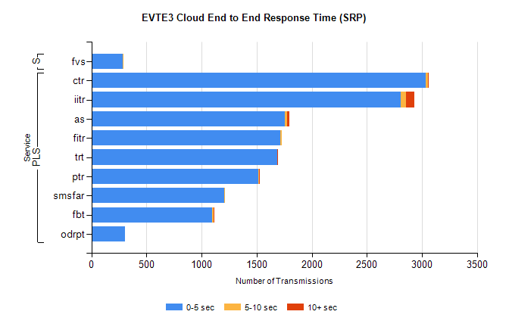
Stream | Service | 0-5 sec | 5-10 sec | >10 sec | Total | % within 5 sec timing target
PLS | ctr | 3032 | 23 | 2 | 3058 | 99.1%
PLS | iitr | 2805 | 48 | 78 | 2934 | 95.6%
PLS | as | 1757 | 22 | 15 | 1866 | 94.2%
PLS | fitr | 1716 | 12 | 0 | 1728 | 99.3%
PLS | trt | 1685 | 4 | 1 | 1701 | 99.1%
PLS | ptr | 1518 | 3 | 1 | 1522 | 99.7%
PLS | smsfar | 1209 | 1 | 0 | 1210 | 99.9%
PLS | fbt | 1094 | 17 | 3 | 1118 | 97.9%
PLS | odrpt | 307 | 0 | 0 | 309 | 99.4%
Super | fvs | 283 | 2 | 0 | 285 | 99.3%

SBR2 External Vendor Testing Environment (EVTE3)

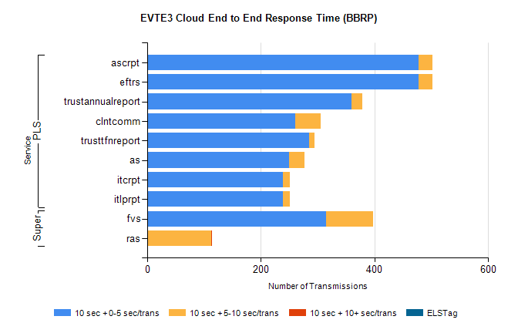
Stream | Service | 10 sec + 0-5 sec /trans | 10 sec + 5-10 sec /trans | 10 sec + >10 sec /trans | Processing Incomplete | ELStag | Total
PLS | eftrs | 478 | 24 | 0 | 0 | 0 | 502
PLS | ascrpt | 478 | 24 | 0 | 0 | 0 | 502
PLS | trustannualreport | 360 | 18 | 0 | 0 | 0 | 380
PLS | clntcomm | 261 | 44 | 0 | 0 | 0 | 305
PLS | trusttfnreport | 285 | 10 | 0 | 0 | 0 | 295
PLS | as | 250 | 27 | 0 | 1 | 0 | 278
PLS | itlprpt | 239 | 12 | 0 | 0 | 0 | 251
PLS | itcrpt | 239 | 12 | 0 | 0 | 0 | 251
Super | fvs | 315 | 83 | 0 | 0 | 0 | 407
Super | ras | 0 | 113 | 1 | 145 | 0 | 275

