Transmission Timings Report Week - 51
16/12/2024 - 22/12/2024

SBR2 Cloud Production2 - Single Requests (SRP)

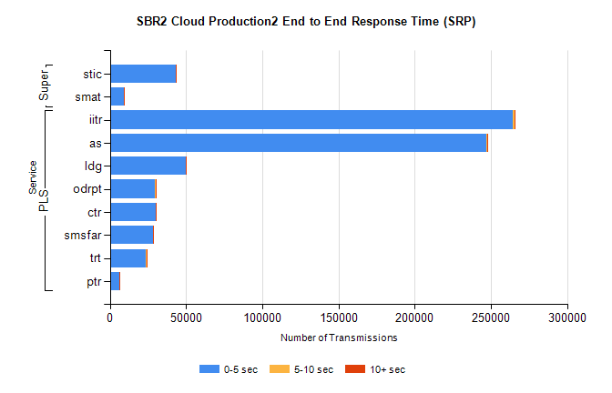
Stream | Service | 0-5 sec | 5-10 sec | >10 sec | Total | % within 5 sec timing target
PLS | iitr | 264412 | 1344 | 280 | 266063 | 99.4%
PLS | as | 246772 | 604 | 164 | 247567 | 99.7%
PLS | ldg | 49877 | 80 | 17 | 49975 | 99.8%
PLS | odrpt | 29617 | 731 | 85 | 30433 | 97.3%
PLS | ctr | 30173 | 64 | 18 | 30258 | 99.7%
PLS | smsfar | 28406 | 52 | 29 | 28492 | 99.7%
PLS | trt | 23838 | 66 | 33 | 23938 | 99.6%
PLS | ptr | 6154 | 10 | 18 | 6183 | 99.5%
Super | stic | 43196 | 181 | 61 | 43440 | 99.4%
Super | smat | 8967 | 67 | 25 | 9059 | 99.0%

SBR2 Cloud Production2 - Bulk or Batch Requests (BBRP)

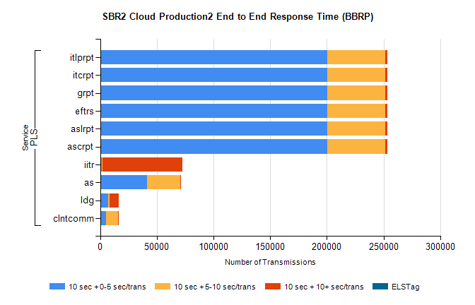
Stream | Service | 10 sec + 0-5 sec /trans | 10 sec + 5-10 sec /trans | 10 sec + >10 sec /trans | Processing Incomplete | ELStag | Total
PLS | ascrpt | 200427 | 50959 | 2238 | 27 | 0 | 257708
PLS | aslrpt | 200427 | 50959 | 2238 | 27 | 0 | 257708
PLS | eftrs | 200427 | 50959 | 2238 | 27 | 0 | 257708
PLS | grpt | 200427 | 50959 | 2238 | 27 | 0 | 257708
PLS | itcrpt | 200427 | 50959 | 2238 | 27 | 0 | 257708
PLS | itlprpt | 200427 | 50959 | 2238 | 27 | 0 | 257708
PLS | iitr | 1131 | 705 | 70835 | 461 | 0 | 76052
PLS | as | 41057 | 29331 | 887 | 328 | 0 | 71822
PLS | ldg | 7120 | 1294 | 7857 | 28 | 0 | 17356
PLS | clntcomm | 5207 | 10832 | 381 | 0 | 0 | 17090

SBR2 Cloud Production2 - ...

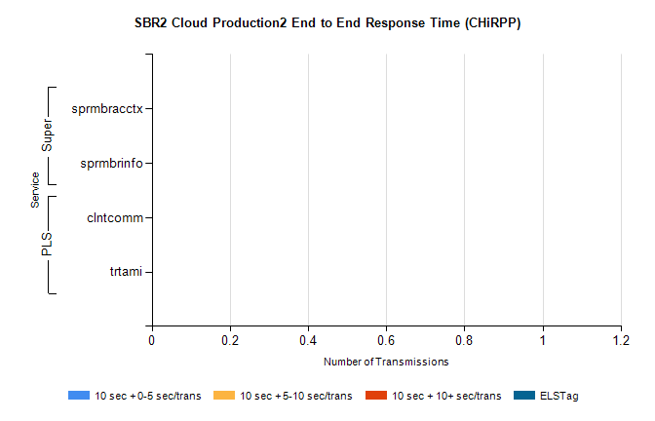
Stream | Service | 10 sec + 0-5 sec /trans | 10 sec + 5-10 sec /trans | 10 sec + >10 sec /trans | Total | % within 5 sec timing target
PLS | clntcomm | 0 | 0 | 0 | 19281 | 0.0%
PLS | trtami | 0 | 0 | 0 | 40 | 0.0%
Super | sprmbracctx | 0 | 0 | 0 | 3284 | 0.0%
Super | sprmbrinfo | 0 | 0 | 0 | 2925 | 0.0%

SBR1 Production Transactions

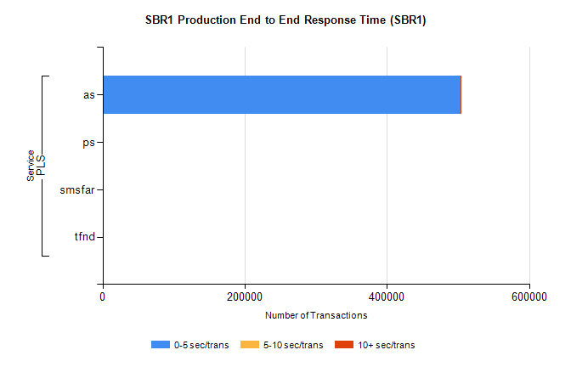
Stream | Service | 0-5 sec/trans | 5-10 sec/trans | 10+ sec/trans | Total | % within 5 sec timing target
PLS | as | 503233 | 230 | 115 | 503578 | 99.9%
PLS | ps | 30 | 52 | 119 | 201 | 14.9%
PLS | smsfar | 4 | 8 | 2 | 14 | 28.6%
PLS | tfnd | 5 | 3 | 4 | 12 | 41.7%

