Transmission Timings Report Week - 52
23/12/2024 - 29/12/2024

SBR2 External Vendor Testing Environment (EVTE3)

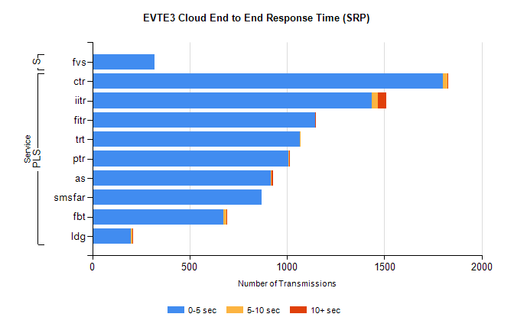
Stream | Service | 0-5 sec | 5-10 sec | >10 sec | Total | % within 5 sec timing target
PLS | ctr | 1800 | 25 | 1 | 1829 | 98.4%
PLS | iitr | 1434 | 32 | 45 | 1511 | 94.9%
PLS | fitr | 1146 | 0 | 1 | 1148 | 99.8%
PLS | trt | 1066 | 1 | 0 | 1074 | 99.3%
PLS | ptr | 1008 | 4 | 1 | 1014 | 99.4%
PLS | as | 917 | 3 | 10 | 940 | 97.6%
PLS | smsfar | 871 | 0 | 0 | 871 | 100.0%
PLS | fbt | 673 | 18 | 1 | 697 | 96.6%
PLS | ldg | 200 | 4 | 7 | 214 | 93.5%
Super | fvs | 321 | 0 | 0 | 321 | 100.0%

SBR2 External Vendor Testing Environment (EVTE3)

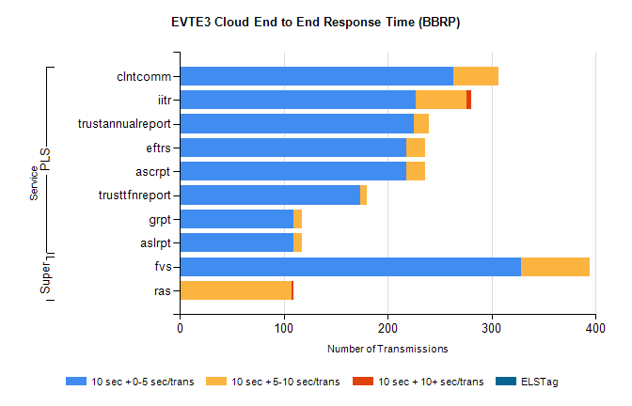
Stream | Service | 10 sec + 0-5 sec /trans | 10 sec + 5-10 sec /trans | 10 sec + >10 sec /trans | Processing Incomplete | ELStag | Total
PLS | clntcomm | 263 | 44 | 0 | 0 | 0 | 308
PLS | iitr | 227 | 49 | 4 | 0 | 0 | 287
PLS | trustannualreport | 225 | 15 | 0 | 0 | 0 | 240
PLS | ascrpt | 218 | 18 | 0 | 0 | 0 | 236
PLS | eftrs | 218 | 18 | 0 | 0 | 0 | 236
PLS | trusttfnreport | 174 | 6 | 0 | 0 | 0 | 180
PLS | aslrpt | 109 | 9 | 0 | 0 | 0 | 118
PLS | grpt | 109 | 9 | 0 | 0 | 0 | 118
Super | fvs | 328 | 66 | 0 | 0 | 0 | 395
Super | ras | 0 | 108 | 1 | 129 | 0 | 257

