Transmission Timings Report Week - 52
23/12/2024 - 29/12/2024

SBR2 Cloud Production2 - Single Requests (SRP)

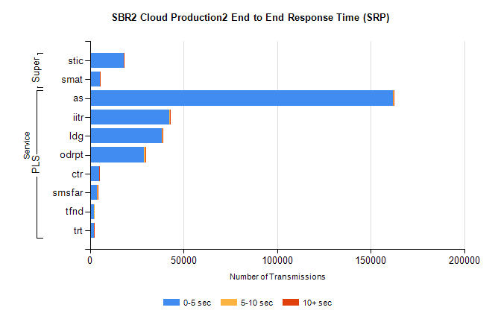
Stream | Service | 0-5 sec | 5-10 sec | >10 sec | Total | % within 5 sec timing target
PLS | as | 161958 | 425 | 14 | 162404 | 99.7%
PLS | iitr | 42227 | 389 | 54 | 42682 | 98.9%
PLS | ldg | 38543 | 67 | 8 | 38618 | 99.8%
PLS | odrpt | 28873 | 674 | 179 | 29727 | 97.1%
PLS | ctr | 4945 | 45 | 2 | 4994 | 99.0%
PLS | smsfar | 3953 | 29 | 2 | 3984 | 99.2%
PLS | tfnd | 2338 | 14 | 0 | 2352 | 99.4%
PLS | trt | 2328 | 18 | 4 | 2350 | 99.1%
Super | stic | 18069 | 98 | 34 | 18201 | 99.3%
Super | smat | 5203 | 89 | 20 | 5312 | 97.9%

SBR2 Cloud Production2 - Bulk or Batch Requests (BBRP)

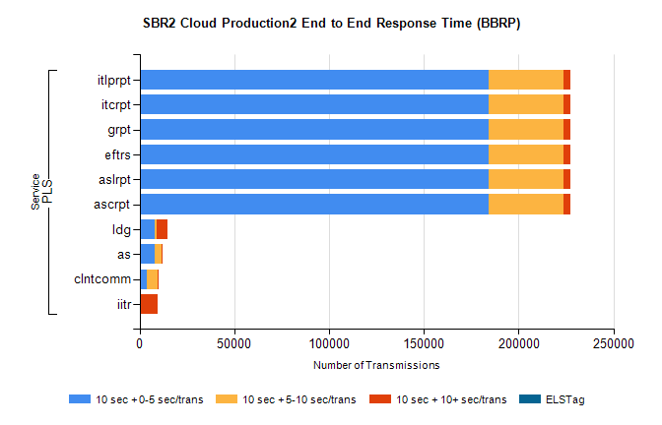
Stream | Service | 10 sec + 0-5 sec /trans | 10 sec + 5-10 sec /trans | 10 sec + >10 sec /trans | Processing Incomplete | ELStag | Total
PLS | ascrpt | 184339 | 39304 | 3791 | 10 | 0 | 230599
PLS | aslrpt | 184339 | 39304 | 3791 | 10 | 0 | 230599
PLS | eftrs | 184339 | 39304 | 3791 | 10 | 0 | 230599
PLS | grpt | 184339 | 39304 | 3791 | 10 | 0 | 230599
PLS | itcrpt | 184339 | 39304 | 3791 | 10 | 0 | 230599
PLS | itlprpt | 184339 | 39304 | 3791 | 10 | 0 | 230599
PLS | ldg | 7797 | 1149 | 5631 | 31 | 0 | 15505
PLS | as | 7789 | 3583 | 6 | 58 | 0 | 11473
PLS | clntcomm | 3863 | 5513 | 287 | 0 | 0 | 9984
PLS | iitr | 325 | 34 | 8900 | 13 | 0 | 9329

SBR2 Cloud Production2 - ...

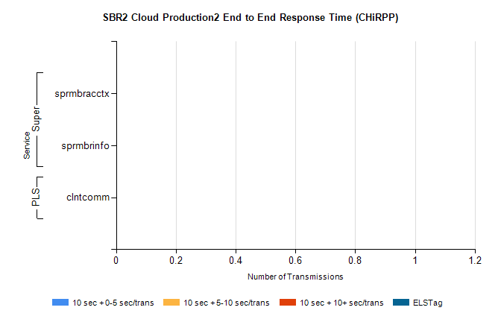
Stream | Service | 10 sec + 0-5 sec /trans | 10 sec + 5-10 sec /trans | 10 sec + >10 sec /trans | Total | % within 5 sec timing target
PLS | clntcomm | 0 | 0 | 0 | 6213 | 0.0%
Super | sprmbracctx | 0 | 0 | 0 | 1982 | 0.0%
Super | sprmbrinfo | 0 | 0 | 0 | 1827 | 0.0%

SBR1 Production Transactions

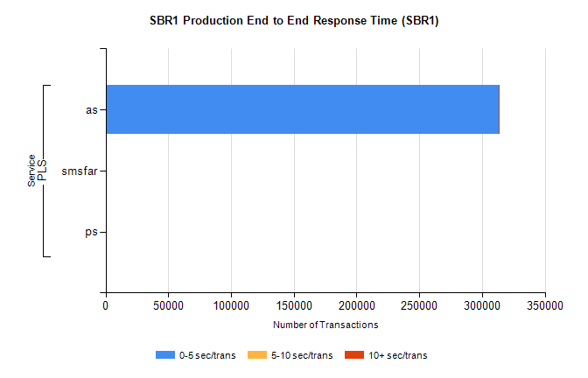
Stream | Service | 0-5 sec/trans | 5-10 sec/trans | 10+ sec/trans | Total | % within 5 sec timing target
PLS | as | 313268 | 279 | 31 | 313578 | 99.9%
PLS | smsfar | 1 | 18 |  | 19 | 5.3%
PLS | ps | 2 | 3 | 8 | 13 | 15.4%

