Transmission Timings Report Week - 5
27/01/2025 - 2/02/2025

SBR2 External Vendor Testing Environment (EVTE3)

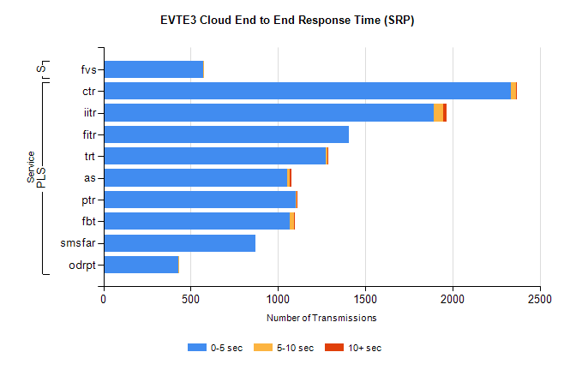
Stream | Service | 0-5 sec | 5-10 sec | >10 sec | Total | % within 5 sec timing target
PLS | ctr | 2334 | 28 | 2 | 2366 | 98.6%
PLS | iitr | 1891 | 57 | 20 | 1970 | 96.0%
PLS | fitr | 1408 | 0 | 0 | 1408 | 100.0%
PLS | trt | 1275 | 7 | 1 | 1317 | 96.8%
PLS | as | 1054 | 13 | 10 | 1141 | 92.4%
PLS | ptr | 1102 | 7 | 1 | 1122 | 98.2%
PLS | fbt | 1069 | 23 | 4 | 1102 | 97.0%
PLS | smsfar | 869 | 0 | 0 | 869 | 100.0%
PLS | odrpt | 427 | 2 | 0 | 429 | 99.5%
Super | fvs | 573 | 4 | 0 | 577 | 99.3%

SBR2 External Vendor Testing Environment (EVTE3)

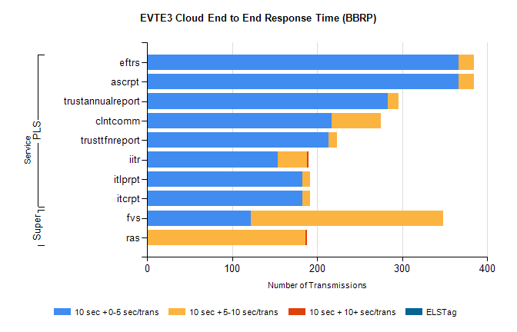
Stream | Service | 10 sec + 0-5 sec /trans | 10 sec + 5-10 sec /trans | 10 sec + >10 sec /trans | Processing Incomplete | ELStag | Total
PLS | ascrpt | 366 | 18 | 0 | 2 | 0 | 386
PLS | eftrs | 366 | 18 | 0 | 2 | 0 | 386
PLS | trustannualreport | 283 | 13 | 0 | 0 | 0 | 296
PLS | clntcomm | 217 | 58 | 0 | 0 | 0 | 275
PLS | trusttfnreport | 213 | 10 | 0 | 0 | 0 | 224
PLS | iitr | 154 | 34 | 2 | 1 | 0 | 201
PLS | itcrpt | 183 | 9 | 0 | 1 | 0 | 193
PLS | itlprpt | 183 | 9 | 0 | 1 | 0 | 193
Super | fvs | 122 | 226 | 0 | 0 | 0 | 372
Super | ras | 0 | 186 | 2 | 13 | 0 | 214

