Transmission Timings Report Week - 5
27/01/2025 - 2/02/2025

SBR2 Cloud Production2 - Single Requests (SRP)

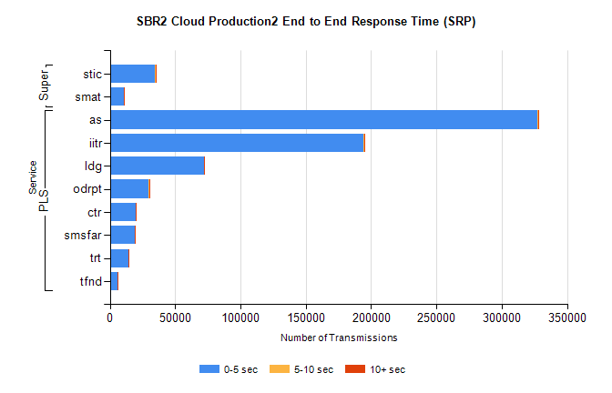
Stream | Service | 0-5 sec | 5-10 sec | >10 sec | Total | % within 5 sec timing target
PLS | as | 327285 | 805 | 231 | 328334 | 99.7%
PLS | iitr | 193963 | 1144 | 244 | 195381 | 99.3%
PLS | ldg | 71858 | 135 | 26 | 72021 | 99.8%
PLS | odrpt | 29750 | 630 | 72 | 30452 | 97.7%
PLS | ctr | 19762 | 56 | 16 | 19836 | 99.6%
PLS | smsfar | 18935 | 49 | 40 | 19033 | 99.5%
PLS | trt | 14393 | 47 | 20 | 14461 | 99.5%
PLS | tfnd | 5895 | 17 | 2 | 5915 | 99.7%
Super | stic | 34705 | 193 | 87 | 34987 | 99.2%
Super | smat | 10549 | 147 | 48 | 10748 | 98.1%

SBR2 Cloud Production2 - Bulk or Batch Requests (BBRP)

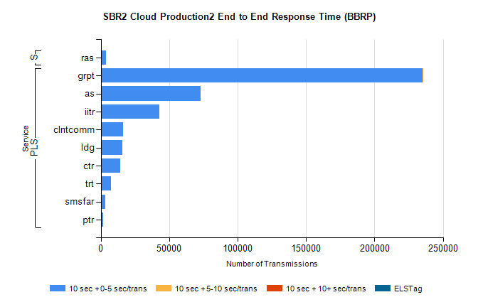
Stream | Service | 10 sec + 0-5 sec /trans | 10 sec + 5-10 sec /trans | 10 sec + >10 sec /trans | Processing Incomplete | ELStag | Total
PLS | grpt | 234993 | 46 | 0 | 0 | 0 | 235058
PLS | as | 72731 | 0 | 0 | 0 | 0 | 72731
PLS | iitr | 42787 | 0 | 0 | 0 | 0 | 42787
PLS | clntcomm | 16237 | 0 | 0 | 0 | 0 | 16237
PLS | ldg | 15741 | 0 | 0 | 0 | 0 | 15741
PLS | ctr | 14263 | 0 | 0 | 0 | 0 | 14263
PLS | trt | 7384 | 0 | 0 | 0 | 0 | 7384
PLS | smsfar | 3480 | 0 | 0 | 0 | 0 | 3480
PLS | ptr | 1602 | 0 | 0 | 0 | 0 | 1602
Super | ras | 3729 | 0 | 0 | 0 | 0 | 3729

SBR2 Cloud Production2 - ...

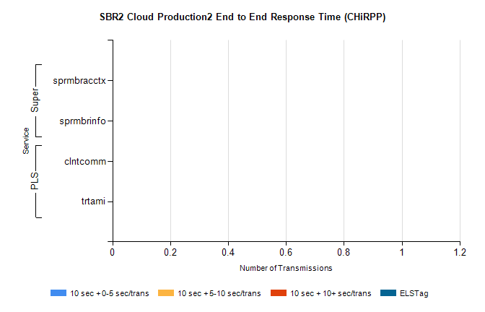
Stream | Service | 10 sec + 0-5 sec /trans | 10 sec + 5-10 sec /trans | 10 sec + >10 sec /trans | Total | % within 5 sec timing target
PLS | clntcomm | 0 | 0 | 0 | 18884 | 0.0%
PLS | trtami | 0 | 0 | 0 | 67 | 0.0%
Super | sprmbracctx | 0 | 0 | 0 | 2938 | 0.0%
Super | sprmbrinfo | 0 | 0 | 0 | 2190 | 0.0%

SBR1 Production Transactions

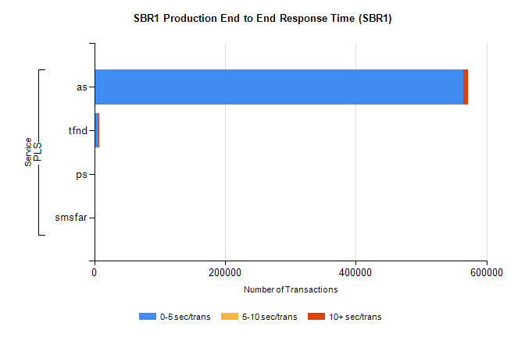
Stream | Service | 0-5 sec/trans | 5-10 sec/trans | 10+ sec/trans | Total | % within 5 sec timing target
PLS | as | 564288 | 210 | 7030 | 571528 | 98.7%
PLS | tfnd | 6078 | 53 | 6 | 6137 | 99.0%
PLS | ps | 186 | 50 | 89 | 325 | 57.2%
PLS | smsfar | 5 | 16 | 1 | 22 | 22.7%

