Transmission Timings Report Week - 6
3/02/2025 - 9/02/2025

SBR2 External Vendor Testing Environment (EVTE3)

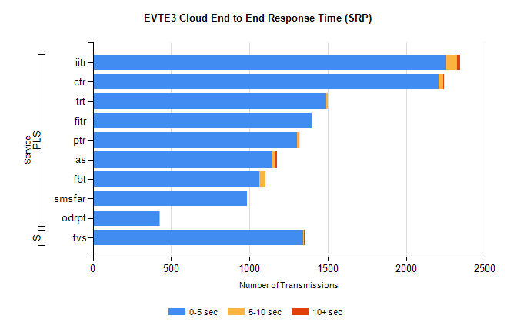
Stream | Service | 0-5 sec | 5-10 sec | >10 sec | Total | % within 5 sec timing target
PLS | iitr | 2258 | 65 | 23 | 2348 | 96.2%
PLS | ctr | 2206 | 28 | 2 | 2238 | 98.6%
PLS | trt | 1492 | 9 | 0 | 1536 | 97.1%
PLS | fitr | 1395 | 0 | 0 | 1395 | 100.0%
PLS | ptr | 1302 | 13 | 2 | 1381 | 94.3%
PLS | as | 1144 | 23 | 9 | 1208 | 94.7%
PLS | fbt | 1063 | 40 | 0 | 1110 | 95.8%
PLS | smsfar | 984 | 0 | 0 | 984 | 100.0%
PLS | odrpt | 423 | 2 | 0 | 438 | 96.6%
Super | fvs | 1341 | 7 | 1 | 1349 | 99.4%

SBR2 External Vendor Testing Environment (EVTE3)

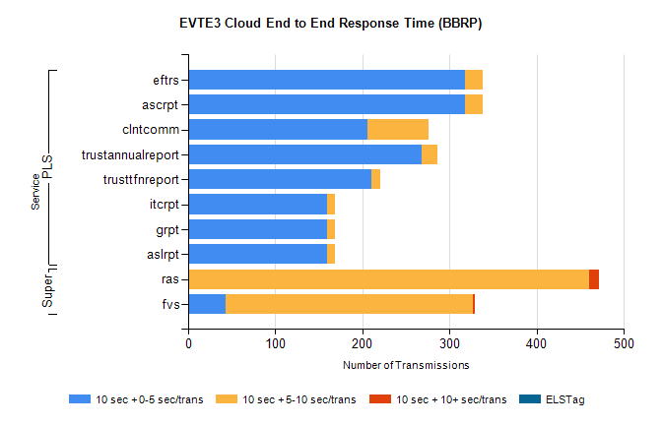
Stream | Service | 10 sec + 0-5 sec /trans | 10 sec + 5-10 sec /trans | 10 sec + >10 sec /trans | Processing Incomplete | ELStag | Total
PLS | ascrpt | 318 | 20 | 0 | 0 | 0 | 338
PLS | eftrs | 318 | 20 | 0 | 0 | 0 | 338
PLS | clntcomm | 206 | 70 | 0 | 46 | 0 | 322
PLS | trustannualreport | 268 | 18 | 0 | 0 | 0 | 286
PLS | trusttfnreport | 210 | 11 | 0 | 0 | 0 | 221
PLS | aslrpt | 159 | 10 | 0 | 0 | 0 | 169
PLS | grpt | 159 | 10 | 0 | 0 | 0 | 169
PLS | itcrpt | 159 | 10 | 0 | 0 | 0 | 169
Super | ras | 0 | 460 | 12 | 0 | 0 | 492
Super | fvs | 43 | 284 | 2 | 8 | 0 | 374

